daproim
AFRICA

PROOFREADERS MANUAL

TABLE OF CONTENTS

TABLE OF CONTENTS...2
1. INTRODUCTION...6
OBJECTIVE...6
MISSION...6
2. STEPWISE SPECIFICATIONS FOR VALIDATION...7
Validation Instructions...7
MAKE THIS CHANGES ON YOUR WORD OFFICE TO AVOID AUTO CORRECTIONS...8
4. SPELL CHECK SETTINGS...9
5. RESCAN ISSUES...11
3. STEPS FOR VALIDATING...12
i. PREPARATION PHASE...12
1. CREATE A WORK ENVIRONMENT...12
ii. VALIDATION PHASE...20
a. TITLE PAGE/COPYRIGHT PAGE...20
CHECK IF THE ISBN NUMBER IS CORRECT...23
HEADINGS AND SUBHEADINGS...24
PROTECTION OF CHAPTER HEADERS...26
HEADERS AND FOOTERS...27
ADDRESSES...28
BLANK PAGE...29
FOREIGN LANGUAGE...30
FOREIGN LANGUAGE TRANSLATION...31
BULLETS...34
UNIFORMITY IN BOOKS...36
ACCENTED AND SYMBOLS...37
HOW TO READ THIS BOOK...38
MARKING...42
TEXTBOX...44
LINE BREAKS...46
IMAGE DESCRIPTION...49
MAPS...50
GRAPHS AND PIE CHARTS...52
IMAGES WITH CAPTIONS...56
IMAGES WITHOUT CAPTIONS...58
STORIES...59
CARTOONS...60
IMAGES WITH NO CAPTIONS HEADINGS OR DESCRIPTIONS...61
MORE ILLUSTRATIONS...62
INTERRUPTION OF SENTENCE FLOW...66
TABLES...67
FOOTNOTES...71
HYPHENATED WORDS...72
HYPHENATED WORD APPEARING IN BETWEEN TWO PAGES...73
TABLES...75
31. LISTS...76
Terms to Know...76
POEMS...79
Long Story...80
SUPERSCRIPTS AND SUBSCRIPTS...81
TIMELINES...82
Major Events...84
MATH BOOKS...86
BIBLIOGRAPHY, NOTES AND REFERENCES...89
BOOKSHARE RULES...92
ENGLISH AND SPANISH TEXT...94
38. PRONUNCIATION GUIDES...96
39. INDEX...98
40. SEARCHING FOR QUOTATION MARKS IN DIALOGUES...103
41. SEARCH FOR JUNK CHARACTERS...105
13. TABLE OF CONTENTS...107
42. ACCENTED LETTERS OF THE ALPHABET...111
Alt key + Four digits...130
SPECIAL CHARACTERS...133
NB: For the list below you have to copy and paste....133
Mathematical Operators...140

1. INTRODUCTION

OCR stands for Optical Character Recognition

OCR is simply technology that enables you to convert documents such as PDF files, pictures captured by a digital camera into searchable and editable data.
In other words, it is the electronic translation of scanned images of handwritten, typewritten or printed text into machine-encoded text.

OBJECTIVE

The goal of this project is to make books accessible to people with print disabilities such as, the visually impaired or students with language-based learning disability, known as dyslexia. We've made this goal a reality by converting already printed books into soft copies (Microsoft word) which we edit following a set of guidelines provided.
In addition, these books can be converted to an MP3 CD, or to an E-book whereby the reader can access it online.
With a dynamic leadership team and dedicated members, Stepwise is making this goal a reality.

MISSION

Ensuring that all individuals with print disabilities have equal and timely access to print materials.

2. STEPWISE SPECIFICATIONS FOR VALIDATION

NOTE: This instruction may change. Ensure that the instructions are followed to the letter. Submitted books must adhere to the instructions. An accuracy rate of less than 99% is not acceptable. All books must be spell – checked.

Submitted books will be redone by the agent as many times as necessary to bring it to not less than 99% accuracy. Utmost care should be taken to avoid reformatting the books to a form different from the original other than what is indicated herein.

Validation Instructions

This section addresses the most common issues validators will encounter when proofreading a file resulting from an OCR conversion. This document assumes work is being done in Microsoft Word.

MAKE THIS CHANGES ON YOUR WORD OFFICE TO AVOID AUTO CORRECTIONS

1. Click 'Format' on the Standard tool bar
2. Select 'Auto format'
3. Click on the 'Options' tab
4. Click 'Auto format As You Type'

Then ensure your settings are set as below:

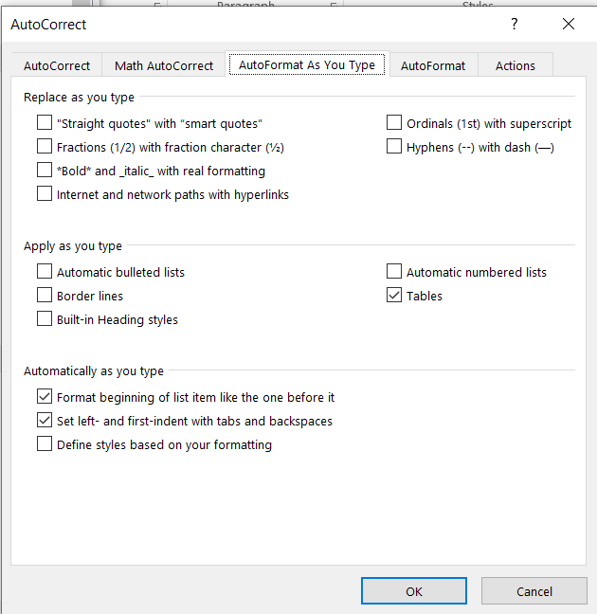

5. Click on the 'Autoformat' tab and ensure your settings are as below

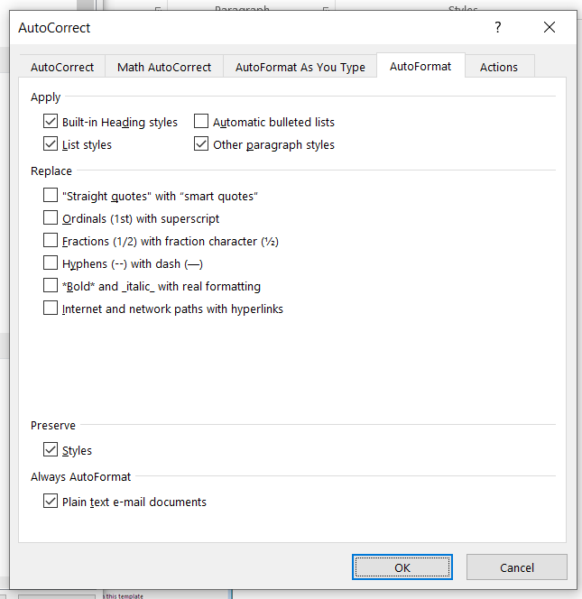

6. Click 'OK"

4. SPELL CHECK SETTINGS

Click the 'Options…' tab and ensure your settings are set as below:

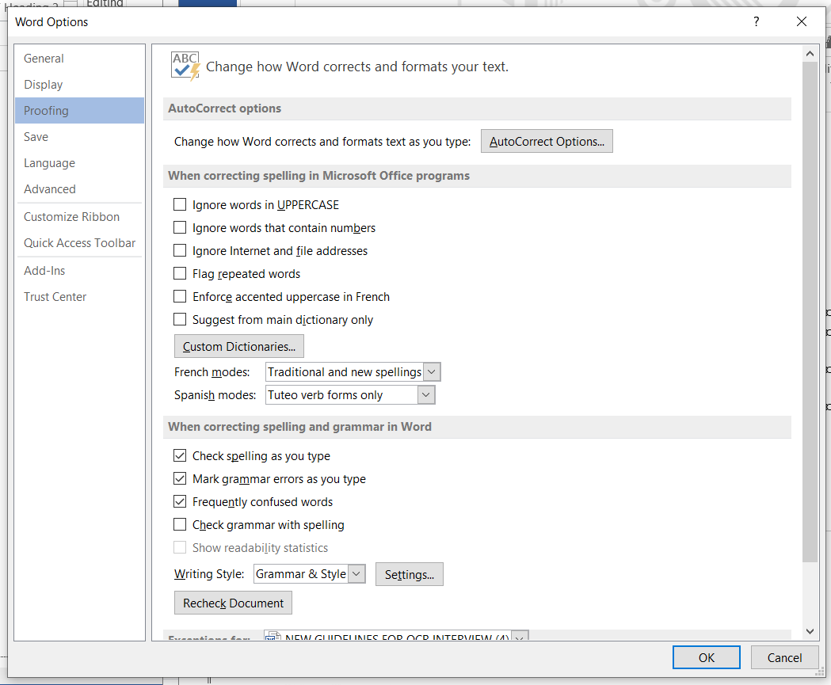

4. Then click ok.

5. RESCAN ISSUES

If a book has rescan issues notify Stepwise for either a better scan or a better physical copy.
If a book has the following rescan issues it should not be validated:
1. If the copyright date is missing
2. If the title page is missing
3. If a book has unclear text
Unclear text means words which a validator cannot make out what they are.

Illustration
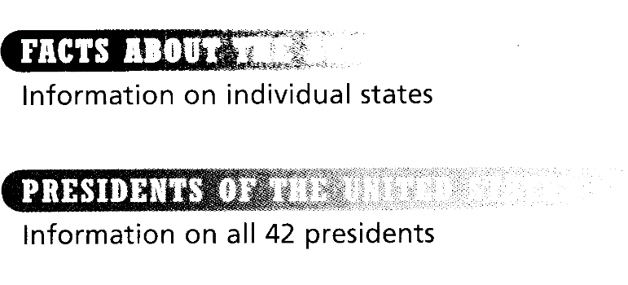

4. If a book has missing pages

Perform a page count to confirm the number of pages.
Find the first page number and compare to the page number given at the bottom of Microsoft Word. Determine how many pages off the count is. Go to the last page of the book and see if the page numbers are still off by the same number of pages. If not, go to the middle of the book and check again. Continue until missing pages or extra pages are found.
# Page numbers in the word doc must equal the page numbers in the image doc.

5. If a book has a lot of scribing
6. Too much formatting for a particular level
Some books especially lower levels may contain too much formatting e.g., too much spell check, images, tables and a lot typing. These books should not be validated but they should be sent back to the company for upgrade.

3. STEPS FOR VALIDATING

i. PREPARATION PHASE

You will be provided with two similar books one will be in Microsoft word format and the other copy will be in PDF Format.

1. CREATE A WORK ENVIRONMENT

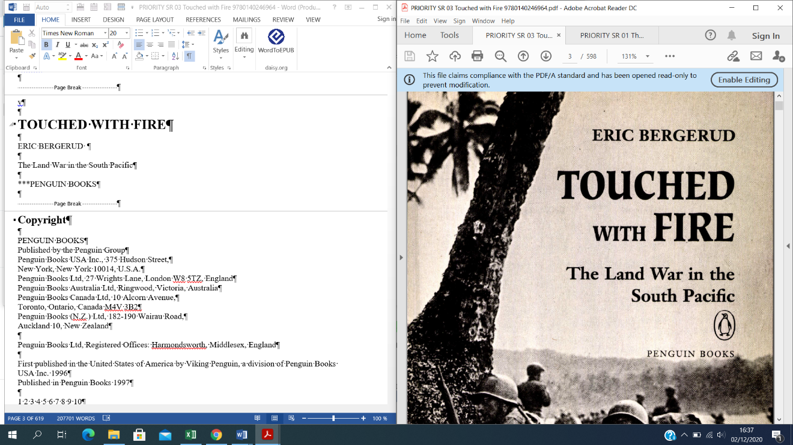

Proofread (edit/validate) the Microsoft word book while crossing checking it with the PDF file. Apply the guidelines provided when proofreading.
NOTE: As much as we are trying to make the word doc look similar to the PDF file, do not center align, or right align any text. Text should run from left to right. Just as it appears on the word doc. Do not indent as well.
On the word document provided please do the following steps:

PREPARATION PHASE BEFORE VALIDATION

STEP 1

Make the following changes on the indents and spacing settings (paragraph settings) to ensure that each paragraph it totally left aligned.
* Highlight the whole document (Ctrl+A)
* Click on the arrow right beside to the paragraph category  and make the following changes on the settings then press OK.

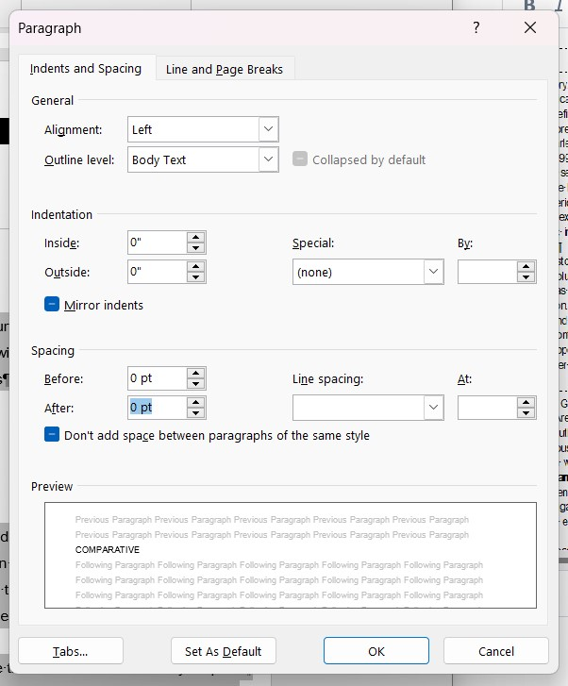

STEP 2

* Highlight the whole document (Ctrl+A)
* Click on Layout (located on the ribbon) and select the first option which is margins.
* Select "Normal" to ensure that all the pages have boarder spaces all-round them.

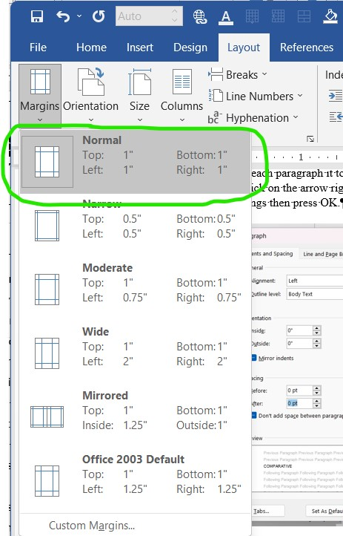

STEP 3

* Highlight the entire document Ctrl+A
* Change the text colors to black 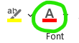.
NB/= Text found on shaded regions are white in color so we have change them all to black.

STEP 4

Remove all shadings inside the file.
* Select the entire document (Ctrl+A)
* Click on the shading options to change the background color of selected text 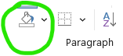.

STEP 5

Replace page break with two entries followed by a page break.
* Press Ctrl+H
* Fill the 2 boxes (find what and replace with) as in the screenshot below.
^m is the denote for page break
^p is the denote for an entry

So we'll replace ^m with ^p^p^m

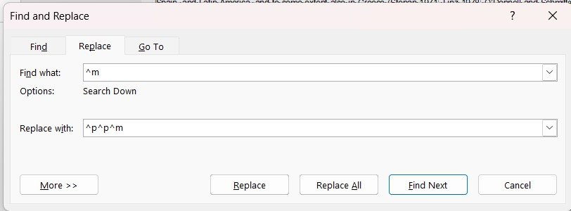

STEP 6

Replace tab spaces with normal spaces
* Press Ctrl+H
* Fill the 2 boxes on the dialog box that popped up
NB: The box for Replace with: should have a single entry in it
^w is the denote for a tab space
So, we'll replace ^w with a single space

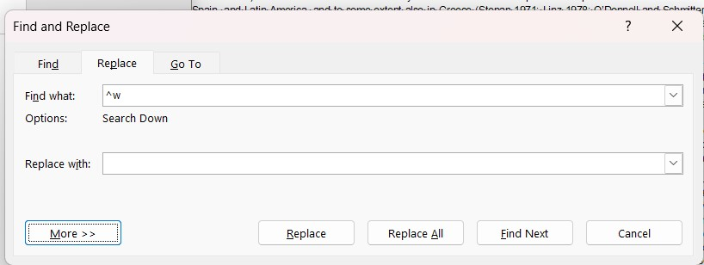

STEP 7

Select the Entire Document (Ctrl+A)
* Remove the bolded and italic parts. Bold the entire file then remove bolded parts, make all words to be italic then remove italic parts.

STEP 8

Modify Normal (style) to times new roman.
* Click on the arrow that beside style
* Place your cursor on top of normal then right click and select modify
* Change the font type only to Times New Roman

STEP 9

* Select the entire word document (Ctrl+A) and generalize the text to font size 12

STEP 10

Find double space and replace with a single space
How to do it:
1. Hold down Ctrl + H
2. In the Find what: tab Press space bar twice.
3. In the Replace with: tab Press space bar once
4. Click replace all.
5. Continue replacing until there are zero replacements to be made.

STEP 11

Find em dash—[alt 0151] and replace with two hyphens--
To do this: Press Ctrl+ H on your keyboard and find and replace.
How to do it:
1. Hold down Ctrl + H
2. In the Find what: tab type — by pressing down alt + 0151 [which is a long dash]
3. In the Replace with: tab type -- [two dashes]. As shown below.
4. Click replace all.

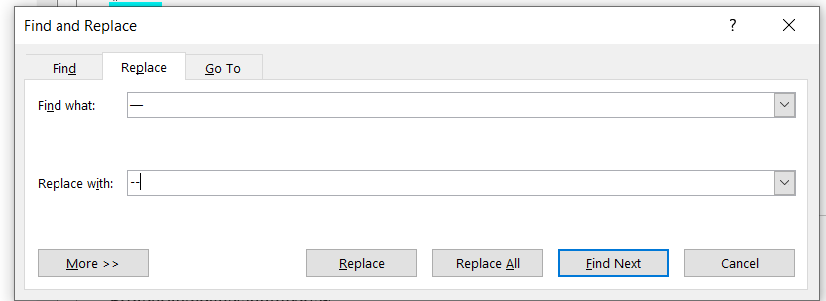

Since we don't have the em dash symbol on the keyboard, hold the alt key+0151 (this generates the em dash) and replace with two hyphens --

STEP 12

Find dot space dot and replace with two joined dots without a space in between
To do this:
1. Hold down Ctrl + H
2. In the Find what: tab type . . (dot space dot)
3. In the Replace with: tab type .. (dot dot) [NB: With no space between the dots]

STEP 13

Protect your page numbers.
To do this:
Highlight the whole document
Press Ctrl+Shift +F9

ii. VALIDATION PHASE

a. TITLE PAGE/COPYRIGHT PAGE

The first two pages on our Word doc must always be the title page followed by the copyright page, no matter where they are located on the PDF doc.
* You must cut and paste them to be the first 2 pages on the Word doc.
NB: The only things that are supposed to be bolded on this page are the titles only.
*Be keen to identify the main title page; there are some pages that contain the name of the book, yet they are not the main title page.
* The title of the book in the Word document MUST always be font 20, bold, Times New Roman.
NB: Only the main title of the book should be font 20 bold; the other repeated titles should remain as font 12.
* To know the title of the book, confirm how the word document is named at the title bar.
* On the copyright page, we must always type in the title COPYRIGHT in the Word doc, because on the PDF side it's not normally indicated.
* The copyright page should be arranged the same way as it appears on the pdf. Ensure that all short paragraphs stand alone.
NB: Images on the title page, copyright page, and TOC are not represented.

Illustration
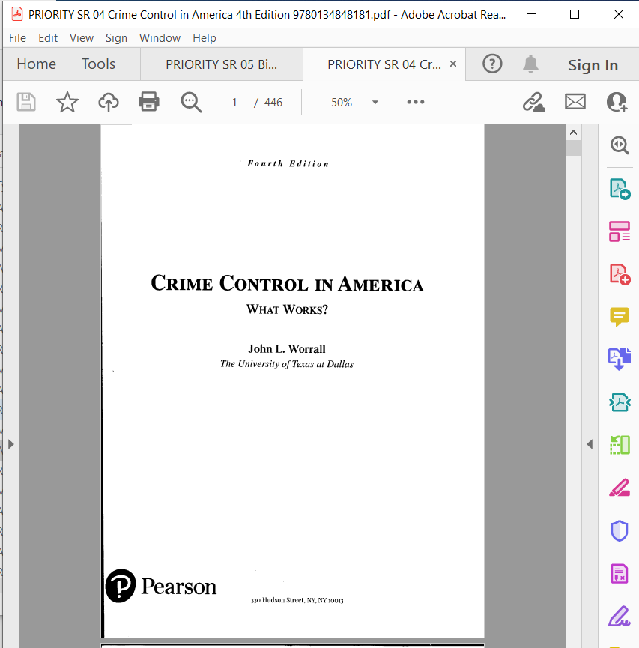

Correct format:

CRIME CONTROL IN AMERICA FOURTH EDITION

What Works?

John L. Worrall
The University of Texas at Dallas

*** Pearson
330 Hudson Street, NY, NY 10013

CHECK IF THE ISBN NUMBER IS CORRECT

The ISBN number should match with the one that appears in the image document. In some cases some alphabets are replaced by numerical numbers e.g. S appears as 5 and I as 1 or vise verse.

Before Validation:
Correct format:
Library of Congress Cataloging-in-Publication Data
Names: Meredith, Jack R„ author. | Shafer, Scott M., author.
Title: Operations and supply chain management for MBAs / Jack R. Meredith and Scott M. Shafer.
Description: Seventh edition. | Hoboken: Wiley, 2019. |Includes index.
Identifiers: LCCN 2019024035 (print) |LCCN 2019024036 (ebook) |ISBN 9781119563235 (paperback) |ISBN 9781119605492 (adobe pdf) |ISBN 9781119563075(epub)
Subjects'. LCSH: Production management. |Business logistics.
Classification: LCC TS155 .M393 2019 (print) |LCC TS155 (ebook) |DDC 658.5--dc23
LC record available at https://lccn.loc.gov/2019024035
LC ebook record available at https://lccn.loc.gov/2019024036

Printing identification and country of origin will either be included on this page and/or the end of the book. In addition, if the ISBN on this page and the back cover do not match, the ISBN on the back cover should be considered the correct ISBN.

Printed in the United States of America

SKY10021429_092220

HEADINGS AND SUBHEADINGS

The book is formatted (also known as “tagging”) with Microsoft Word’s styles. There are two categories of styles: paragraph and character. Paragraph styles contain formatting definitions that include character styles, such as font and font size. Character styles will only affect font and size and should not be used.
The table below lists the tag names and their use.

Category I
Style Name | Use | Font
Book Title | Title of the book | 20
Heading 1 | Part/section/unit, Copyright, Content, About the Author, About the Illustrator, Acknowledgements, Foreword, Preface, Introduction, Answers, Glossary, Appendix, References, Bibliography, Index | 18
Heading 2 | Chapter Heading | 18
Heading 3 | Subheading | 16
Heading 4 | Sub-subtitles | 14
Normal | Text (paragraphs) | 12

Category II
Style Name | Use | Font
Book Title | Title of the book | 20
Heading 1 | Copyright, Content, About the Author, About the Illustrator, Acknowledgements, Foreword, Preface, Introduction, All Chapters, Answers, Glossary, Appendix, References, Bibliography, Index | 18
Heading 2 | Subheading | 16
Heading 3 | Sub-subtitles | 14
Normal | Text (paragraphs) | 12

NB: Titles that should be font 18 bold
* Copyright
* Content
* About the Author
* About the Illustrator
* Acknowledgements
* Foreword
* Preface
* Introduction
* All chapter headings
* Answers
* Glossary
* Appendix
* References
* Bibliography
* Index

Illustration

Image:
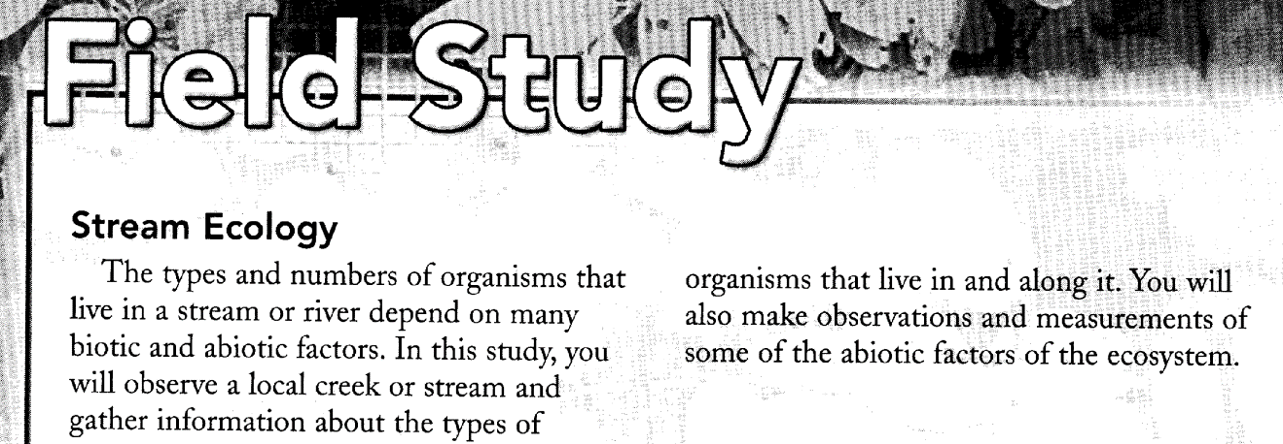

Before validation
Field Study
Stream Ecology
The types and numbers of organisms that live in a stream or river depend on many biotic and abiotic factors. In this study, you will observe a local creek or stream and gather information about the types of organisms that live in and along it. You will also make observations and measurements some of the abiotic factors of the ecosystem.

After Validation:

Field Study

Stream Ecology

The types and numbers of organisms that live in a stream or river depend on many biotic and abiotic factors. In this study, you will observe a local creek or stream and gather information about the types of organisms that live in and along it. You will also make observations and measurements some of the abiotic factors of the ecosystem.

PROTECTION OF CHAPTER HEADERS

When a page begins with the word 'Chapter' the RTF=> DAISY converter that processes the .rtf will treat it as a header and remove it. Protect the Chapter headers by typing the page number on top the line before the word "Chapter".

IMAGE:
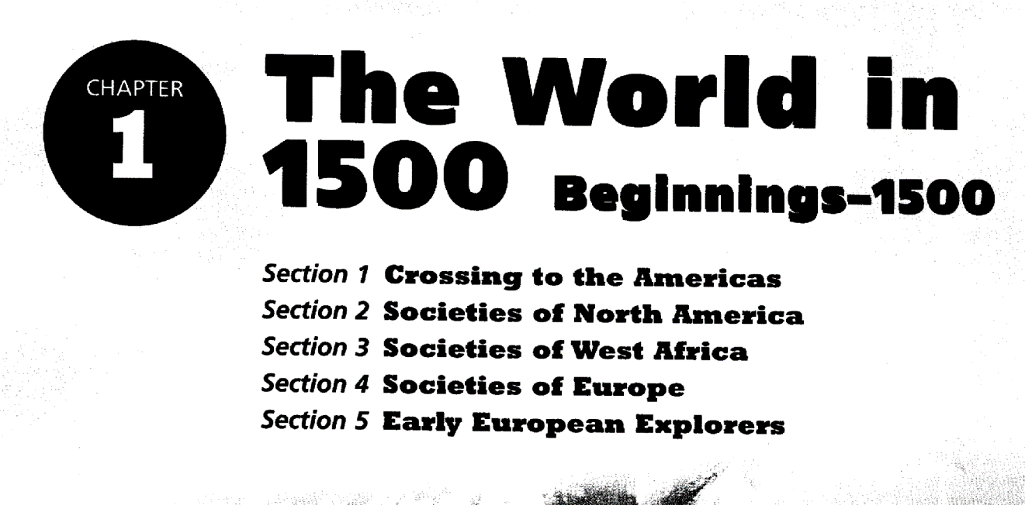

CORRECT FORMAT:

CHAPTER 1 THE WORLD IN 1500 BEGINNINGS-1500

Section 1 Crossing to the Americans
Section 2 Societies of North America
Section 3 Societies of West Africa
Section 4 Societies of Europe
Section 5 Early European Explorers

N/B: The protection for Chapter headings is unnecessary if there is a page number/ word before the word ‘Chapter.’

Heading Levels
Heading levels should be arranged as follows:
Heading Level 1
Heading Level 2
Heading Level 3
Heading Level 3
Heading Level 2
Heading Level 1
The order is important. If a Heading Level 3 is under a Heading Level 1, an error message will be generated when the book is converted to an ePub. The error must be fixed.
As headings are assigned a heading level tag or style, they will appear in the Navigation Pane. The navigation panel can be used to move around in the book without scrolling while proofreading.

HEADERS AND FOOTERS

These are comments, files names, dates, page numbers etc. that can be printed on any document. Headers are shown at the top of the page while footers are shown at the bottom.
All recurring headers and footers should be removed in the word document

Example of footer

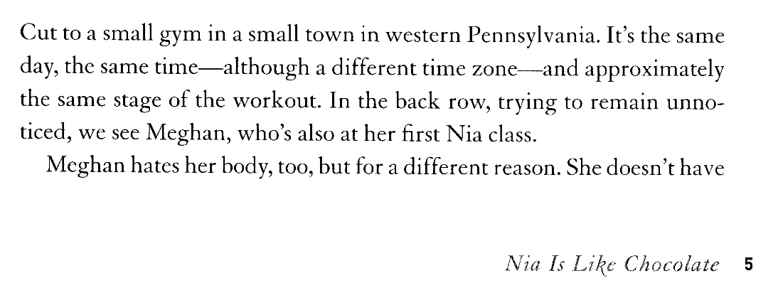

After Validation:
Cut to a small gym in a small town in western Pennsylvania. It’s the same day, the same time—although a different time zone—and approximately the same stage of the workout. In the back row, trying to remain unnoticed, we see Meghan, who’s also at her first Nia class.
Meghan hates her body, too, but for a different reason. She doesn’t have

5

Example of a header

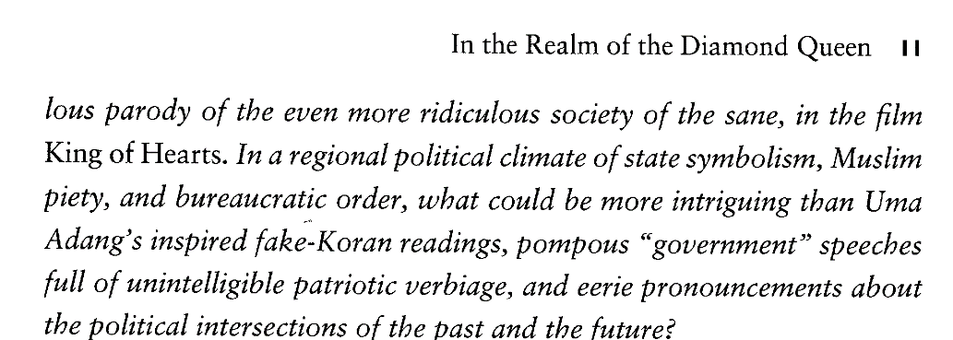

ADDRESSES

Addresses should be arranged just like they appear on the image document.

IMAGE DOCUMENT
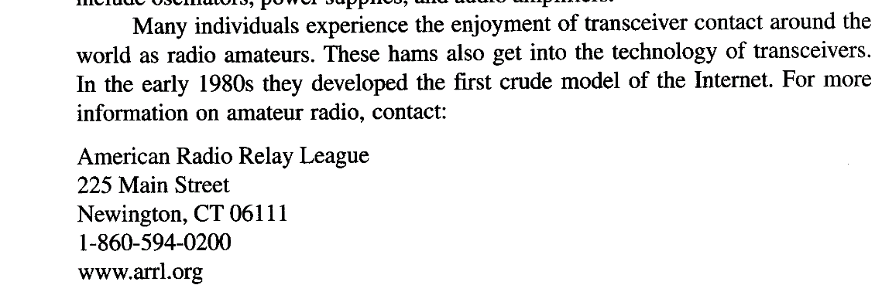

AFTER VALIDATION
Many individuals experience the enjoyment of transceiver contact around the world as radio amateurs. These hams also get into the technology of transceivers. In the early 1980s they developed the first crude model of the Internet. For more information on amateur radio, contact:

American Radio Relay League
225 Main Street
Newington, CT 06111
1-860-594-0200
www.arrl.org

BLANK PAGE

Where there is a blank page type the word blank page and protect it with square brackets
Blank pages are not numbered.

[BLANK PAGE]

N/B: Make sure that the word blank page is not italicized, not bold and its font size 12.

Columns and Sidebars
There are two exceptions to the “exact copy” rule: two column format and sidebars.
If the text is presented in two columns, the Word file can be changed to a single column.
Sidebars can be presented in the main text body, enclosed with square brackets as follows:
[sidebar This is an example of how a sidebar should be formatted. The square brackets appear at the beginning and end of the sidebar text.]

FOREIGN LANGUAGE

Use [FOREIGN LANGUAGE] for text that is not in English

IMAGE:
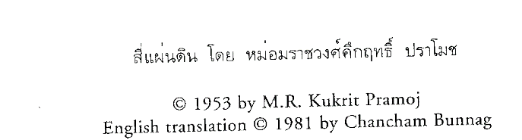

Correct Format:

[FOREIGN LANGUAGE]

© 1953 by M.R. Kukrit Pramoj
English translation © 1981 by Chancham Bunnag

N/B: The text that was initially in foreign language has been replaced with the phrase [FOREIGN LANGUAGE]

FOREIGN LANGUAGE TRANSLATION

https://lingvanex.com/translation/english-to-swahili

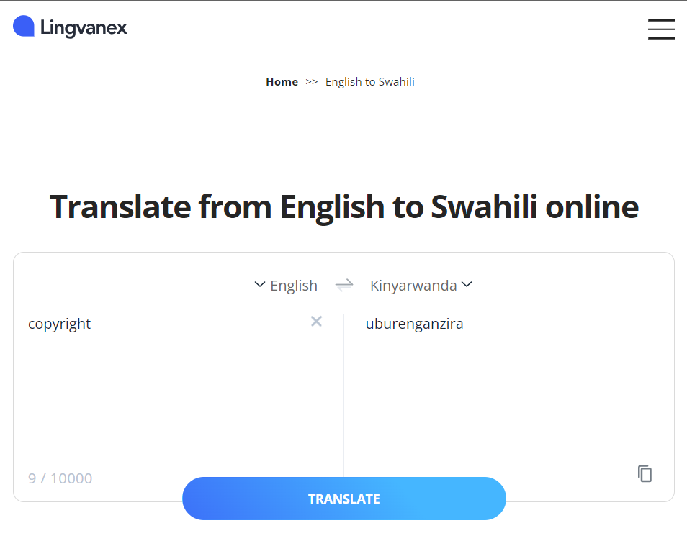

English to Swahili

[Caption: | [Maelezo mafupi:
[Graph: | [Grafu:
[Map: | [Ramani:
[Pie chart: | [Chati ya pai:
[Image: A boy and girl.] | [Picha: Mvulana na msichana.]
[figure removed] | [takwimu imeondolewa]
[image removed] | [picha imeondolewa]
[illustration removed] | [mfano ulioondolewa]
[chemical structure removed] | [muundo wa kemikali ulioondolewa]
[diagram removed] | [mchoro ulioondolewa]
[sidebar] | [pembeni]
[box] | [sanduku]
[table] | [meza]
COPYRIGHT | HAKIMILIKI
[BLANK PAGE] | [PICHA ZA BLANK]

English to Kinyarwanda

[Caption: | [Inyandiko:
[Graph: | [Igishushanyo:
[Map: | [Ikarita:
[Pie chart: | [Imbonerahamwe:
[Image: A boy and girl.] | [Ishusho: Umuhungu numukobwa.]
[figure removed] | [Ishusho yakuweho]
[image removed] | [ishusho yakuweho]
[illustration removed] | [urugero yakuweho]
[chemical structure removed] | [imiterere yimiti yakuweho]
[diagram removed] | [igishushanyo cyakuweho]
[sidebar] | [uruhande]
[box] | [agasanduku]
[table] | [ameza]
COPYRIGHT | UBURENGANZIRA
[BLANK PAGE] | [URUPAPURO RWA BLANK]

English to French

[Caption: | [Légende:
[Graph: | [Graphique:
[Map: | [Carte:
[Pie chart: | [Tableau des pièces:
[Image: A boy and girl.] | [Image: Un garçon et une fille.]
[figure removed] | [chiffre supprimé]
[image removed] | [image supprimée]
[illustration removed] | [illustration supprimée]
[chemical structure removed] | [structure chimique supprimée]
[diagram removed] | [diagramme supprimé]
[sidebar] | [barre latérale]
[box] | [boîte]
[table] | [table]
COPYRIGHT | DROIT
[BLANK PAGE] | [PAGE BLANK]

English to Spanish

[Caption: | [Leyenda:
[Graph: | [Gráfico:
[Map: | [Mapa:
[Pie chart: | [Gráfico circular:
[Image: A boy and girl.] | [Imagen: Un niño y una niña.]
[figure removed] | [figura eliminada]
[image removed] | [imagen eliminada]
[illustration removed] | [ilustración eliminada]
[chemical structure removed] | [estructura química eliminada]
[diagram removed] | [diagrama eliminado]
[sidebar] | [barra lateral]
[box] | [caja]
[table] | [tabla]
COPYRIGHT | DERECHO DE AUTOR
[BLANK PAGE] | [PÁGINA EN BLANCO]

English to German

[Caption: | [Untertitel:
[Graph: | [Graph:
[Map: | [Karte:
[Pie chart: | [Kuchendiagramm:
[Image: A boy and girl.] | [Bild: Ein junge und ein mädchen.]
[figure removed] | [abbildung entfernt]
[image removed] | [bild entfernt]
[illustration removed] | [abbildung entfernt]
[chemical structure removed] | [chemische Struktur entfernt]
[diagram removed] | [diagramm entfernt]
[sidebar] | [seitenleiste]
[box] | [kasten]
[table] | [tisch]
COPYRIGHT | URHEBERRECHTE
[Image: Illustration.] | [Bild: Illustration.]

BULLETS

Use * to represent all types of bullets in the word document.
Examples of different types of bullets:

Illustration

Image:
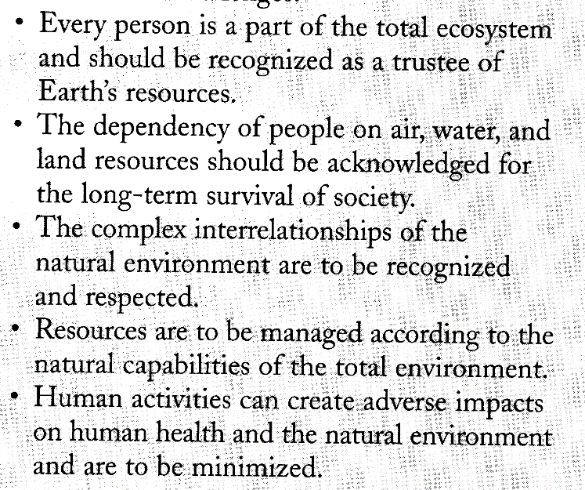

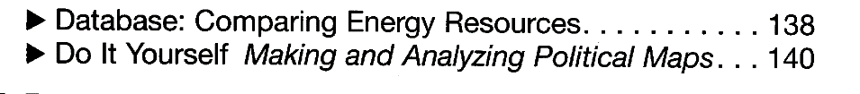



Before validation:
• Every person is a part of the total ecosystem and should be recognized as a trustee of Earth’s resources.
• The dependency of people on air, water, and land resources should be acknowledged for the long-term survival of society
• The complex interrelationships of the natural environment are to be recognized and respected.
• Resources are to be managed according to the natural capabilities of the total environment.
• Human activities can create adverse impacts on human health and the natural environment
and are to be minimized.

After validation:
* Every person is a part of the total ecosystem and should be recognized as a trustee of Earth’s resources.
* The dependency of people on air, water, and land resources should be acknowledged for the long-term survival of society
* The complex interrelationships of the natural environment are to be recognized and respected.
* Resources are to be managed according to the natural capabilities of the total environment.
* Human activities can create adverse impacts on human health and the natural environment and are to be minimized.

Correct Format:
Ctrl + H
Find what: • the bullet then replace with * then replace all.

UNIFORMITY IN BOOKS

Make sure that there is uniformity in formatting

Go through each page number and ascertain that they are in numerals. The page numbers should have uniformity in a sense that, if they are bolded they should be bolded all through, and if they are italicized they should be italicized from the first to the last page.

ACCENTED AND SYMBOLS

Accented letters are words with different pronunciations. e.g José
Make sure that accented marks are retained in the word document as they appear in the image document.
Don't ever perform Global Replacement because not all accented words are similar.
NB: Find the accented code shortcuts in the last pages

Illustration
Image:
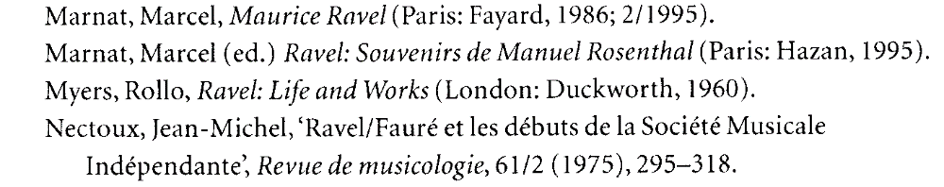

Before Validation:
Marnat, Marcel, Maurice Ravel (Paris: Fayard, 1986; 2/1995).
Marnat, Marcel (ed.) Ravel: Souvenirs de Manuel Rosenthal (Paris: Hazan, 1995).
Myers, Rollo, Ravel: Life and Works (London: Duckworth, 1960).
Nectoux, Jean-Michel, ‘Ravel/Faure et les debuts de la Societe Musicale Independante Revue de musicologie, 61/2 (1975), 295—318.

After Validation:
Marnat, Marcel, Maurice Ravel (Paris: Fayard, 1986; 2/1995).
Marnat, Marcel (ed.) Ravel: Souvenirs de Manuel Rosenthal (Paris: Hazan, 1995).
Myers, Rollo, Ravel: Life and Works (London: Duckworth, 1960).
Nectoux, Jean-Michel, ‘Ravel/Fauré et les débuts de la Société Musicale Indépendante Revue de musicologie, 61/2 (1975), 295--318.

Make sure that all the symbols in the word document are replaced and look alike as per the image document
Illustration
Image Document

α [alt + 945] β [alt + 946] γ [alt + 947]

HOW TO READ THIS BOOK

Sometimes among the first pages there are illustrations indicating some of the content that you will find inside the book. Delete the illustrations, and retain the explanations listed.

IMAGE:
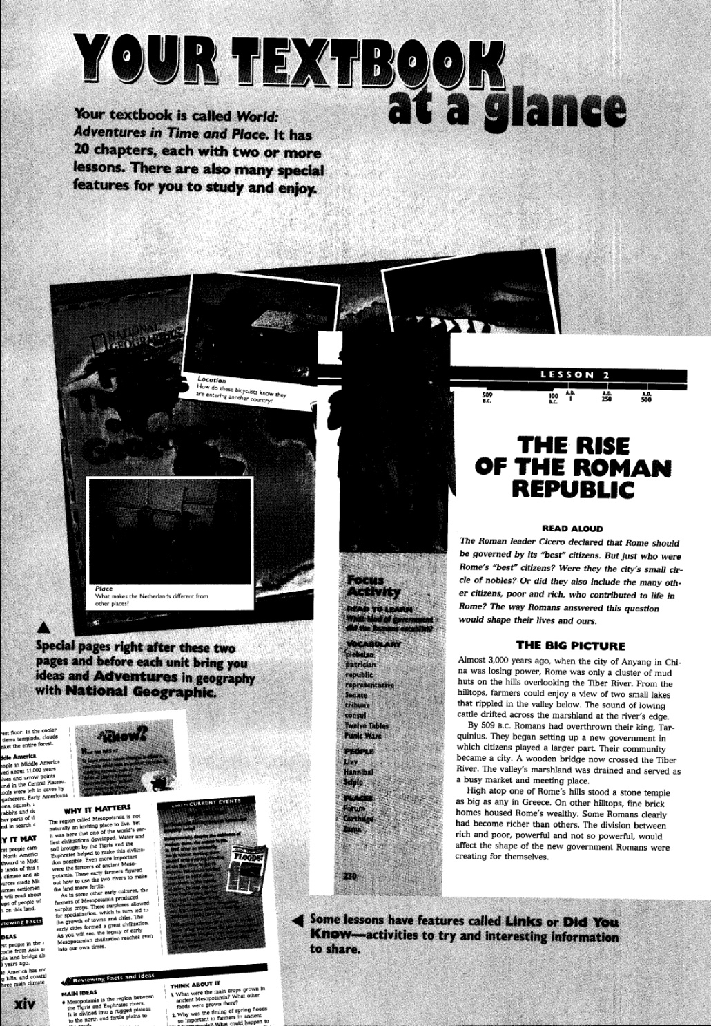

Correct format:

YOUR TEXTBOOK at a glance

Your textbook is called World: Adventures in Time and Place, It has 20 chapters, each with two or more lessons. There are also many special features for you to study and enjoy.

[Caption: Special pages right after these two pages and before each unit bring you ideas and Adventure in geography with National Geographic.]

[Caption: Some lessons have features ailed Links or Did You Know --activities to try and interesting Information to share.]

THE RISE OF THE ROMAN REPUBLIC
READ ALOUD
The roman leader…

IMAGE:
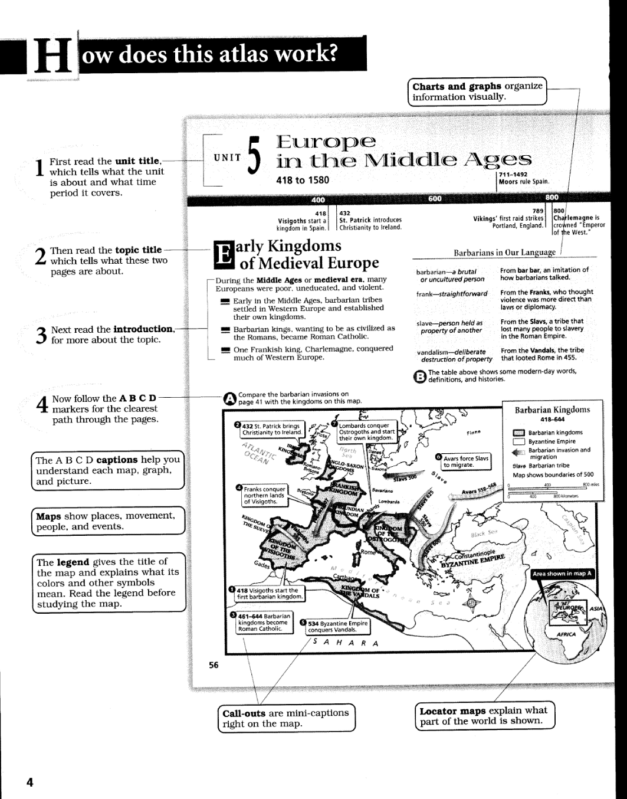

After Validation:

How does this atlas work?

[Illustration Removed]

1. First read the unit title, which tells what the unit is about and what time period it covers.
2. Then read the topic title which tells what these two pages are about.
3. Next read the introduction, for more about the topic.
4. Now follow the A B C D -markers for the clearest path through the pages.
The A B C D captions help you understand each map, graph, and picture.
Maps show places, movement, people, and events.
The legend gives the title of the map and explains what its colors and other symbols mean. Read the legend before studying the map.
Charts and graphs organize information visually.
Call-outs are mint-captions right on the map.
Locator maps explain what part of the world is shown.

MARKING

Add *** for sections in the books where there is some sort of image depicting a change of topic or a different section. Many books use symbols to denote a difference in the text within the page prose. Such images should be replaced with *** instead. See examples below.

IMAGE:
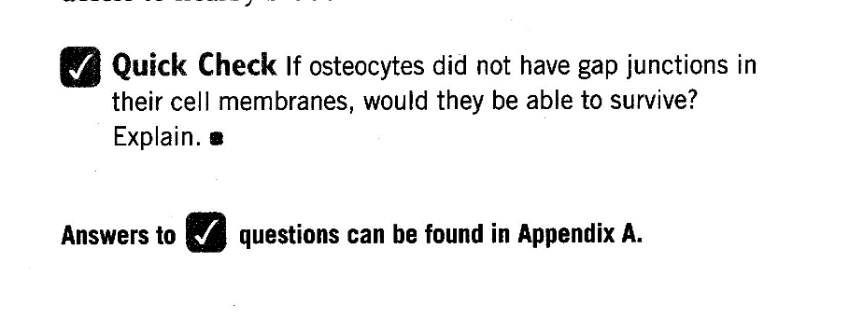

Correct format:

*** Quick Check If osteocytes did not have gap junctions in their cell membranes, would they be able to survive?
Explain.

Answers to *** questions can be found in Appendix A.

IMAGE:
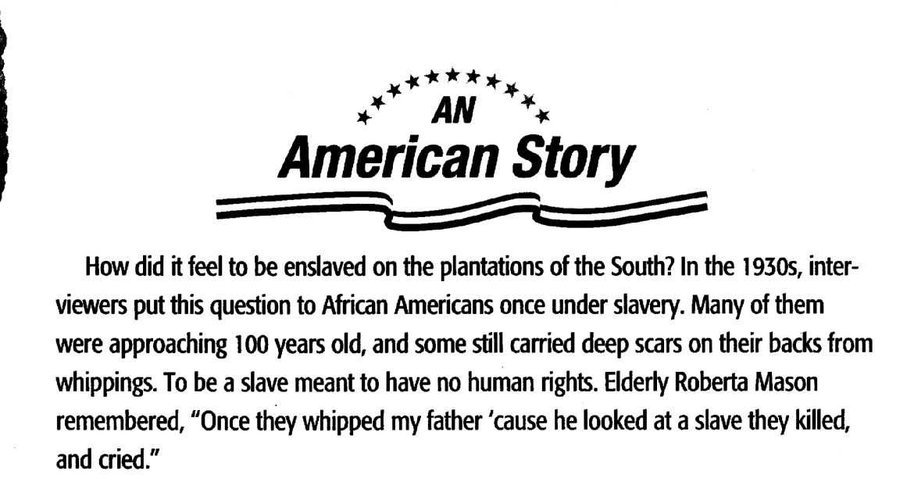

After Validation:

*** AN American Story

How did it feel to be enslaved on the plantations of the South? In the 1930s, interviewers put this question to African Americans once under slavery. Many of them were approaching 100 years old, and some still carried deep scars on their backs from whippings. To be a slave meant to have no human rights. Elderly Roberta Mason remembered, "Once they whipped my father 'cause he looked at a slave they killed, and cried."

TEXTBOX

Put the code [box] on top of the textbox.
If a box has no title you will be required to type in the word box in square brackets [box], but if it has a title you'll only have to bold its title.

IMAGE:
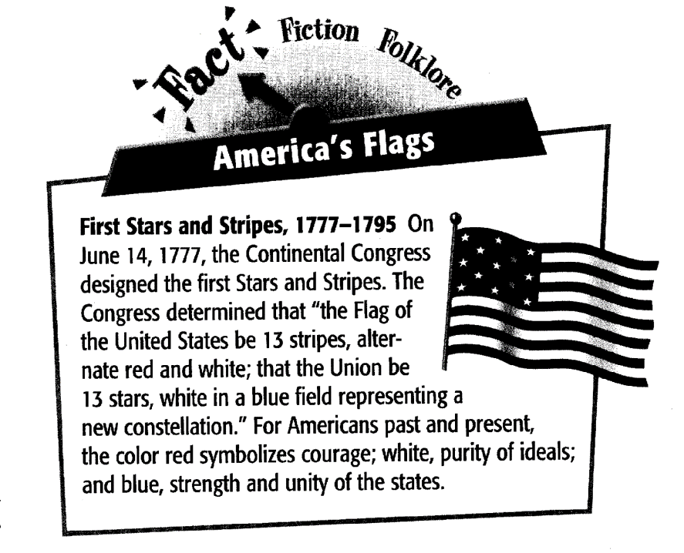

After Validation:

Fact Fiction Folklore

America's Flags
First Stars and Stripes, 1777-1795 On June 14, 1777, the Continental Congress designed the first Stars and Stripes. The Congress determined that “the Flag of the United States be 13 stripes, alternate red and white; that the Union be 13 stars, white in a blue field representing a new constellation.” For Americans past and present, the color red symbolizes courage; white, purity of ideals; and blue, strength and unity of the states.

IMAGE:

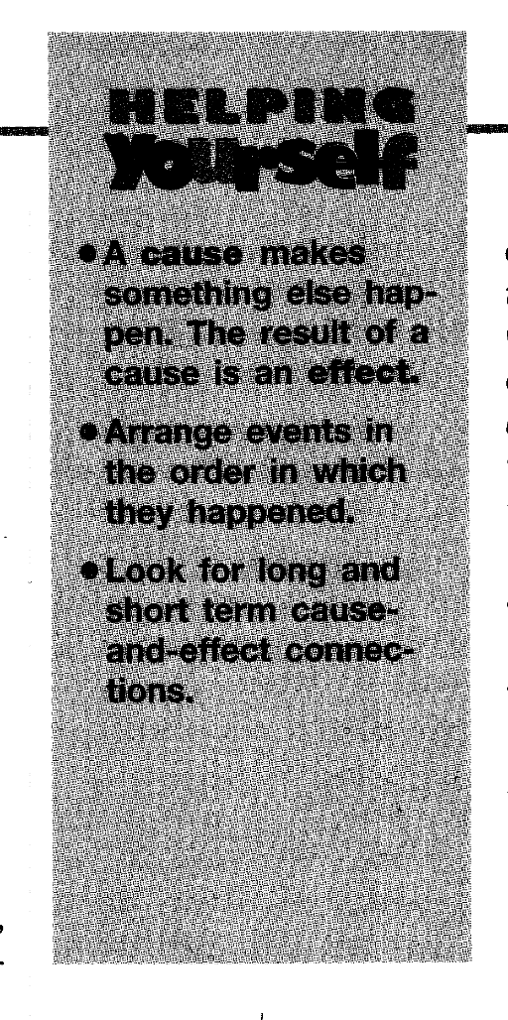

Correct format:

HELPING Yourself
* A cause makes something else happen. The result of a cause is a n effect
* Arrange events in the order in which they happened.
* Look for long and short term cause-effect connections.

LINE BREAKS

Ensure you put all the line breaks as they are in the image document by pressing enter key once.

NB: It is unnecessary to retain indentations or multiple line breaks

Illustration

Image:

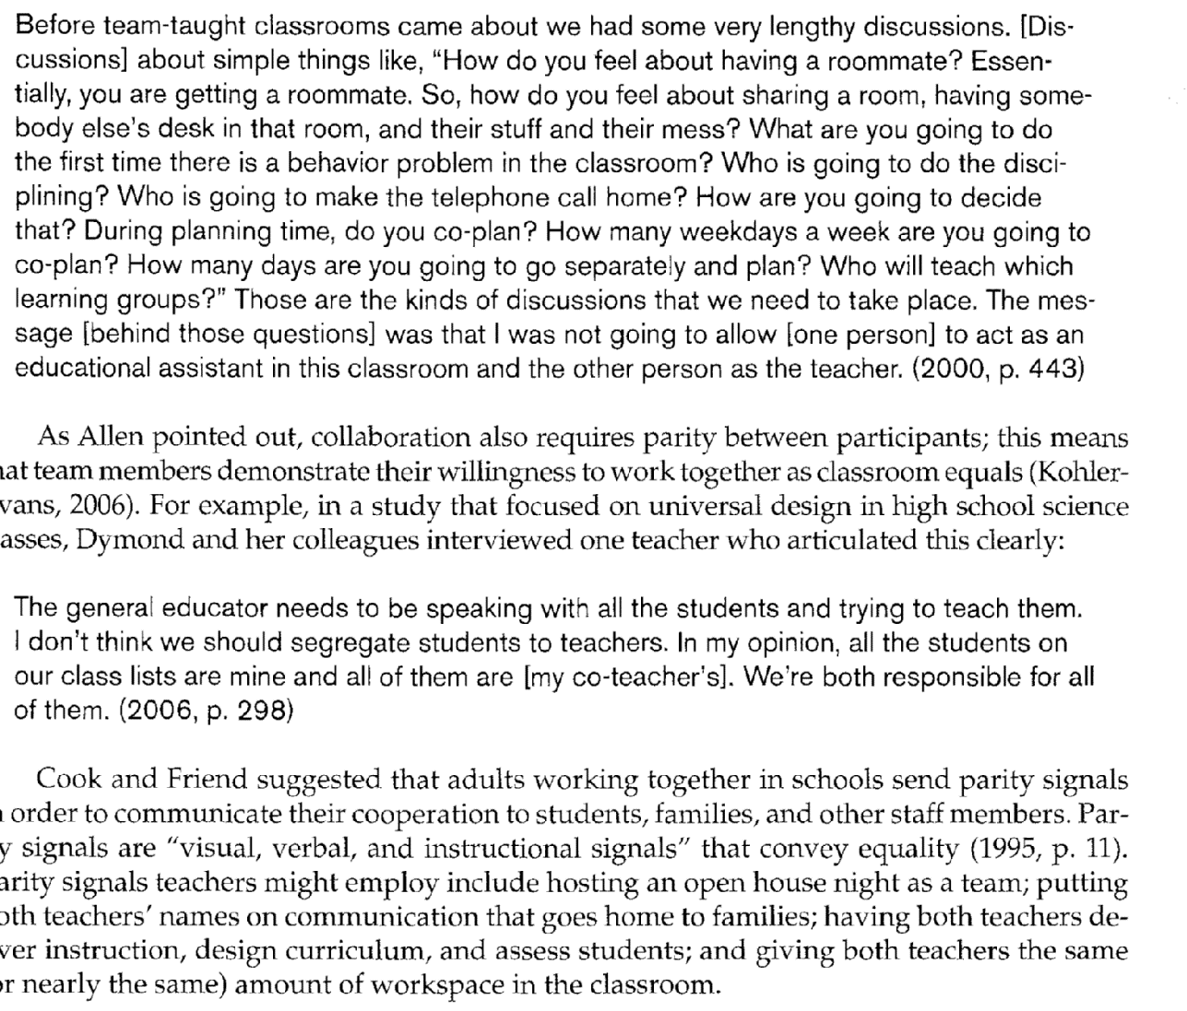

Before validation
Before team-taught classrooms came about we had some very lengthy discussions. [Discussions] about simple things like, “How do you feel about having a roommate? Essentially, you are getting a roommate. So, how do you feel about sharing a room, having somebody else’s desk in that room, and their stuff and their mess? What are you going to do the first time there is a behavior problem in the classroom? Who is going to do the disciplining? Who is going to make the telephone call home? How are you going to decide that? During planning time, do you co-plan? How many weekdays a week are you going to co-plan? How many days are you going to go separately and plan? Who will teach which learning groups?” Those are the kinds of discussions that we need to take place. The message [behind those questions] was that I was not going to allow [one person] to act as an educational assistant in this classroom and the other person as the teacher. (2000, p. 443)
As Allen pointed out, collaboration also requires parity between participants; this means that team members demonstrate their willingness to work together as classroom equals (KohierEvans, 2006). For example, in a study that focused on universal design in high school science classes, Dymond and her colleagues interviewed one teacher who articulated this clearly:
The general educator needs to be speaking with all the students and trying to teach them. I don’t think we should segregate students to teachers. In my opinion, all the students on our class lists are mine and all of them are [my co-teacher’s]. We’re both responsible for all of them. (2006, p. 298)
Cook and Friend suggested that adults working together in schools send parity signals in order to communicate their cooperation to students, families, and other staff members. Parity signals are “visual, verbal, and instructional signals” that convey equality (1995, p. 11). Parity signals teachers might employ include hosting an open house night as a team; putting both teachers’ names on communication that goes home to families; having both teachers deliver instruction, design curriculum, and assess students; and giving both teachers the same (or nearly the same) amount of workspace in the classroom.

After Validation:
Before team-taught classrooms came about we had some very lengthy discussions. [Discussions] about simple things like, “How do you feel about having a roommate? Essentially, you are getting a roommate. So, how do you feel about sharing a room, having somebody else’s desk in that room, and their stuff and their mess? What are you going to do the first time there is a behavior problem in the classroom? Who is going to do the disciplining? Who is going to make the telephone call home? How are you going to decide that? During planning time, do you co-plan? How many weekdays a week are you going to co-plan? How many days are you going to go separately and plan? Who will teach which learning groups?” Those are the kinds of discussions that we need to take place. The message [behind those questions] was that I was not going to allow [one person] to act as an educational assistant in this classroom and the other person as the teacher. (2000, p. 443)

As Allen pointed out, collaboration also requires parity between participants; this means that team members demonstrate their willingness to work together as classroom equals (KohierEvans, 2006). For example, in a study that focused on universal design in high school science classes, Dymond and her colleagues interviewed one teacher who articulated this clearly:

The general educator needs to be speaking with all the students and trying to teach them. I don’t think we should segregate students to teachers. In my opinion, all the students on our class lists are mine and all of them are [my co-teacher’s]. We’re both responsible for all of them. (2006, p. 298)

Cook and Friend suggested that adults working together in schools send parity signals in order to communicate their cooperation to students, families, and other staff members. Parity signals are “visual, verbal, and instructional signals” that convey equality (1995, p. 11). Parity signals teachers might employ include hosting an open house night as a team; putting both teachers’ names on communication that goes home to families; having both teachers deliver instruction, design curriculum, and assess students; and giving both teachers the same (or nearly the same) amount of workspace in the classroom.

IMAGE DESCRIPTION

When describing images:
1. Use the captions given in the text that accompany maps, graphs, and charts.
2. When no caption is given in the book, simple descriptions should be created as needed.
3. Other pertinent information may be added as needed.
4. For illustrations in children's picture books, basic descriptions are required. Keep vocabulary and grammar comparable to the whole of the text.
5. Use perfect English while describing [e.g., The first letter of the noun must be a capital letter]
6. Image description must be protected by square brackets i.e.
NB: This format should neither be bold, italic or underlined

ILLUSTRATIONS

MAPS

IMAGE:
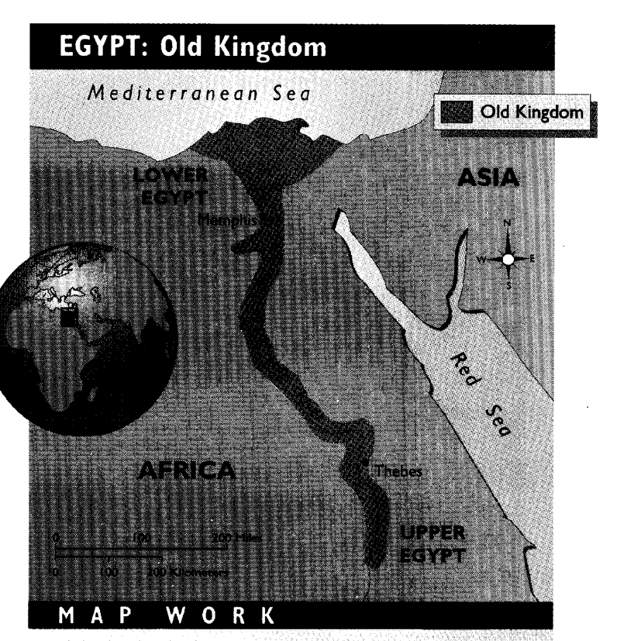

In this case the map has a title so the description will be:

[Map: EGYPT: Old Kingdom.]

IMAGE:
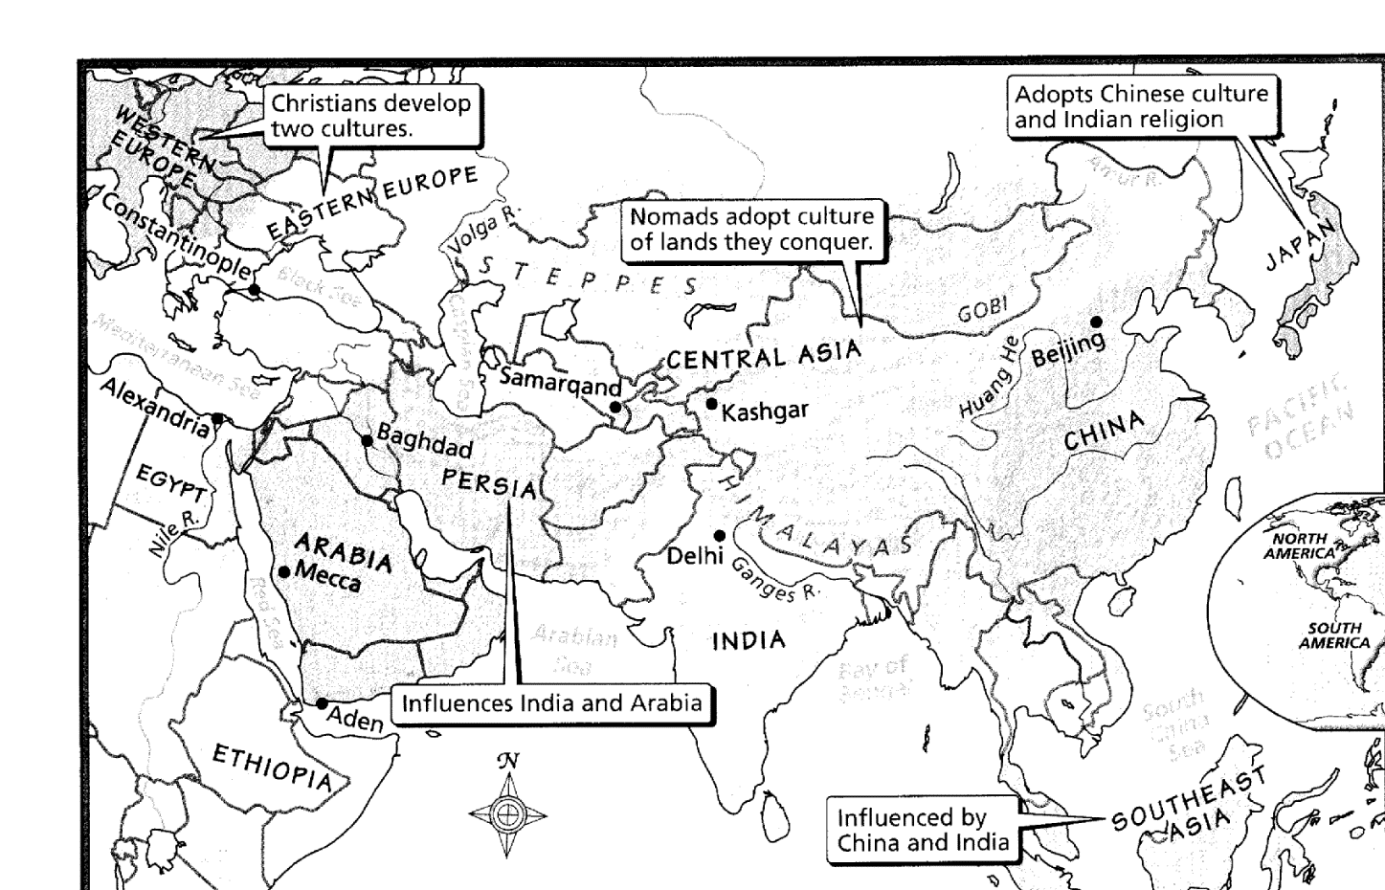

In this case the map has no title so the description will be:

[Image: A map.]

GRAPHS AND PIE CHARTS

IMAGE:
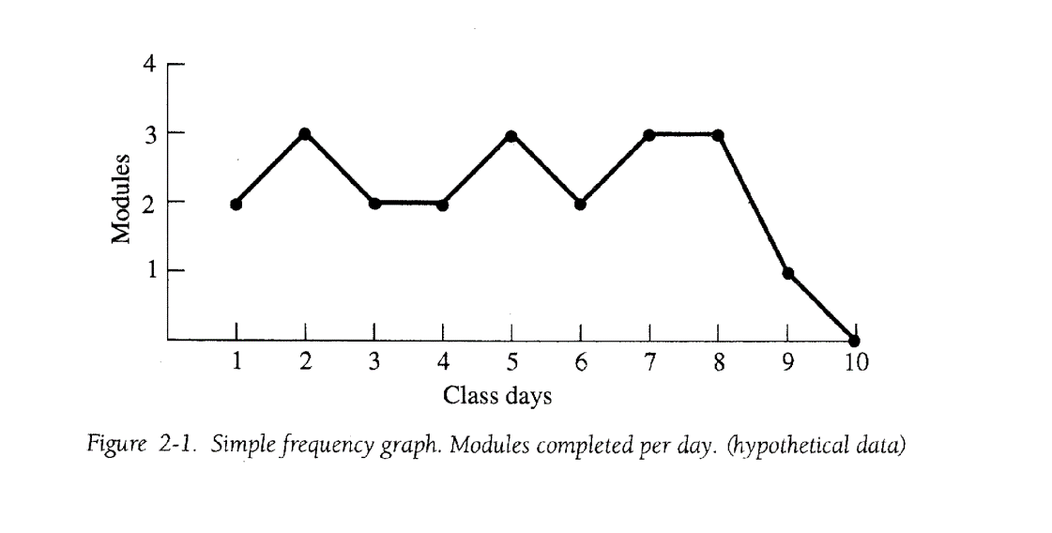
In this case the graph has a caption so the description will be:

[Graph: "Figure 2-1. Simple frequency graph. Modules completed per day. (hypothetical data).]

IMAGE:
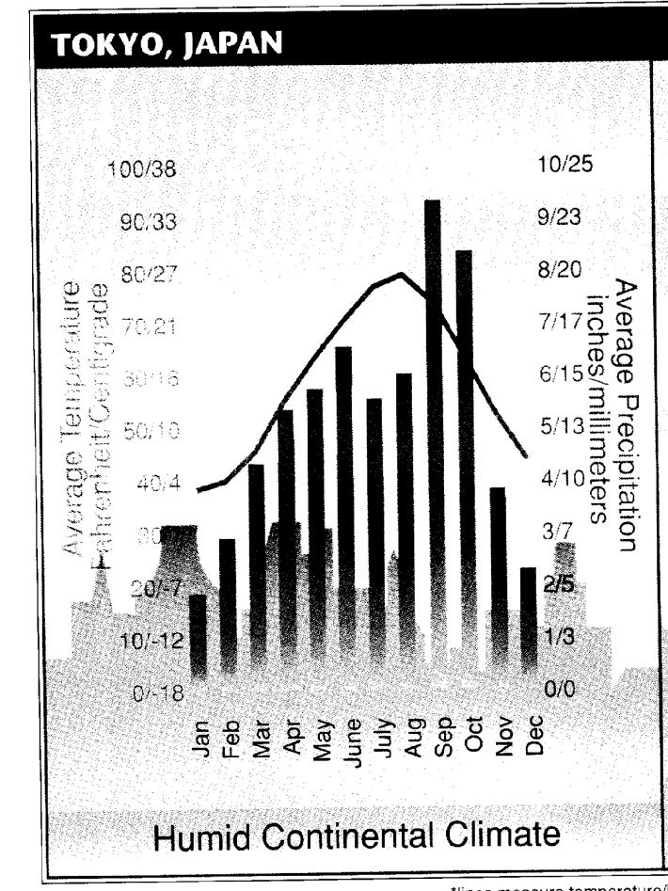

In this case the graph has a title so the description will be:

[Graph: TOKYO, JAPAN.]

IMAGE:
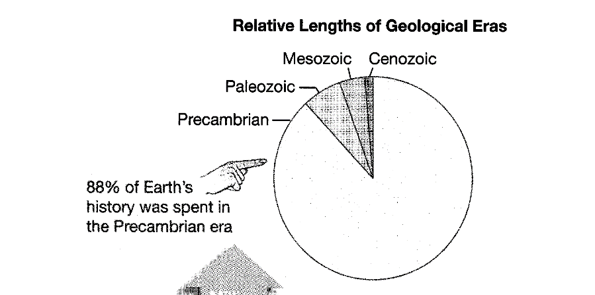

In this case the pie chart has a title so the description will be:

[Pie chart: Relative Lengths of Geological Era.]

IMAGE:
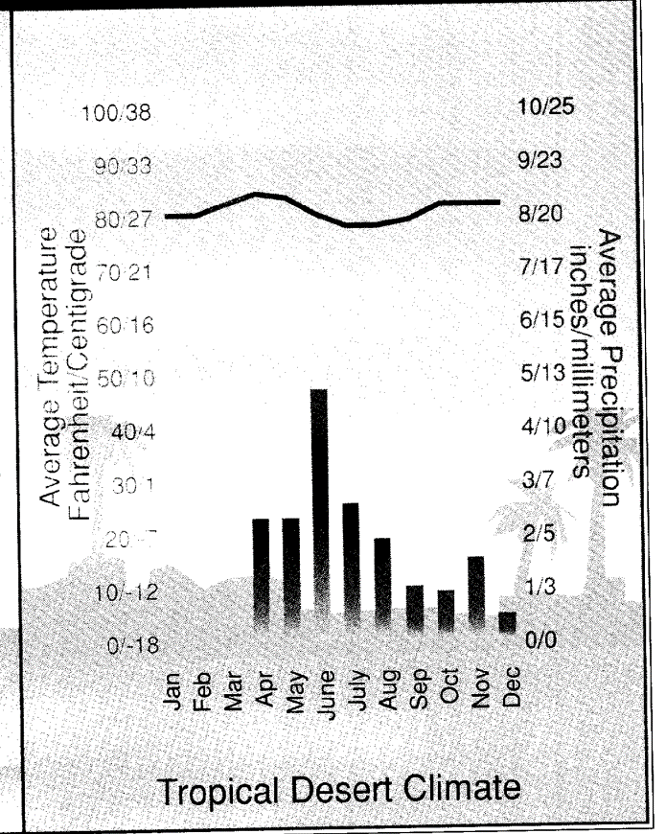

In this case the graph has no caption or title so the description will be:

[Image: A graph.]

IMAGES WITH CAPTIONS

IMAGE:
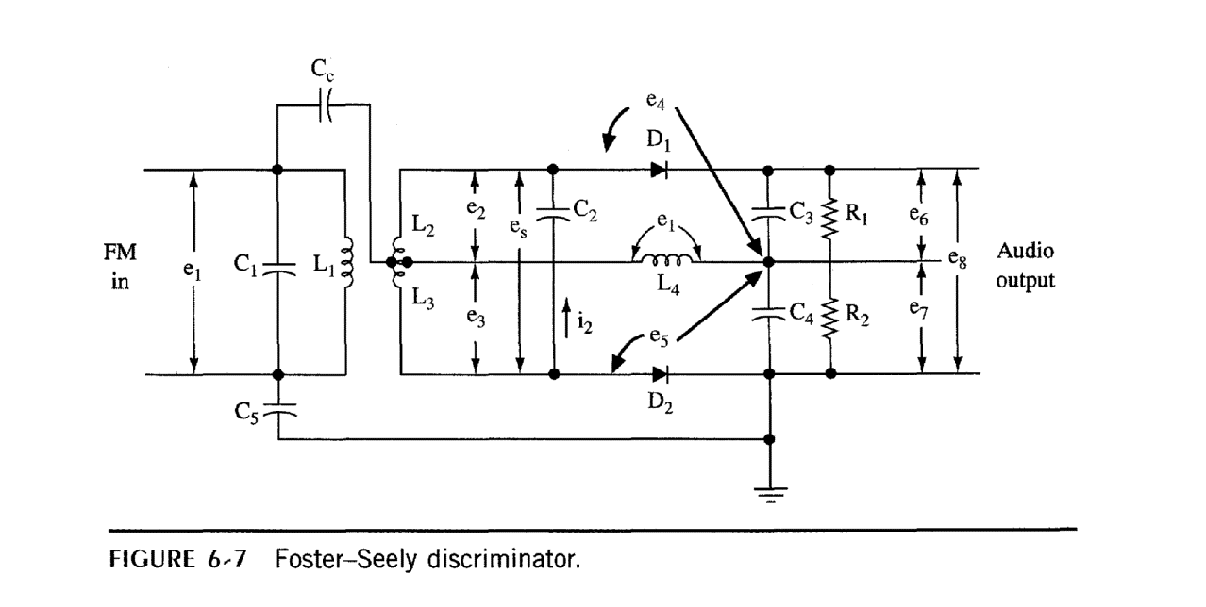

In this case the image has a caption so the description will be:

[Caption: Figure 6-7 Foster-Seely discriminator.]

IMAGE:
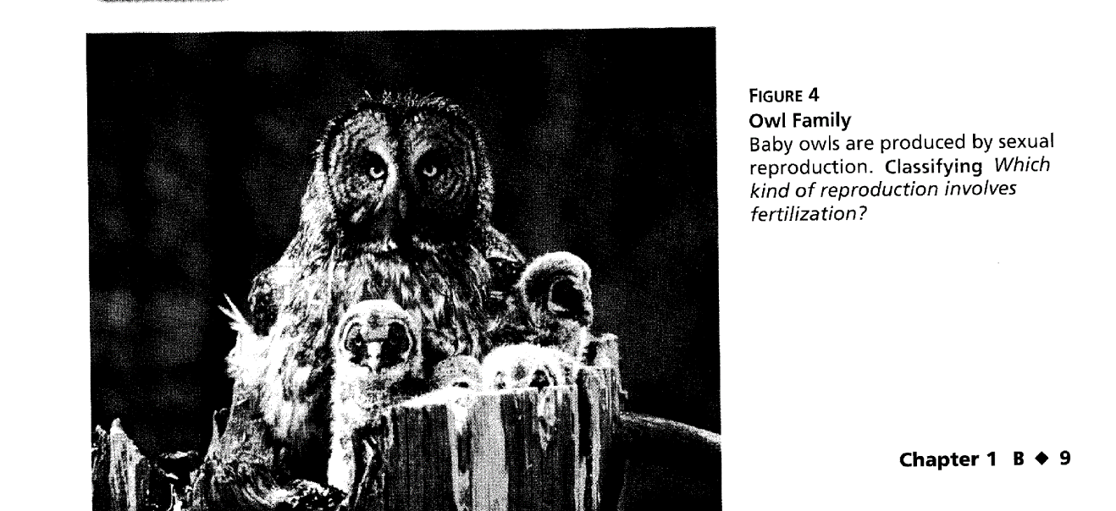

In this case the image has a caption so the description will be:

[Caption: FIGURE 4 Owl Family Baby owls are produced by sexual reproduction. Classifying Which kind of reproduction involves fertilization?]

IMAGES WITHOUT CAPTIONS

IMAGE:
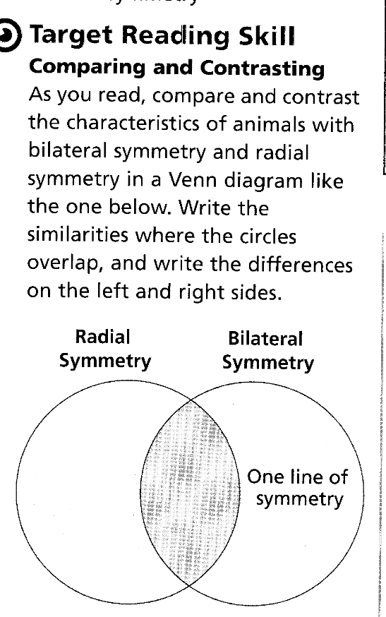

In this case the image has no title or caption so you have to get the description by reading the text. Here the image is described as a Venn diagram in the text so the description will be:

[Diagram Removed]

STORIES

When it comes to story book you have to read the story to find out who is in the image.

IMAGE:
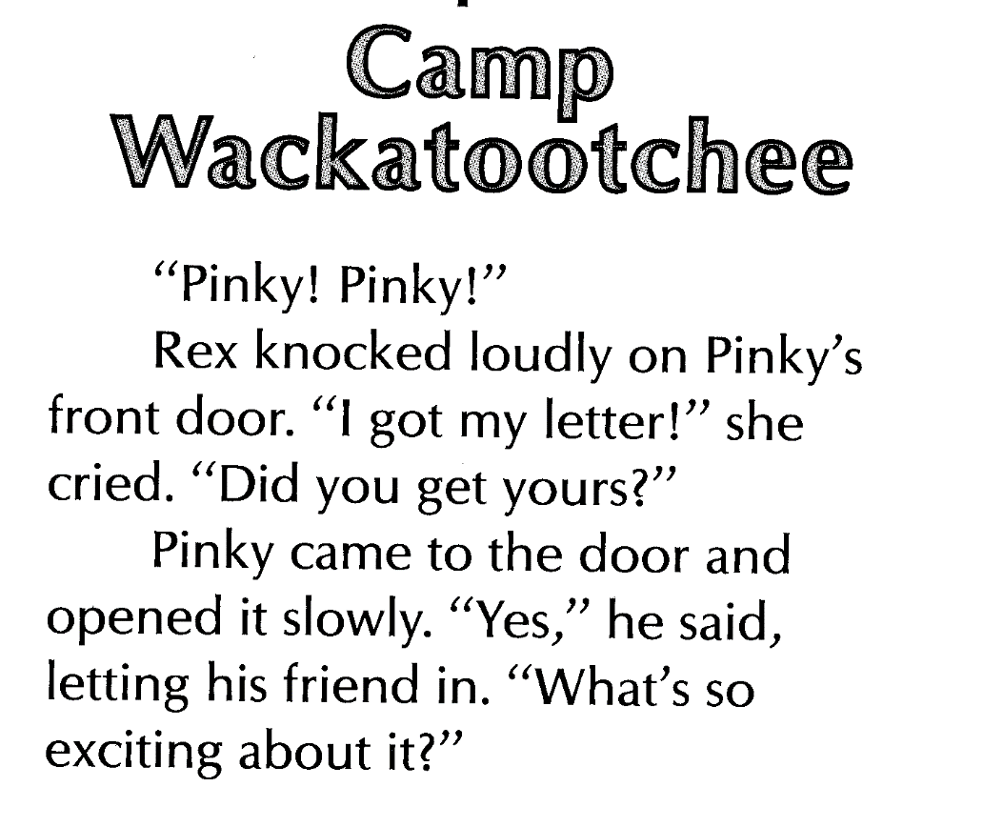

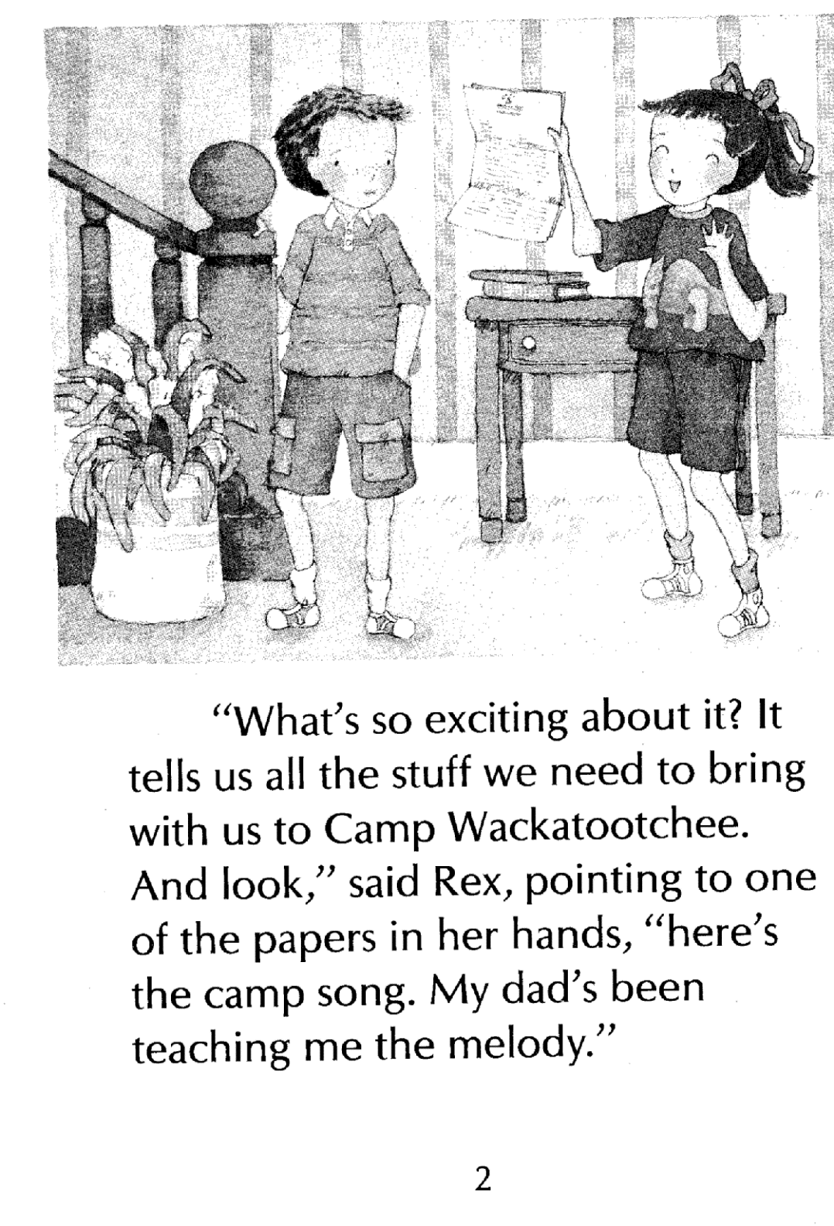

The kids in the picture are referred to as Pinky and Rex in the story so the description will be:

[Image: Pinky and Rex.]

CARTOONS

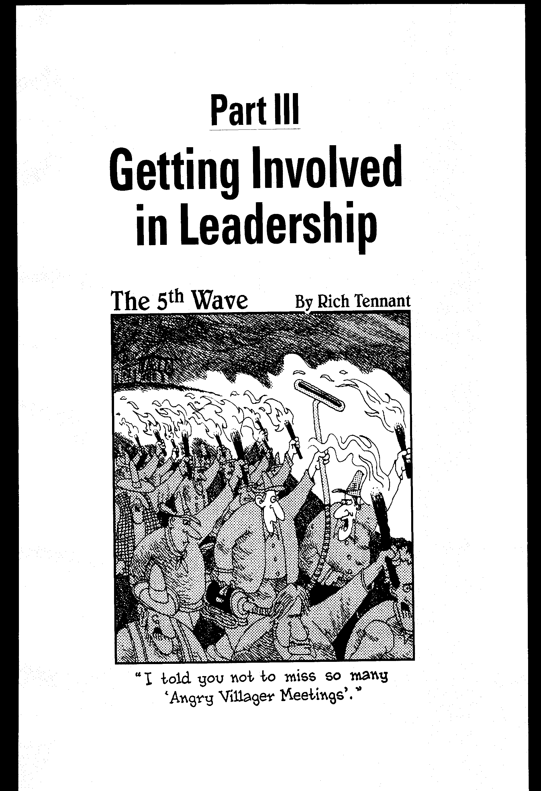

In this case the image has a caption so the description will be:

[Caption: The 5th Wave by Rich Tennant.]

"I told you not to miss so many 'Angry Villager Meetings'."

IMAGE:
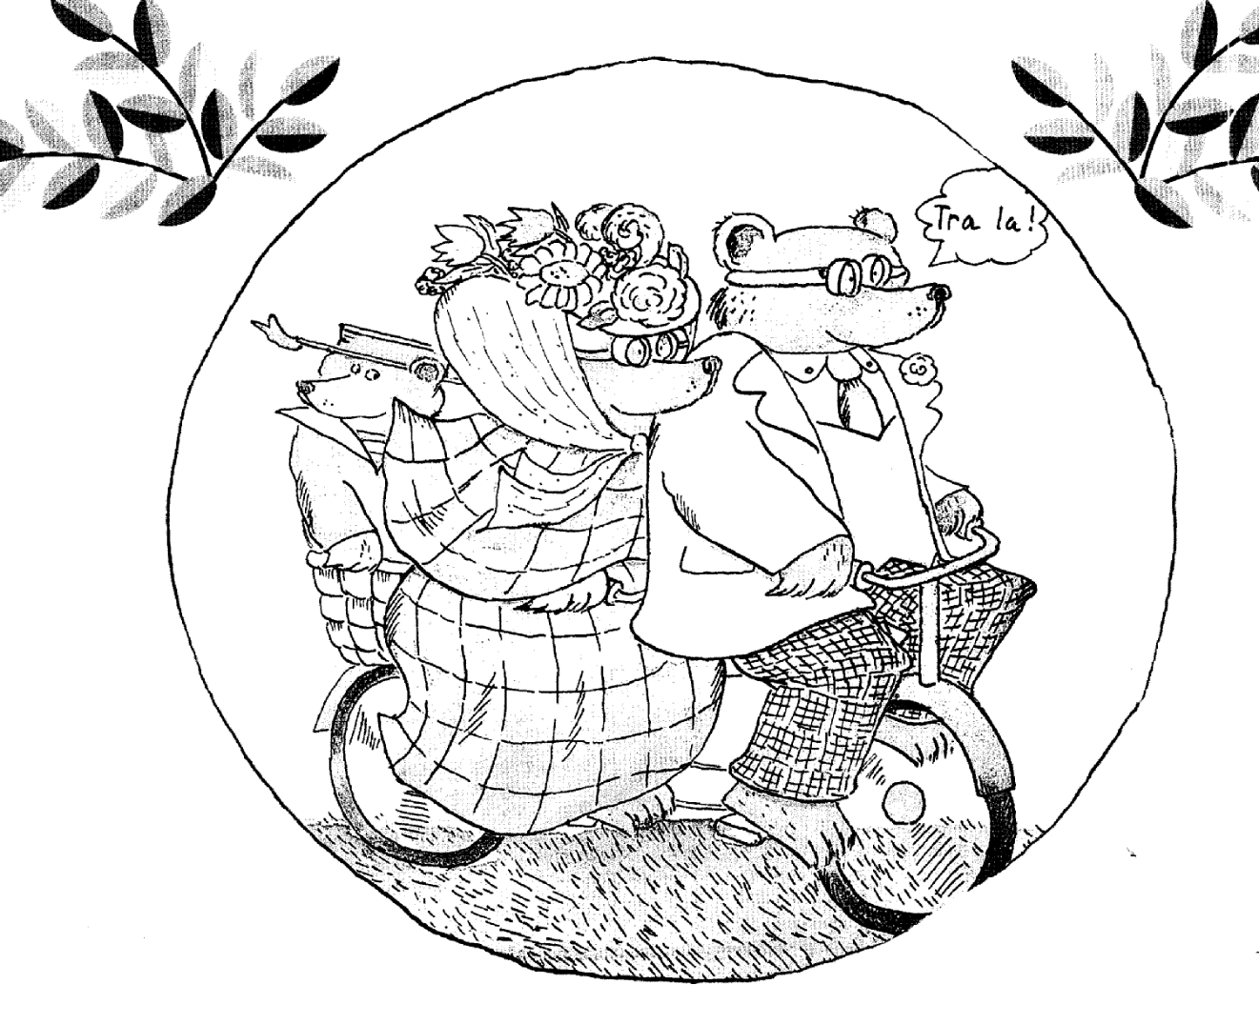

In this case the image has not title or caption. So the description will be:

[Image: Cartoon.]

IMAGES WITH NO CAPTIONS HEADINGS OR DESCRIPTIONS

In a case where there is no caption or heading and you can't tell what kind of image it is you put the description as 'Diagram'. This mostly occurs in Math, Physics or Chemistry books.

IMAGE:

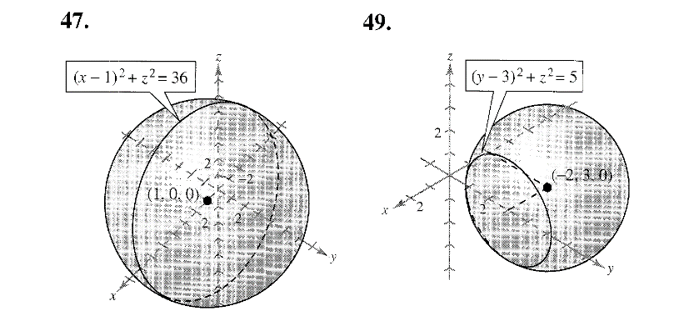

47. [Figure Removed]

49. [Figure Removed]

IMAGE:

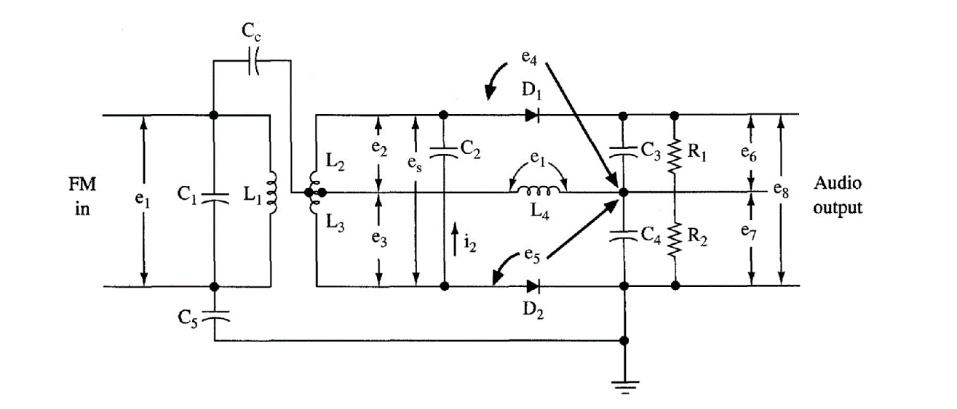

[Figure Removed]

MORE ILLUSTRATIONS

IMAGE:
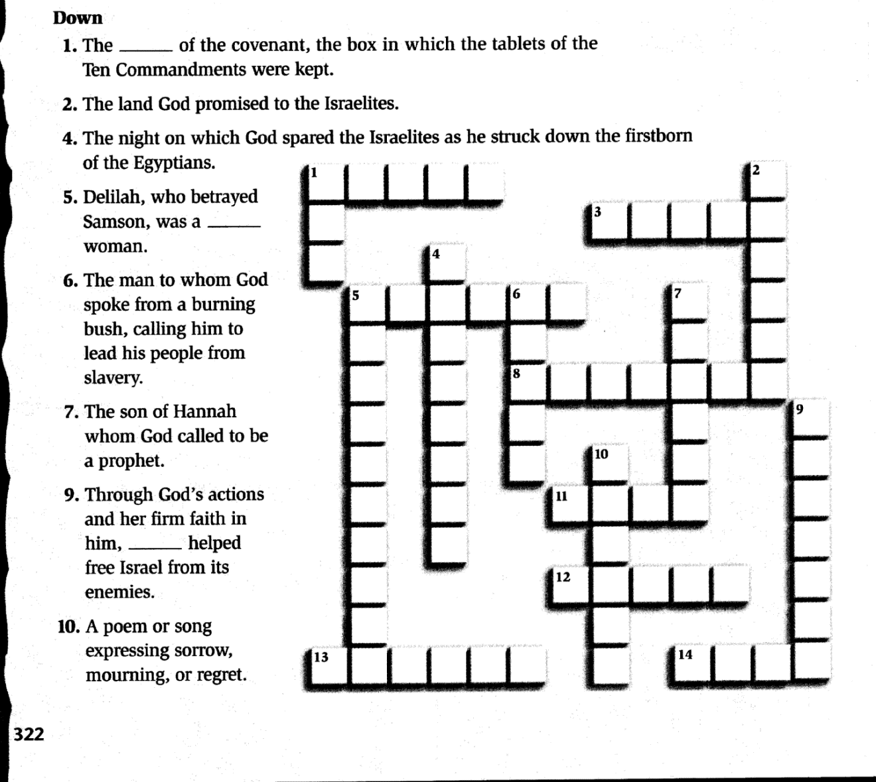

[Image: A puzzle.]

IMAGE:
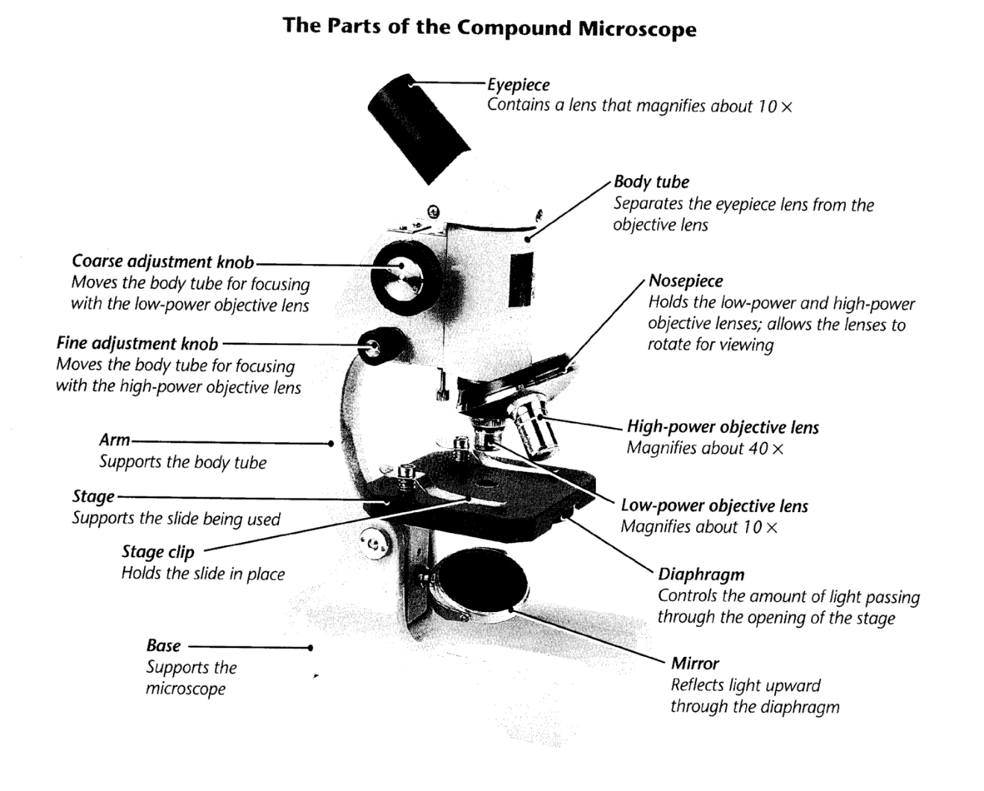

[Caption: The Parts of the Compound Microscope.]

Stage Supports the Coarse adjustment knob Moves the body tube for focusing with the low-power objective lens
Fine adjustment knob Moves the body tube for focusing with the high-power objective lens
Arm Supports the body tube
Stage clip Holds the slide in place
Base Supports the microscope
Eyepiece Contains a lens that magnifies about 10 x
Body tube Separates the eyepiece lens from the objective lens
Nosepiece Holds the low-power and high-power objective lenses; allows the lenses to rotate for viewing
High-power objective lens Magnifies about 40 x
Low-power objective lens Magnifies about 10 x
Diaphragm Controls the amount of light passing through the opening of the stage
Mirror Reflects light upward through the diaphragm

IMAGE:
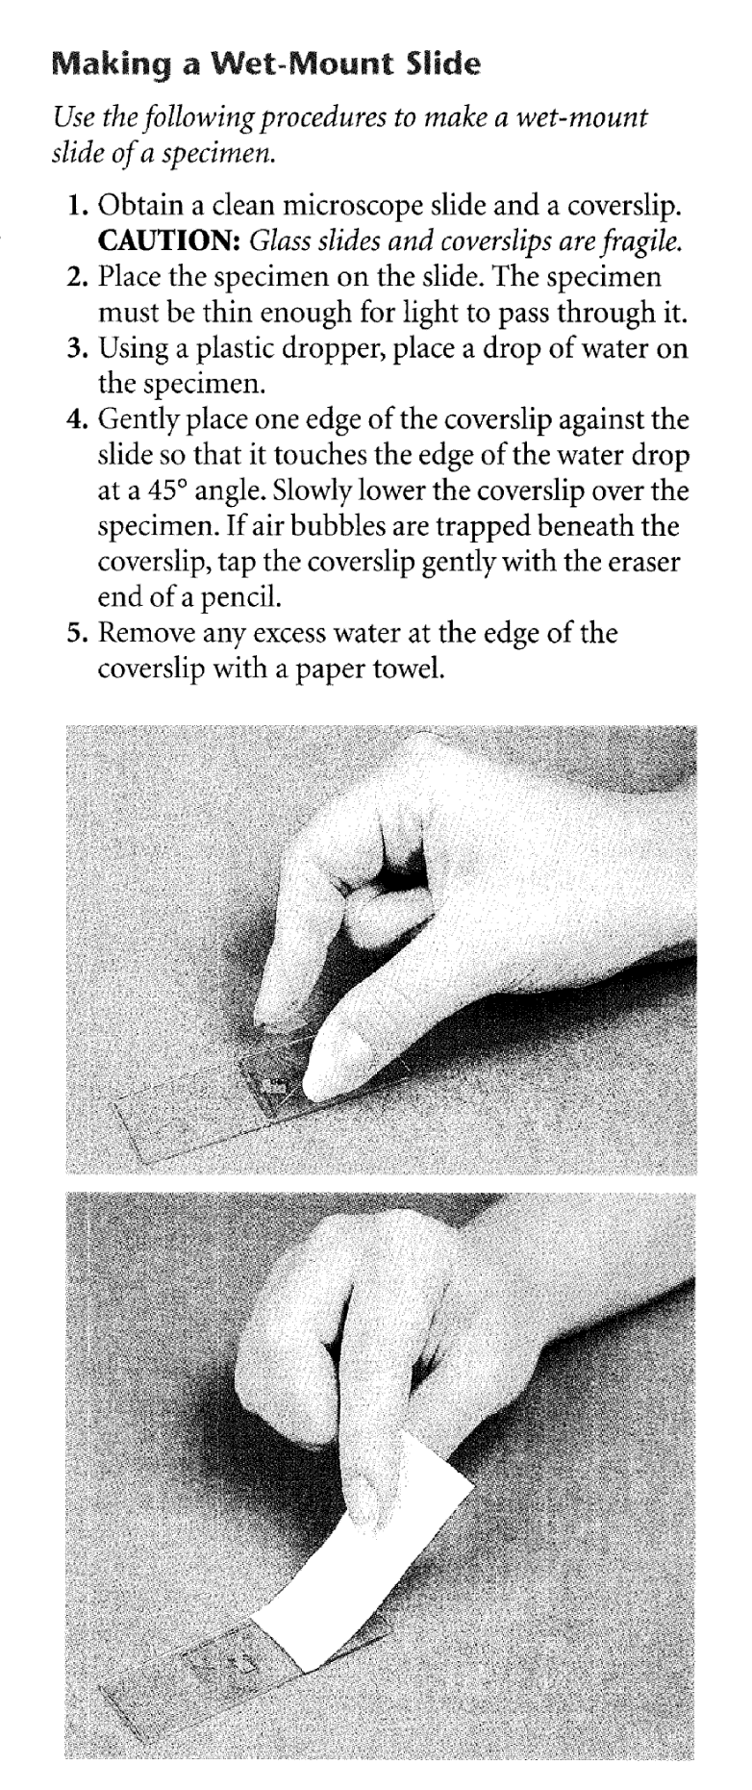

[Image Removed]

IMAGE:
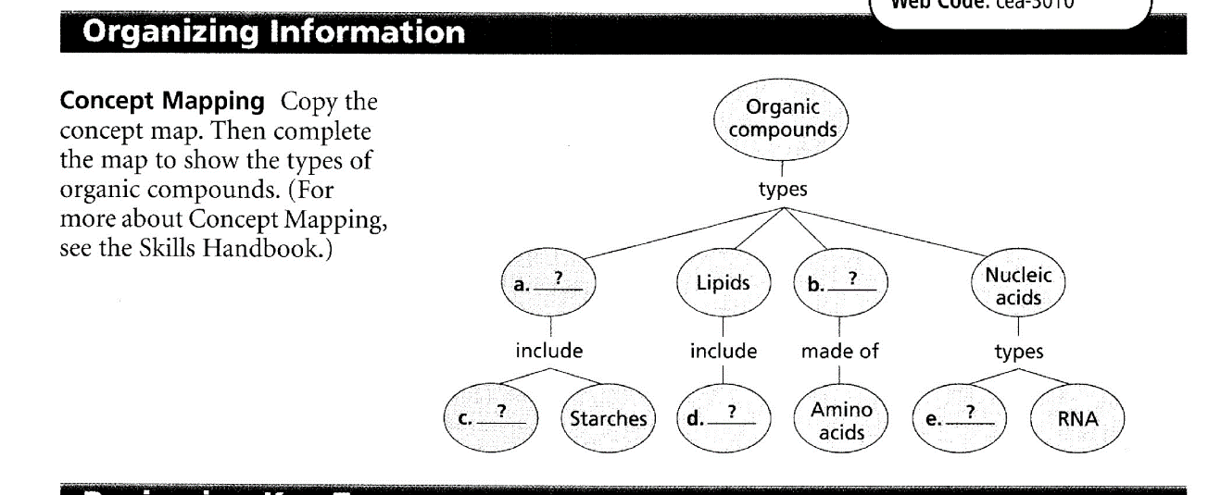

[Illustration Removed] or [Diagram Removed]

INTERRUPTION OF SENTENCE FLOW

Join sentences which are interrupted by either paragraphs, footnotes, tables or other sentences.

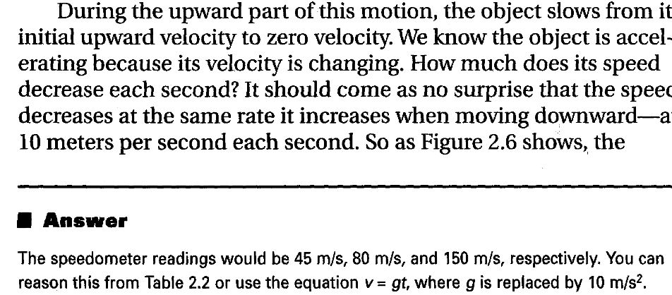

Note the difference after validation

During the upward part of this motion, the object slows from its initial upward velocity to zero velocity. We know the object is accelerating because its velocity is changing. How much does its speed decrease each second? It should come as no surprise that the speed decreases at the same rate it increases when moving downward—at 10 meters per second each second.

* Answer
The speedometer readings would be 45 m/s, 80 m/s. and 150 m/s, respectively. You can reason this from Table 2.2 or use the equation v = gt, where g is replaced by 10 m/s².

TABLES

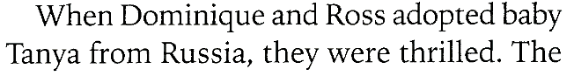
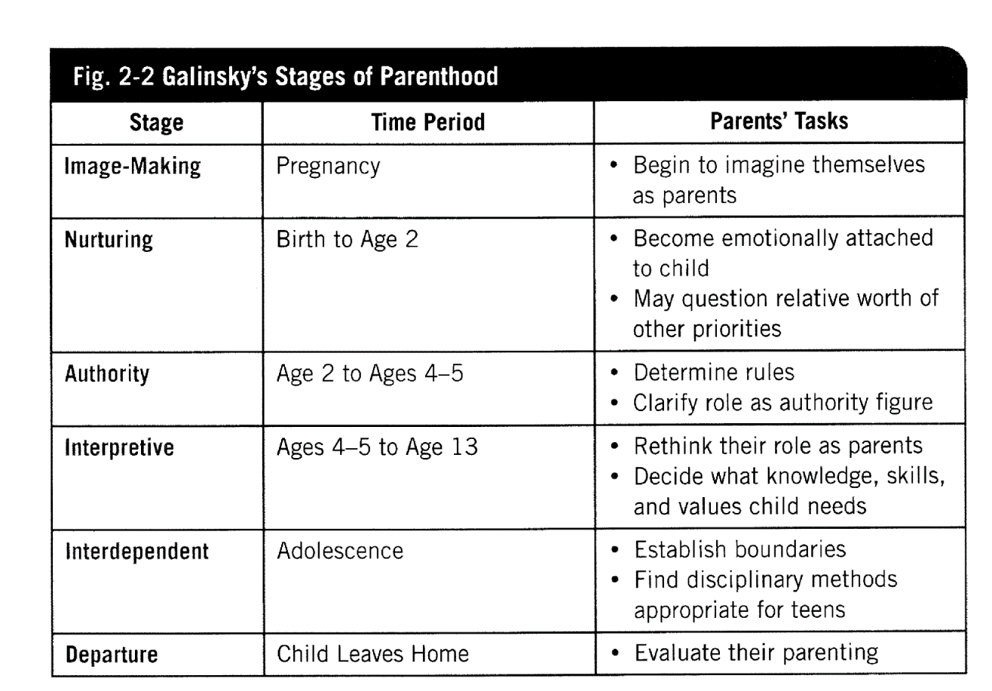

N/B: The Word "The" has being interrupted by the table.

After Validation:
When Dominique and Ross adopted baby Tanya from Russia, they were thrilled.

Fig. 2-2 Galinsky's Stages of Parenthood
Stage | Time Period | Parents' Tasks
Image-Making | Pregnancy | * Begin to imagine themselves as parents
Nurturing | Birth to Age 2 | * Become emotionally attached to child  * May question relative worth of other priorities
Authority | Age 2 to Ages 4-5 | * Determine rules  * Clarify role as authority figure
Interpretive | Ages 4-5 to Age 13 | * Rethink their role as parents  * Decide what knowledge, skills, and values child needs
Interdependent | Adolescence | * Establish boundaries  * Find disciplinary methods appropriate for teens
Departure | Child Leaves Home | * Evaluate their parenting

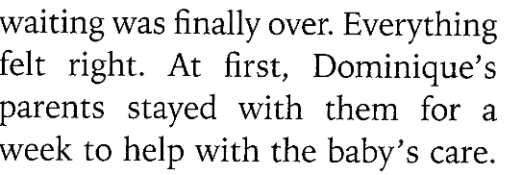

The waiting was finally over. Everything felt right. At first, Dominique's parents stayed with them for a week to help with the baby's care.

* Make sure to auto fit and change the properties of a row to be 0.1

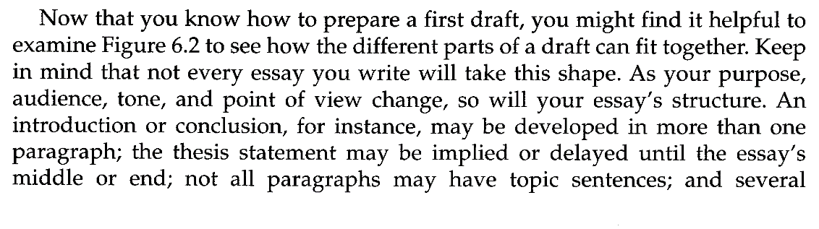
After Validation:
Now that you know how to prepare a first draft, you might find it helpful to examine Figure 6.2 to see how the different parts of a draft can fit together. Keep in mind that not every essay you write will take this shape. As your purpose, audience, tone, and point of view change, so will your essay's structure. An introduction or conclusion, for instance, may be developed in more than one paragraph; the thesis statement may be implied or delayed until the essay's middle or end; not all paragraphs may have topic sentences; and several supporting paragraphs may be needed to develop a single topic sentence.

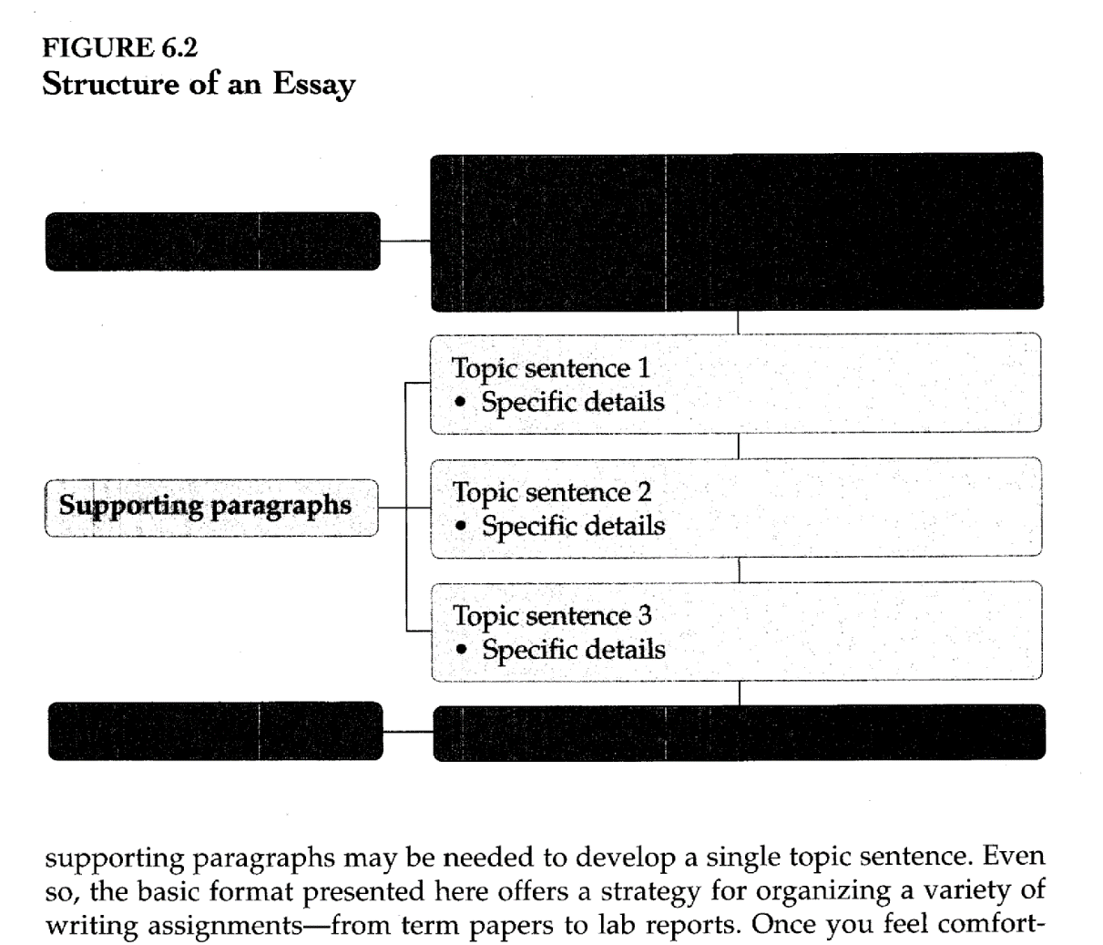

FIGURE 6.2 Structure of an Essay
Introductory paragraphs | Opening comments  Thesis statement  Plan of development (optional)
Supporting paragraphs | Topic sentence 1  * Specific details  Topic sentence 2  * Specific details  Topic sentence 3  * Specific details
Concluding paragraphs | Closing comments

Even so, the basic format presented here offers a strategy for organizing a variety of writing assignments--from term papers to lab reports. Once you feel comfortable with the structure, you have a foundation on which to base your variations.

FOOTNOTES

Each footnote should be positioned at the end of the paragraph where the superscripted number/letter is.

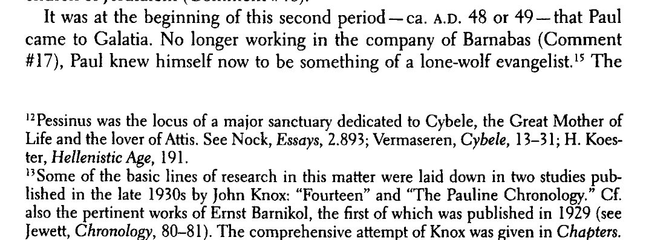

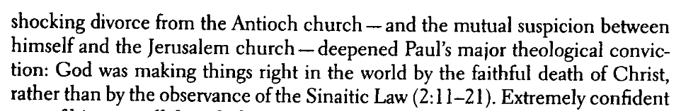

After Validation:
It was at the beginning of this second period --ca. A.D. 48 or 49 --that Paul came to Galatia. No longer working in the company of Barnabas (Comment #17), Paul knew himself now to be something of a lone-wolf evangelist.15

* * *

¹² Pessinus was the locus of a major sanctuary dedicated to Cybele, the Great Mother of Life and the lover of Attis. See Nock, Essays, 2.893; Vermaseren, Cybele, 13-31; H. Koester, Hellenistic Age, 191.
¹³ Some of the basic lines of research in this matter were laid down in two studies published in the late 1930s by John Knox: "Fourteen" and "The Pauline Chronology." Cf. also the pertinent works of Ernst Barnikol, the first of which was published in 1929 (see Jewett, Chronology, 80-81). The comprehensive attempt of Knox was given in Chapters.]

The shocking divorce from the Antioch church -- and the mutual suspicion between himself and the Jerusalem church -- deepened Paul's major theological conviction: God was making things right in the world by the faithful death of Christ, rather than by the observance of the Sinaitic Law (2:11-21). Extremely confident

HYPHENATED WORDS

A hyphenated word appears when a word at the end of a line is separated using a hyphen (-).
In such cases the hyphen should be removed to make a complete word.

The scanner settings should automatically join hyphenated words. If not, join them manually. Consult the .tif file [Image] or physical text as needed.

Join hyphenated words that span two pages. Use a Find to locate hyphens at the end of a page:

Image:

Before Validation:
In 1674, the pioneer Dutch microscopist Antonie van Leeu-wenhoek observed Giardia in his own feces without knowing it:

After Validation:
In 1674, the pioneer Dutch microscopist Antonie van Leeuwenhoek observed Giardia in his own feces without knowing it:

HYPHENATED WORD APPEARING IN BETWEEN TWO PAGES

In such cases one should drag one half of the word and attach it to the other to make a complete word.

Image:

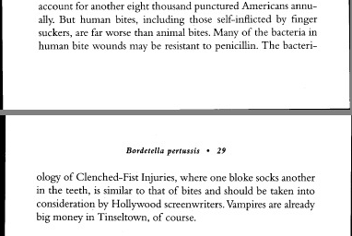

Before Validation:
account for another eight thousand punctured Americans annually. But human bites, including those self-inflicted by finger suckers, are far worse than animal bites. Many of the bacteria in human bite wounds may be resistant to penicillin. The bacteri¬

………………………………………….Page Break……………………………………..

Bordetella pertussis • 29
ology of Clenched-Fist Injuries, where one bloke socks another in the teeth, is similar to that of bites and should be taken into consideration by Hollywood screenwriters. Vampires are already big money in Tinseltown, of course.

After Validation:
account for another eight thousand punctured Americans annually. But human bites, including those self-inflicted by finger suckers, are far worse than animal bites. Many of the bacteria in human bite wounds may be resistant to penicillin. The bacteriology

………………………………………….Page Break……………………………………..

29

of Clenched-Fist Injuries, where one bloke socks another in the teeth, is similar to that of bites and should be taken into consideration by Hollywood screenwriters. Vampires are already big money in Tinseltown, of course.

TABLES

Make sure that tables read across correctly
a. Insert borders and set row to be 0.1 in all tables
b. If a table lacks a heading, protect it with this code: [table]

Example 1
May | June | July | August | September
20 | 60 | 125 | 500 | 40
3 | -2 | 7 | 115 | 900

How to insert borders:

Select the whole table, right click on the table, click on the table properties then select the tables bar, click on the borders and shading then borders select all then ok.

On the same table properties bar, click on the row bar check on the specify height type 0.1 then click ok.

[table]
May | June | July | August | September
20 | 60 | 125 | 500 | 40
3 | -2 | 7 | 115 | 900

b. Align tables with the text

All tables should be aligned with the text.

Max | Ben | Ann
1,200 | 500 | 1,500
5,000 | 850 | 9,000

Correct

[table]
Max | Ben | Ann
1,200 | 500 | 1,500
5,000 | 850 | 9,000

31. LISTS

Lists should be arranged vertically

Example 1
Image:
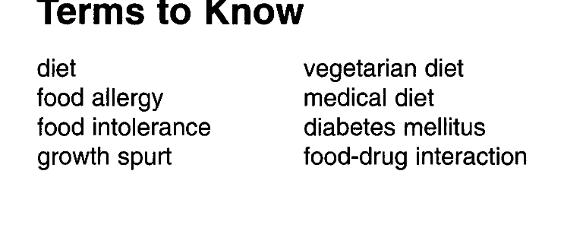

After Validation:

Terms to Know

diet
food allergy
food intolerance
growth spurt
vegetarian diet
medical diet
diabetes mellitus
food-drug interaction

Example 2

Image:

After Validation:
79. (a) [7, -1]
(b) [5, -2]
© [-11, 5]

ONE WORD SENTENCE:

WRONG FORMAT
(One word having a special hyphen followed by a space)
hydrau¬ lic
immis¬ cible
pres¬ sure

CORRECT FORMAT
(remove both the hyphen and the space.)
hydraulic
immiscible
pressure

TWO WORDS SENTENCES

Wrong format (examples)
coal¬burning
turbine¬generator
phase¬change
single¬phase
triple¬point

Correct format (examples)
(Replace magic hyphen with a straight (-) hyphen)
coal-burning
turbine-generator
phase-change
single-phase

NB: Special hyphen looks like this: ¬
A normal hyphen looks like this: -

TO REPLACE CURVED QUOTES

Search:
Opening quotation marks -Alt+0147 → “
Replace with straight quotes on your keyboard → "
Closing quotation marks-Alt +0148 → ”
Single opening quotation marks Alt+0145 → ‘
Replace with straight quotes → '
Closing Alt+0146 → ’

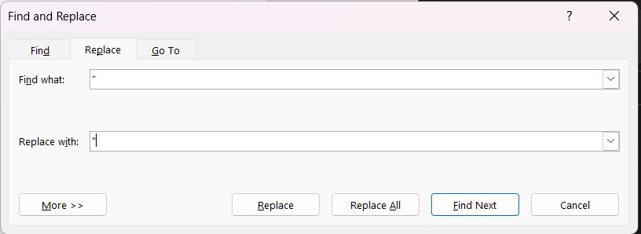

POEMS

Arrange the stanzas of the poem as they appear on the image document.

Illustration

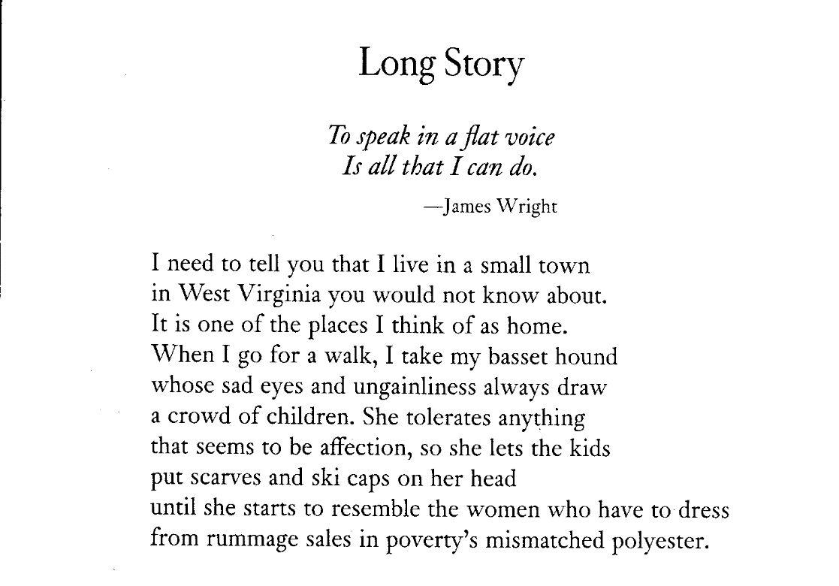

Before Validation:

Long Story
To speak in a flat voice Is all that I can do.
—James Wright
I need to tell you that I live in a small town in West Virginia you would not know about.
It is one of the places I think of as home. When I go for a walk, I take my basset hound
whose sad eyes and ungainliness always draw a crowd of children. She tolerates anything
that seems to be affection, so she lets the kids put scarves and ski caps on her head
until she starts to resemble the women who have to dress
from rummage sales in poverty's mismatched polyester.

After Validation:

Long Story

To speak in a flat voice Is all that I can do.
--James Wright

I need to tell you that I live in a small town
in West Virginia you would not know about.
It is one of the places I think of as home.
When I go for a walk, I take my basset hound
whose sad eyes and ungainliness always draw
a crowd of children. She tolerates anything
that seems to be affection, so she lets the kids
put scarves and ski caps on her head
until she starts to resemble the women who have to dress
from rummage sales in poverty's mismatched polyester.

SUPERSCRIPTS AND SUBSCRIPTS

Search for superscripts and subscripts and confirm whether they are in the right order.
To search for superscripts Ctrl + shift key + =
To search for subscript hold down shift key then + [plus]
Then click Find Next tab

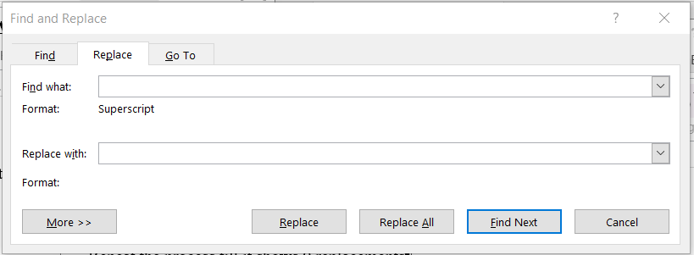

European American history and a large majority committed to the general social scientific goals of anthropology.¹⁵ Although Charles Fairbanks and Robert Ascher had demonstrated that plantation archaeology could allow us to look at the lifeways of slaves, and thus to view the American past in a fundamentally different and more humanistic way¹⁶ most archaeologists working on African American sites took a different path. Following the social scientific majority, archaeologists working on African American sites typically applied the methods then in vogue: they constructed tabular lists of artifact frequencies to define slave or plantation "patterns," they measured the rate at which slaves picked up European traits, and they used artifacts to demonstrate the obvious difference in the economic status of slaves and their owners. Written primarily to fulfill contractual agreements for federally mandated archaeology, these treatments represented expedient applications of methods to newly recovered data without an orientation toward answering significant questions.¹⁷ And, while these reports contain recovered data and interpretations of activities that are extremely valuable, the more general conclusions, with a few exceptions, are of little anthropological or historical interest.¹⁸
Bluntly, most archaeologists working with African American sites, even those working today, have had little academic background in African American history or the contemporary issues of social politics; we come from a different scholarly tradition. While historians like W.E.B. Dubois, cultural anthropologists like Melville Herskovits, and folklorists like the Works Projects Administration writers of the 1930s were busy piecing together black American history, our archaeological fathers, and a few mothers, were focusing on prehistoric Indians and wealthy or famous white people.¹⁹

TIMELINES

All timelines should be arranged according to the year and events as they appear on the image document.

Example 1

Illustration

Image:
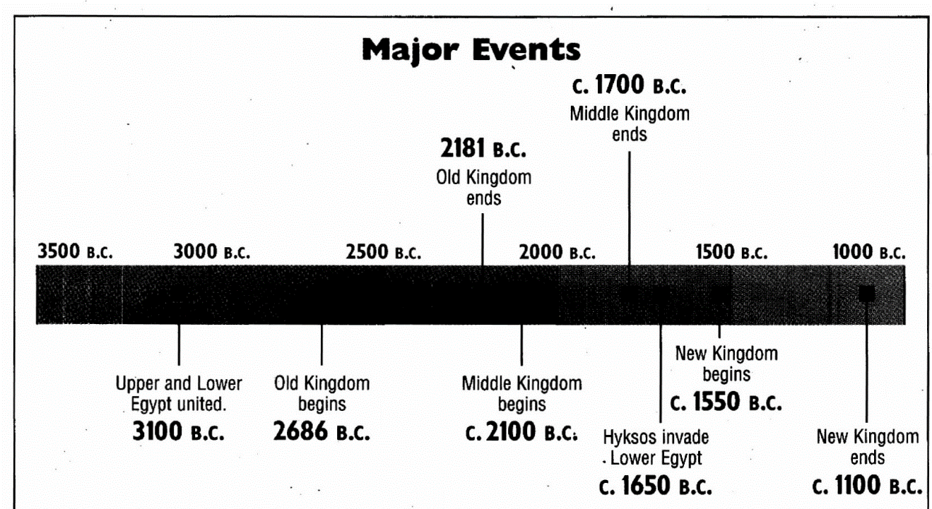

Before validation:

Major Events

c.1700 B.C.
2181 B.C.
Middle Kingdom ends
Old Kingdom ends
Hyksos invade Lower Egypt
C. 1650 B.C.
I New Kingdom I
Upper and Lower Old Kingdom Middle Kingdom J begins I
Egypt united, begins begins C. 1550 B.C.
3100 B.C. 2686 B.C. C. 2100 B.C New Kingdom
ends
C. 1100 B.C.

After Validation:

Major Events

3100 B.C. Upper and Lower Egypt united.
2686 B.C. Old Kingdom begins
C. 2100 B.C. Middle Kingdom begins
2181 B.C. Old Kingdom ends
c.1700 B.C. Middle Kingdom ends
C. 1650 B.C. Hyksos invade Lower Egypt
C. 1550 B.C. New Kingdom begins
C. 1100 B.C. New Kingdom ends

Example 2
Image:

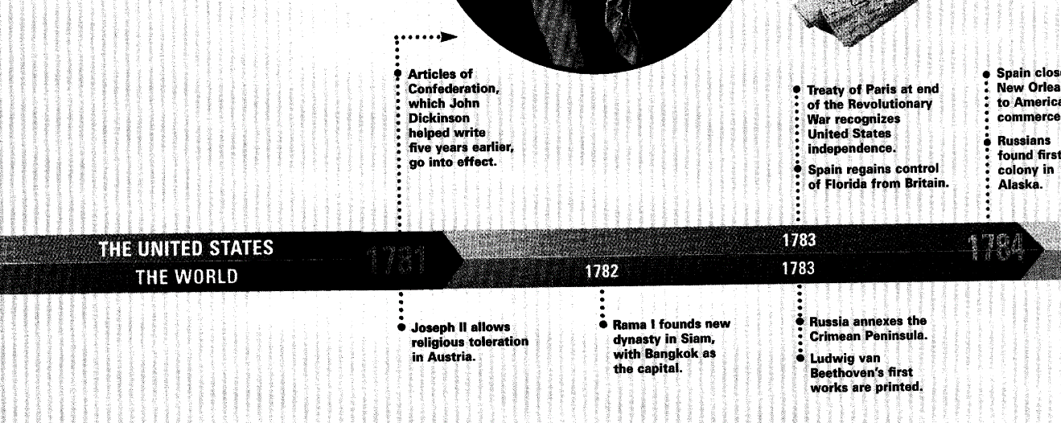
Before Validation:
•ffreaty of Paris at end of the Revolutionary War recognizes United States
independenco
Spain regains control of Florida from Britain.
4 Articles of Confederation,
which John Dickinson helped write five years earliei go into effect.
• Spain cbs
: Now Orlea
: to Amaric commerce
I Russians found firs colony in Alaska.
Joseph II allows religious toleration in Austria.
Rama I founds new dynasty in Siam, with Bangkok as the capital.

f Russia annexes the : Crimean Peninsula.
Ludwig van Beethoven’s first works are rintout

After Validation:

THE UNITED STATES

1781 Articles of Confederation, which John Dickinson helped write five years earlier, go into effect.
1783 Treaty of Paris at end of the Revolutionary War recognizes United States independence.
1783 Spain regains control of Florida from Britain.

THE WORLD

1782 Rama I founds new dynasty in Siam, with Bangkok as the capital.
1783 Russia annexes the Crimean Peninsula.
1783 Ludwig van Beethoven's first works are printed.
1784 Spain closed New Orleans to America commerce
1784 Russians found first colony in Alaska.
1784 Joseph II allows religious toleration in Austria.

MATH BOOKS

1. All equations and formulas should be exactly as they are in the image.
2. A space has to be put before and after a symbol/sign
e.g.
1+2 [INCORRECT] [Note: There is no space in between the symbols and numbers]
$1 + 2$ [CORRECT] [Note: There is a space in between the symbols and numbers]

4. NEVER insert symbols from the formatting toolbar. Instead use the ones that have been provided in the manual.

ILLUSTRATIONS:

IMAGE
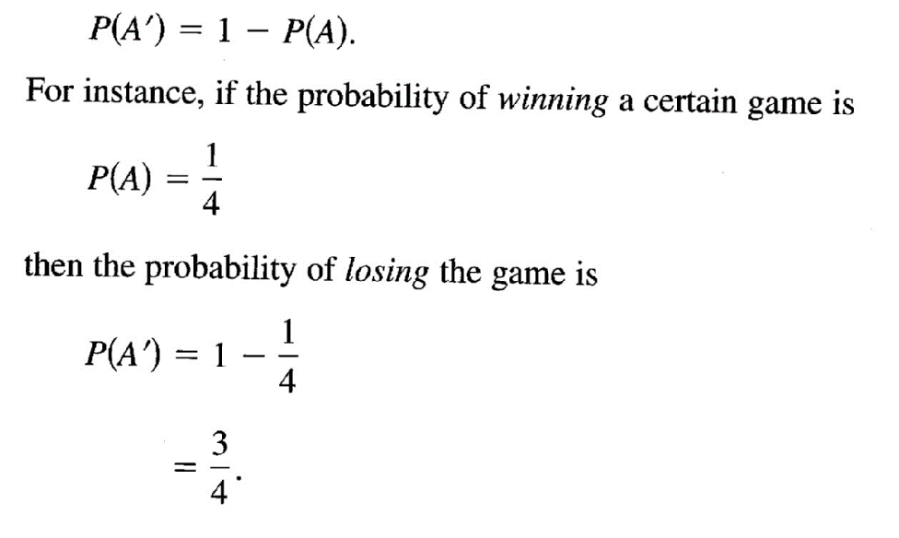

Should be arranged as follows:
$P(A') = 1 - P(A)$.

For instance, if the probability of winning a certain game is
$P(A) = 1/4$

then the probability of losing the game is
$P(A') = 1 - 1/4$
= 3/4.

IMAGE
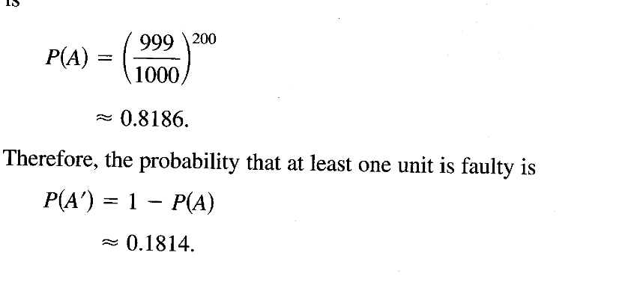

Should be arranged as follows:

$P(A) = (999/1000)200$
≈ 0.8186

Therefore, the probability that at least one unit is faulty is
$P(A') = 1 - P(A)$
≈ 0.1814.

IMAGE
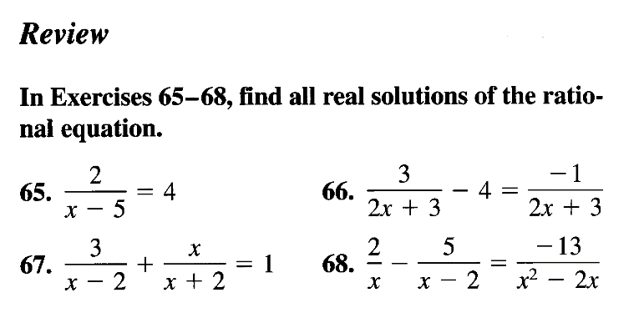

After Validation:

Review

In Exercises 65-68, find all real solutions of the rational equation.
65. $2/x - 5 = 4$
66. $3/2x + 3 - 4 = -1/2x + 3$
67. $3/x-2 + x/x + 2 = 1$
68. $2/x - 5/x - 2 = -13/x2 - 2x$

Should be arranged as follows:
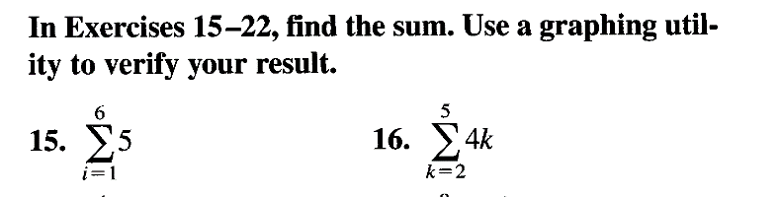

In Exercises 15-22, find the sum. Use a graphing utility to verify your result.
15. $\sum_{i=1}^{6}{5}$
16. $\sum_{k=2}^{5}{4k}$

BIBLIOGRAPHY, NOTES AND REFERENCES

All Bibliography, Notes and References should be arranged exactly as per the image document.
* Ensure you check for broken paragraphs and reconnect them.

Illustration

IMAGE:
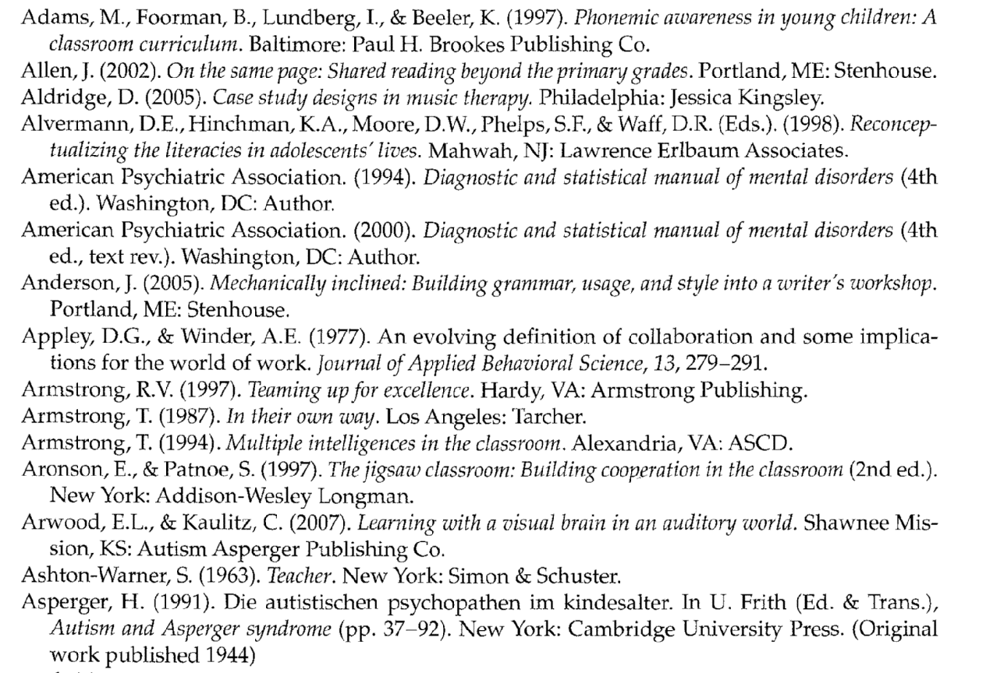

Before validation

Adams, M., Foorman, B., Lundberg, I., & Bee1ei K. (1997). Phonemic awareness in young children: A classroom curriculum. Baltimore: Paul H. Brookes Publishing Co.
Allen, J. (2002). On the same page: Shared reading beyond the primary grades. Portland, ME: Stenhouse. Aidridge, D. (2005). Case study designs in music therapy. Philadelphia: Jessica Kingsley. Alvermarm, D.E., Hinchman, K.A., Moore, D.W., Phelps, S.F., & Waff, D.R. (Eds.). (1998). Reconceptualizing the literacies in adolescents’ lives. Mahwah, NJ: Lawrence Eribaum Associates.
American Psychiatric Association. (1994). Diagnostic and statistical manual of mental disorders (4th ed.). Washington, DC: Author.
American Psychiatric Association. (2000). Diagnostic and statistical manual of mental disorders (4th ed., text rev.). Washington, DC: Author.
Anderson, 1. (2005). Mechanically inclined: Building grammar, usage, and style into a writer’s workshop. Portland, ME: Stenhouse.
Appley, D.G., & Winder, AlE. (1977). An evolving definition of collaboration and some implications for the world of work. Journal of Applied Behavioral Science, 13, 279—291.
Armstrong, R.V. (1997). Teaming up for excellence. Hardy, VA: Armstrong Publishing.
Armstrong, T. (1987). In their own way. Los Angeles: Tarcher.
Armstrong, T. (1994). Multiple intelligences in the classroom. Alexandria, VA: ASCD.
Aronson, F., & Patnoe, S. (1997). The jigsaw classroom: Building cooperation in the classroom (2nd ed.). New York: Addison-Wesley Longman.
Arwood, E.L., & Kaulitz, C. (2007). Learning with a visual brain in an auditory world. Shawnee Mission, KS: Autism Asperger Publishing Co.
Ashton-Warner, S. (1963). Teacher. New York: Simon & Schuster.
Asperger, H. (1991). Die autistischen psychopathen im kindesalter. In U. Frith (Ed. & Trans.), Autism and Asperger syndrome (pp. 37—92). New York: Cambridge University Press. (Original work published 1944)

After Validation:
Adams, M., Foorman, B., Lundberg, I., & Bee1ei K. (1997). Phonemic awareness in young children: A classroom curriculum. Baltimore: Paul H. Brookes Publishing Co.
Allen, J. (2002). On the same page: Shared reading beyond the primary grades. Portland, ME: Stenhouse.
Aidridge, D. (2005). Case study designs in music therapy. Philadelphia: Jessica Kingsley. Alvermarm, D.E., Hinchman, K.A., Moore, D.W., Phelps, S.F., & Waff, D.R. (Eds.). (1998). Reconceptualizing the literacies in adolescents’ lives. Mahwah, NJ: Lawrence Eribaum Associates.
American Psychiatric Association. (1994). Diagnostic and statistical manual of mental disorders (4th ed.). Washington, DC: Author.
American Psychiatric Association. (2000). Diagnostic and statistical manual of mental disorders (4th ed., text rev.). Washington, DC: Author.
Anderson, 1. (2005). Mechanically inclined: Building grammar, usage, and style into a writer’s workshop. Portland, ME: Stenhouse.
Appley, D.G., & Winder, AlE. (1977). An evolving definition of collaboration and some implications for the world of work. Journal of Applied Behavioral Science, 13, 279--291.
Armstrong, R.V. (1997). Teaming up for excellence. Hardy, VA: Armstrong Publishing.
Armstrong, T. (1987). In their own way. Los Angeles: Tarcher.
Armstrong, T. (1994). Multiple intelligences in the classroom. Alexandria, VA: ASCD.
Aronson, F., & Patnoe, S. (1997). The jigsaw classroom: Building cooperation in the classroom (2nd ed.). New York: Addison-Wesley Longman.
Arwood, E.L., & Kaulitz, C. (2007). Learning with a visual brain in an auditory world. Shawnee Mission, KS: Autism Asperger Publishing Co.
Ashton-Warner, S. (1963). Teacher. New York: Simon & Schuster.
Asperger, H. (1991). Die autistischen psychopathen im kindesalter. In U. Frith (Ed. & Trans.), Autism and Asperger syndrome (pp. 37—92). New York: Cambridge University Press. (Original work published 1944)

BOOKSHARE RULES

When the glossary/index/dictionary/poem is in a foreign language e.g., Spanish, Mexican, Chinese, Japanese etc insert the following caption at the beginning of the affected text.

[Bookshare proofer's note: The following index/glossary/dictionary/poem has not been proofread or formatted.]

[NB: Make sure to mention what exactly is not been formatted e.g., if it’s a glossary delete index/dictionary/poem and leave the word dictionary only]

IMAGE:



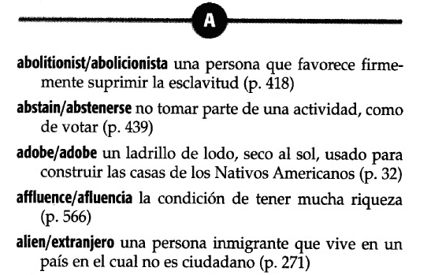

After Validation:
[Bookshare proofer's note: The following Spanish glossary has not been proofread or formatted.]

Spanish Glossary
abolitionist/abolicionista-caravel/carabela

A
abolitionist/abolicionista una persona que favorece firme-mente suprimir la esclavitud (p. 418)
abstain/abstenerse no tomar parte de una actividad, como de votar (p. 439)
adobe/adobe un ladrillo de lodo, seco al sol, usado para construir las casas de los Nativos Americanos (p. 32)
affluence/afluencia la condition de tener mucha riqueza (p. 566)
alien/extranjero una persona inmigrante que vive en un pais en el cual no es ciudadano (p. 271)

ENGLISH AND SPANISH TEXT

In cases where the English and Spanish dictionary/glossary/index etc are on the same page put [Bookshare proofer's note: The following Spanish glossary has not been proofread or formatted.] at the beginning of the affected text then format and spell-check the English parts properly but leave the Spanish parts as they are.

IMAGE:



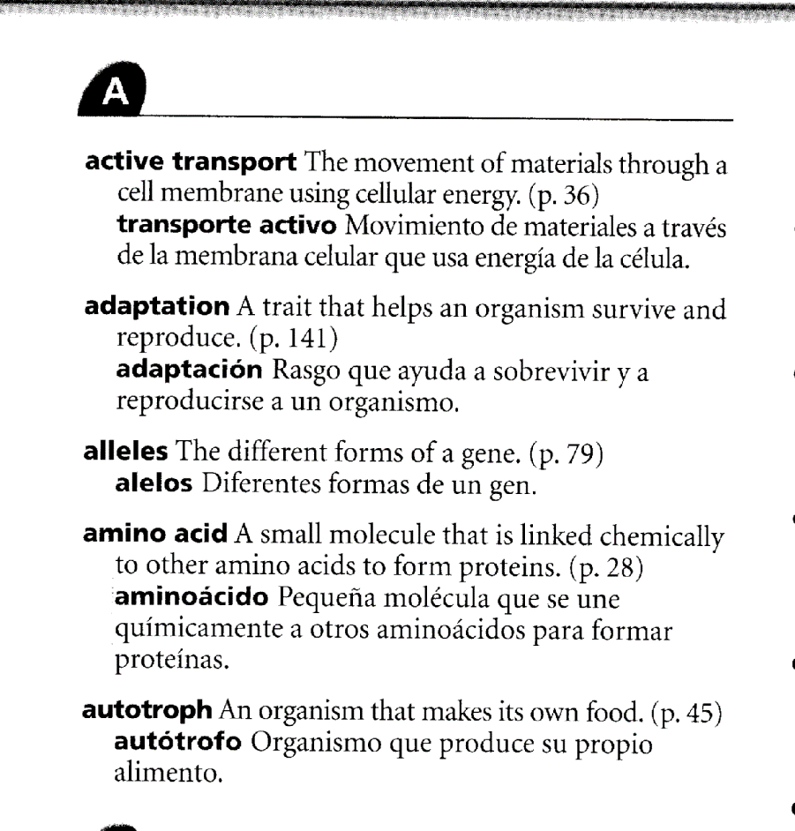

After Validation:

[Bookshare proofer's note: The following Spanish glossary has not been proofread or formatted.]

English and Spanish Glossary

A
***
active transport The movement of materials through a cell membrane using cellular energy, (p. 36)
transporte activo Movimiento de materiales a traves de la membrana celular que usa energia de la celula.
adaptation A trait that helps an organism survive and reproduce, (p. 141)
adaptacion Rasgo que ayuda a sobrevivir y a reproducirse a un organismo.
alleles The different forms of a gene. (p. 79)
alelos Diferentes formas de un gen.
amino acid A small molecule that is linked chemically to other amino acids to form proteins, (p. 28)
aminoacido Pequena molecula que se une quimicamente a otros aminoacidos para formar proteinas.
autotroph An organism that makes its own food. (p. 45)
autotrof o Organismo que produce su propio alimento.

38. PRONUNCIATION GUIDES

When the pronunciation guides have too many accented words delete the pronunciation guides and insert the following caption at the beginning of EVERY affected page.

[Bookshare proofer's note: pronunciation guides have been removed]

IMAGE:
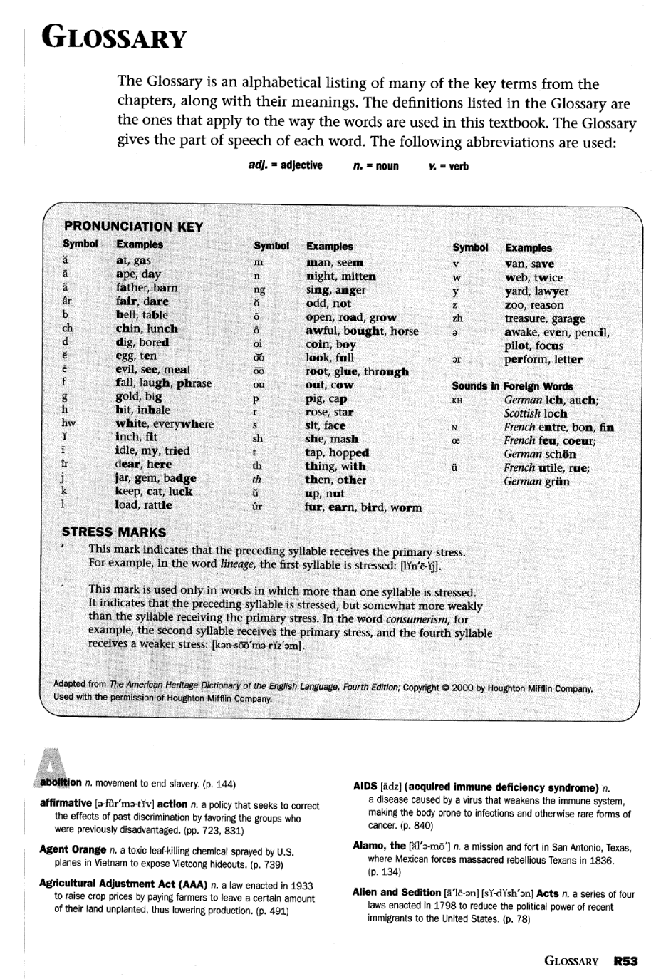

After Validation:
[Bookshare proofer's note: pronunciation guides have been removed]

GLOSSARY

The Glossary is an alphabetical listing of many of the key terms from the chapters, along with their meanings. The definitions listed in the Glossary are the ones that apply to the way the words are used in this textbook. The Glossary gives the part of speech of each word. The following abbreviations are used:
adj. = adjective
n. = noun
v. = verb

***

[Image: PRONUNCIATION KEY.]

STRESS MARKS
' This mark indicates that the preceding syllable receives the primary stress. For example, in the word lineage, the first syllable is stressed: ***
' This mark is used only in words in which more than one syllable is stressed. It indicates that the preceding syllable is stressed, but somewhat more weakly than the syllable receiving the primary stress. In the word consumerism, for example, the second syllable receives the primary stress, and the fourth syllable receives a weaker stress: ***

Adapted from The American Heritage Dictionary of the English Language, Fourth Edition; Copyright © 2000 by Houghton Mifflin Company. Used with the permission of Houghton Mifflin Company.
***
A
abolition n. movement to end slavery, (p. 144)
affirmative action n. a policy that seeks to correct the effects of past discrimination by favoring the groups who were previously disadvantaged, (pp. 723, 831)
Agent Orange n. a toxic leaf-killing chemical sprayed by U.S. planes in Vietnam to expose Vietcong hideouts, (p. 739)
Agricultural Adjustment Act (AAA) n. a law enacted in 1933 to raise crop prices by paying farmers to leave a certain amount of their land unplanted, thus lowering production, (p. 491)

39. INDEX

-It might be quite tedious and time-consuming to arrange the indexes as they appear on the image document. So when formatting this part, separate the alphabets by use of line breaks as they are on the image document.

See the example below

IMAGE
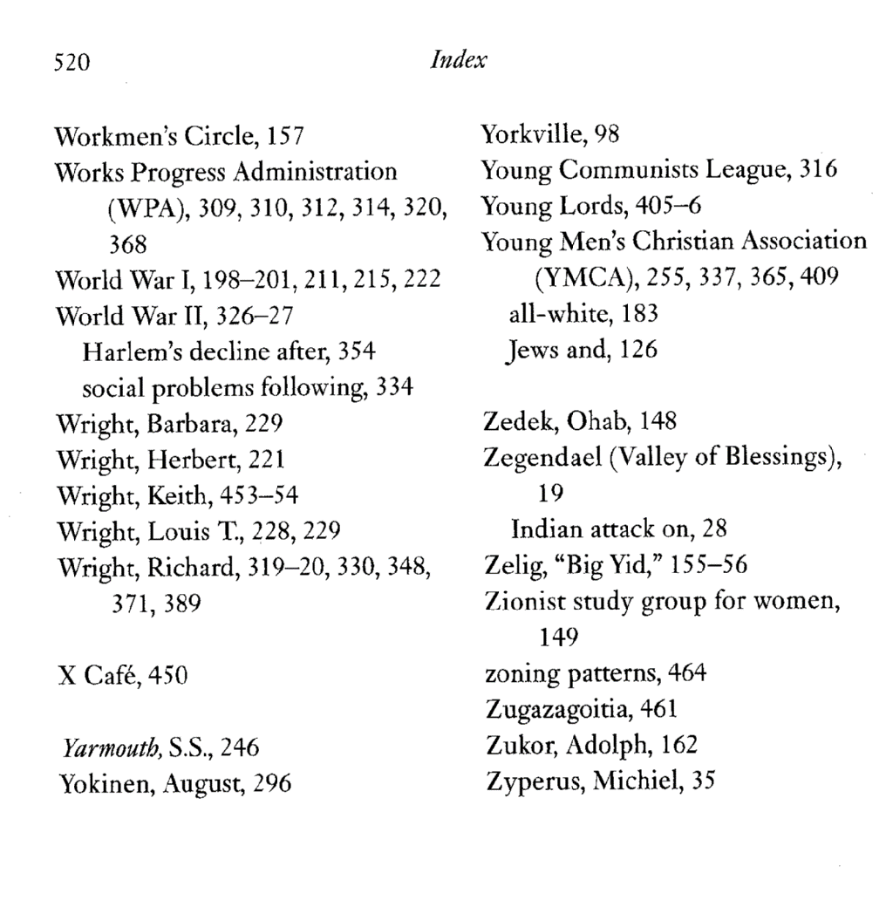

After Validation:
520
Workmen's Circle, 157
Works Progress Administration
(WPA), 309, 310, 312, 314, 320,
368
World War 1,198-201,211, 215, 222
World War II, 326-27
Harlem's decline after, 354 social problems following, 334
Wright, Barbara, 229
Wright, Herbert, 221
Wright, Keith, 453-54

Wright, Louis T., 228, 229
Wright, Richard, 319-20, 330, 348, 371, 389

X Café, 450

Yarmouth, S.S., 246 Yokinen, August, 296
Yorkville, 98
Young Communists League, 316 Young Lords, 405-6 Young Men's Christian Association (YMCA),255, 337, 365,409
all-white, 183
Jews and, 126

Zedek, Ohab, 148 Zegendael (Valley of Blessings), 19
Indian attack on, 28 Zelig, "Big Yid," 155-56 Zionist study group for women, 149
zoning patterns, 464 Zugazagoitia, 461 Zukor, Adolph, 162 Zyperus, Michiel, 35

N/B: If they are separated by letters of alphabets, use the letters as the headings and make them font size 14 bold.

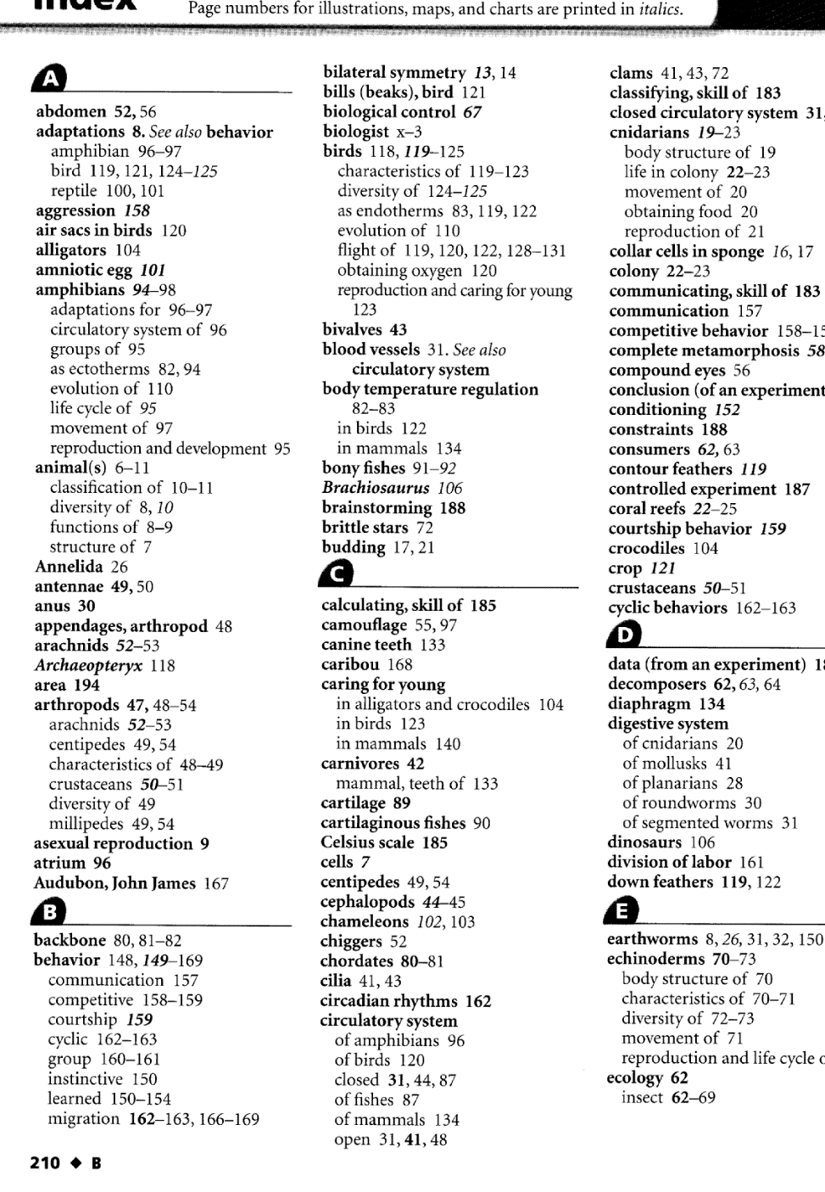

After Validation:

A
***
abdomen 52,56
adaptations 8. See also behavior
amphibian 96-97
bird 119,121, 124-125
reptile 100,101 aggression 158 air sacs in birds 120 alligators 104 amniotic egg 101 amphibians 94-98
adaptations for 96-97
circulatory system of 96
groups of 95
as ectotherms 82, 94
evolution of 110
life cycle of 95
movement of 97
reproduction and development 95 animal(s) 6-11
classification of 10-11
diversity of 8, 10
functions of 8-9
structure of 7 Annelida 26 antennae 49,50 anus 30
appendages, arthropod 48 arachnids 52-53 Archaeopteryx 118 area 194
arthropods 47, 48-54
arachnids 52-53
centipedes 49, 54
characteristics of 48-49
crustaceans 50-51
diversity of 49
millipedes 49, 54 asexual reproduction 9 atrium 96
Audubon, John James 167

B
***
backbone 80,81-82 behavior 148,149-169
communication 157
competitive 158-159
courtship 159

cyclic 162-163
group 160-161
instinctive 150
learned 150-154
migration 162-163,166-169 bilateral symmetry 13,14 bills (beaks), bird 121 biological control 67 biologist x-3 birds 118,119-125
characteristics of 119-123
diversity of 124-125
as endotherms 83,119,122
evolution of 110
flight of 119, 120, 122, 128-131
obtaining oxygen 120
reproduction and caring for young 123 bivalves 43
blood vessels 31. See also
circulatory system body temperature regulation 82-83
in birds 122
in mammals 134 bony fishes 91-92 Brachiosaurus 106 brainstorming 188 brittle stars 72 budding 17,21

C
***
calculating, skill of 185 camouflage 55, 97 canine teeth 133 caribou 168 caring for young
in alligators and crocodiles 104
in birds 123
in mammals 140 carnivores 42
mammal, teeth of 133 cartilage 89 cartilaginous fishes 90 Celsius scale 185 cells 7
centipedes 49, 54 cephalopods 44-45 chameleons 102,103 chiggers 52 chordates 80-81 cilia 41,43
circadian rhythms 162 circulatory system
of amphibians 96 of birds 120 closed 31,44,87 of fishes 87 of mammals 134 open 31,41,48
clams 41,43, 72 classifying, skill of 183 closed circulatory system 31,44 cnidarians 19-23

210

40. SEARCHING FOR QUOTATION MARKS IN DIALOGUES

Search for quotations ["] by:

1. Press Ctrl + F
2. In the Find tab type " " [NB: Make sure there is a space between the two quotation marks] as shown below.

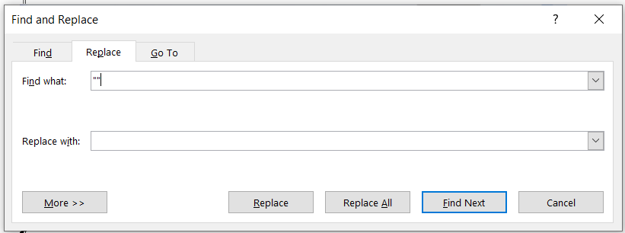

3. Click 'Find next'.
4. Check in the image if the quotations appear in two separate lines or one line and mend as it is in the image. If they appear in two separate lines then press enter to separate the two quotations. If they are in one line then leave as they are.

ILLUSTRATION
NB: Check the highlighted quotations to see the difference.
The quotations in the image below appear on separate lines.

Image:
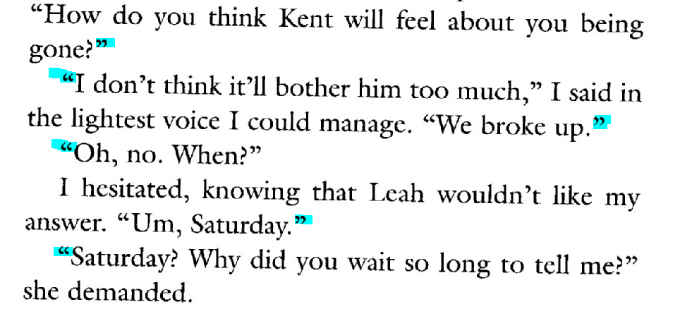
Before validation the quotations appear on the same line which is not in the case with the image.

Before validation:
"How do you think Kent will feel about you being gone?" "I don't think it'll bother him too much," I said in the lightest voice I could manage. "We broke up." "Oh, no. When?"
I hesitated, knowing that Leah wouldn't like my answer. "Um, Saturday." "Saturday? Why did you wait so long to tell me?" she demanded.

After validation the quotations have been separated as they are in the image.

After Validation:
"How do you think Kent will feel about you being gone?"
"I don't think it'll bother him too much," I said in the lightest voice I could manage. "We broke up."
"Oh, no. When?"
I hesitated, knowing that Leah wouldn't like my answer. "Um, Saturday."
"Saturday? Why did you wait so long to tell me?" she demanded.

NB: All quotations both single and double quotes must be straight. So ensure your word settings are set correctly.

INCORRECT:
“
’
CORRECT:
"
'

41. SEARCH FOR JUNK CHARACTERS

Search for all junk characters as you compare with the image document.

Ctrl + F

■
~
@
#
$
%
^
>
<
}
{

/
\
|
« [alt + 174]
» [alt + 175]
1 space
7 space

Space s space
Space j space
Space t space

*Some common mistakes in the word document

Ctrl + F
For example the article the would appear as die.

[Die children survived] instead of [The children survived]

Then cross check with the image document

'A
'Y
'U → 'll
Fm → I'm
Pm → I'm
Tm → I'm
Td → I'd
Pd → I'd
Tve → I'd

die → the
diem →them
diat → that
dian → than
mat → that
odiers → others
bis → his

13. TABLE OF CONTENTS

-Font 20 (Title of the book) style it to heading 1
-Font 16 headings style them to heading 2
-Font 14 headings style them to heading 3

To do this:
Step 1: Modify your titles to be headings
Click on Styles, start with heading 1 → Modify → Change font style to Times New Roman → Font 20→ double click on this two arrows ↓↑ (Line spacing) click okay, then click on your heading.

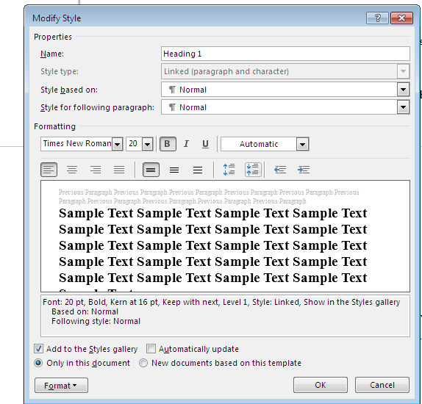

Step 2: Ensure that all the titles and subtitles that are in the pdf's TOC are all modified to be heading on the word document.

To do this:
* Press Ctrl + F (Navigation), and click on headings.
* Check on the list and ensure that all titles and subtitles are present. If we have extra subtitles is OK, but if you have some missing, you must search for them and modify them to be headings.

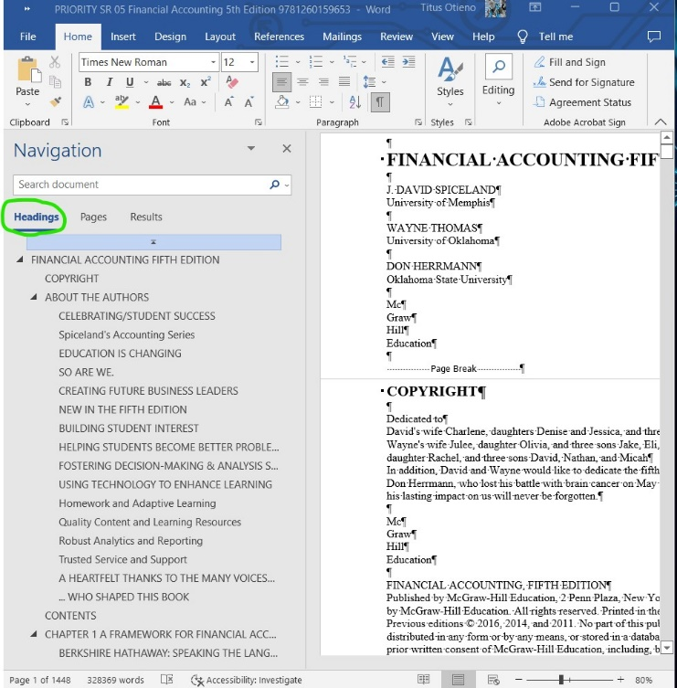

Step 3: Insert the Table of Content
How to insert a table of content.
* Ensure all titles and subtitles appear on the navigation panel.
* Click on REFERENCES on the ribbon

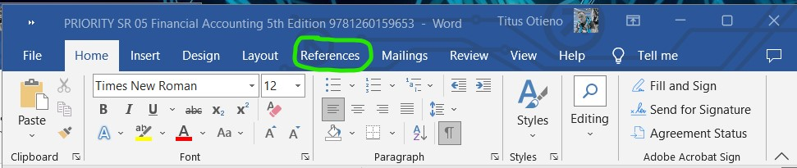

* Click Table of content, and select custom table of content.
* Ensure that the table of content you want to insert covers all the headings [Heading 1, 2 and 3] and click ok.
* Once the table of content appears on that on the last page, cut and paste it on the specified TOC page.
* Select the entire TOC and click on PAGE LAYOUT and ensure that the values on spacing and indent are 0.

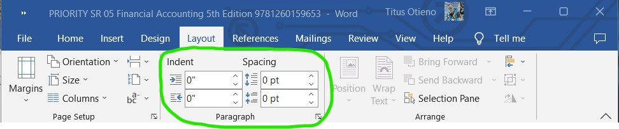

* Press Ctrl+shift+f9 to enable you to edit the TOC [your TOC will turn blueish once you do this]
* Make sure your TOC if font 12 times new roman.
* Hyperlink each title individually.

Example of complete Table of Content
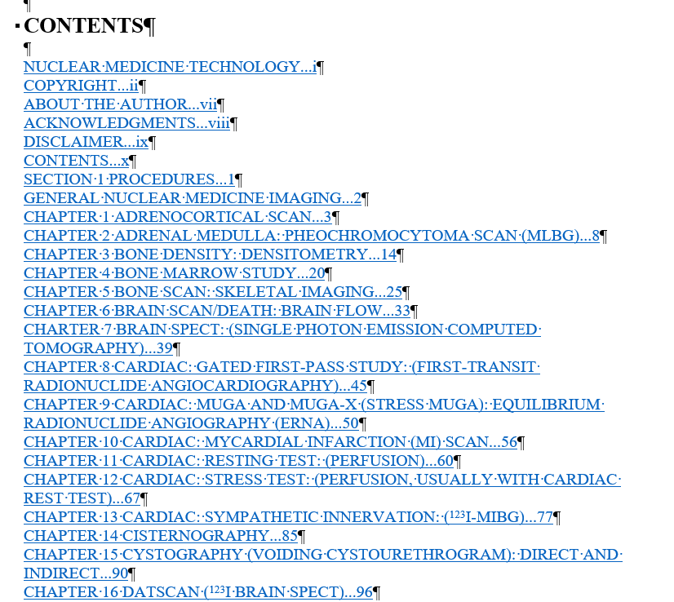

42. ACCENTED LETTERS OF THE ALPHABET

ACCENTED LETTERS AND SPECIAL CHARACTERS for PC
• • •

Hold down the
ALT key
and, using the number pad, type in the numbers corresponding to the accented letter or special character you want (NOTE: for Office XP [MSWord XP] you must have the NUM LOCK key depressed):

ALT+

â 131  ä 132  à 133  á 160  å 134  Ä 142  Å 143  ā 0257  Ā 256  å 134  Ă 258  ă 259  Ą 260 | é 130  ê 136  ë 137  è 138  É 144  Ē ē275  ĕ 277  ĝ 285 | ô 147  ö 148  Ö 153  ò 149  ó 162  ō 333 | û 150  ù 151  ü 129  Ü 154  ú 163  ū 363  ÿ 152
ï 139  î 140  ì 141  í 161 | ç 135  Ç 128  č 269  Č 268  ć 263 | « 174  » 175  € 0128 | ñ 164  Ñ 165
¿ 168  ¡ 173  æ 145  Æ 146 | º 167  • 249  ° 248  · 250 | ½ 171  ¼ 172  ÷ 246 | ¢ 155  £ 156  ¥ 157
↨ 23  ↓ 25  ↑ 24  § 21  → 26  ← 27  ↔ 29  ∩ 239  ∞ 236  Ω 234 | Ω 234  Ă 258  √ 251  ■ 254  Ă  ⁿ 252  Ď 270  Đ 272  ² 253  Ė 279  •7 | ∆ 8710  Π 960  Ð 0208  ♪ 13  ♀ 12  ♂ 11  ◙ 10  ◘ 8  ○ 9  Δ 916  ®  Σ 931  ─ 196  ► 16  ∟ 28 | • 7  ♠ 6  ♣ 5  ♦ 4  ♥ 3  ☻ 2  ☺ 1  —0151

Greek Capital Letters
Character Name | Character | Entity | Hex Entity | HTML Entity
GREEK CAPITAL LETTER ALPHA | Α | &#913; | &#x0391 | &Alpha;
GREEK CAPITAL LETTER BETA | Β | &#914; | &#x0392 | &Beta;
GREEK CAPITAL LETTER GAMMA | Γ | &#915; | &#x0393 | &Gamma;
GREEK CAPITAL LETTER DELTA | Δ | &#916; | &#x0394 | &Delta;
GREEK CAPITAL LETTER EPSILON | Ε | &#917; | &#x0395 | &Epsilon;
GREEK CAPITAL LETTER ZETA | Ζ | &#918; | &#x0396 | &Zeta;
GREEK CAPITAL LETTER ETA | Η | &#919; | &#x0397 | &Eta;
GREEK CAPITAL LETTER THETA | Θ | &#920; | &#x0398 | &Theta;
GREEK CAPITAL LETTER IOTA | Ι | &#921; | &#x0399 | &Iota;
GREEK CAPITAL LETTER KAPPA | Κ | &#922; | &#x039A | &Kappa;
GREEK CAPITAL LETTER LAMDA | Λ | &#923; | &#x039B | &Lamda;
GREEK CAPITAL LETTER MU | Μ | &#924; | &#x039C | &Mu;
GREEK CAPITAL LETTER NU | Ν | &#925; | &#x039D | &Nu;
GREEK CAPITAL LETTER XI | Ξ | &#926; | &#x039E | &Xi;
GREEK CAPITAL LETTER OMICRON | Ο | &#927; | &#x039F | &Omicron;
GREEK CAPITAL LETTER PI | Π | &#928; | &#x03A0 | &Pi;
GREEK CAPITAL LETTER RHO | Ρ | &#929; | &#x03A1 | &Rho;
GREEK CAPITAL LETTER SIGMA | Σ | &#931; | &#x03A3 | &Sigma;
GREEK CAPITAL LETTER TAU | Τ | &#932; | &#x03A4 | &Tau;
GREEK CAPITAL LETTER UPSILON | Υ | &#933; | &#x03A5 | &Upsilon;
GREEK CAPITAL LETTER PHI | Φ | &#934; | &#x03A6 | &Phi;
GREEK CAPITAL LETTER CHI | Χ | &#935; | &#x03A7 | &Chi;
GREEK CAPITAL LETTER PSI | Ψ | &#936; | &#x03A8 | &Psi;
GREEK CAPITAL LETTER OMEGA | Ω | &#937; | &#x03A9 | &Omega;

Greek Lowercase Letters
Character Name | Character | Entity | Hex Entity | HTML Entity
GREEK SMALL LETTER ALPHA | α | &#945; | &#x03B1 | &alpha;
GREEK SMALL LETTER BETA | β | &#946; | &#x03B2 | &beta;
GREEK SMALL LETTER GAMMA | γ | &#947; | &#x03B3 | &gamma;
GREEK SMALL LETTER DELTA | δ | &#948; | &#x03B4 | &delta;
GREEK SMALL LETTER EPSILON | ε | &#949; | &#x03B5 | &epsilon;
GREEK SMALL LETTER ZETA | ζ | &#950; | &#x03B6 | &zeta;
GREEK SMALL LETTER ETA | η | &#951; | &#x03B7 | &eta;
GREEK SMALL LETTER THETA | θ | &#952; | &#x03B8 | &theta;
GREEK SMALL LETTER IOTA | ι | &#953; | &#x03B9 | &iota;
GREEK SMALL LETTER KAPPA | κ | &#954; | &#x03BA | &kappa;
GREEK SMALL LETTER LAMDA | λ | &#955; | &#x03BB | &lamda;
GREEK SMALL LETTER MU | μ | &#956; | &#x03BC | &mu;
GREEK SMALL LETTER NU | ν | &#957; | &#x03BD | &nu;
GREEK SMALL LETTER XI | ξ | &#958; | &#x03BE | &xi;
GREEK SMALL LETTER OMICRON | ο | &#959; | &#x03BF | &omicron;
GREEK SMALL LETTER PI | π | &#960; | &#x03C0 | &pi;
GREEK SMALL LETTER RHO | ρ | &#961; | &#x03C1 | &rho;
GREEK SMALL LETTER FINAL SIGMA | ς | &#962; | &#x03C2
GREEK SMALL LETTER SIGMA | σ | &#963; | &#x03C3 | &sigma;
GREEK SMALL LETTER TAU | τ | &#964; | &#x03C4 | &tau;
GREEK SMALL LETTER UPSILON | υ | &#965; | &#x03C5 | &upsilon;
GREEK SMALL LETTER PHI | φ | &#966; | &#x03C6 | &phi;
GREEK SMALL LETTER CHI | χ | &#967; | &#x03C7 | &chi;
GREEK SMALL LETTER PSI | ψ | &#968; | &#x03C8 | &psi;
GREEK SMALL LETTER OMEGA | ω | &#969; | &#x03C9 | &omega;

Punctuation and Accents
Character Name | Character | Entity | Hex Entity
GREEK NUMERAL SIGN (Dexia keraia) | ʹ | &#884; | &#x0374
GREEK LOWER NUMERAL SIGN (Aristeri keraia) | ͵ | &#885; | &#x0375
GREEK YPOGEGRAMMENI | ͺ | &#890; | &#x037A
GREEK QUESTION MARK (Erotimatiko) | ; | &#894; | &#x037E
GREEK TONOS | ΄ | &#900; | &#x0384
GREEK DIALYTIKA TONOS | ΅ | &#901; | &#x0385
GREEK CAPITAL LETTER ALPHA WITH TONOS | Ά | &#902; | &#x0386
GREEK ANO TELEIA | · | &#903; | &#x0387
GREEK CAPITAL LETTER EPSILON WITH TONOS | Έ | &#904; | &#x0388
GREEK CAPITAL LETTER ETA WITH TONOS | Ή | &#905; | &#x0389
GREEK CAPITAL LETTER IOTA WITH TONOS | Ί | &#906; | &#x038A
GREEK CAPITAL LETTER OMICRON WITH TONOS | Ό | &#908; | &#x038C
GREEK CAPITAL LETTER UPSILON WITH TONOS | Ύ | &#910; | &#x038E
GREEK CAPITAL LETTER OMEGA WITH TONOS | Ώ | &#911; | &#x038F
GREEK SMALL LETTER ALPHA WITH TONOS | ά | &#940; | &#x03AC
GREEK SMALL LETTER EPSILON WITH TONOS | έ | &#941; | &#x03AD
GREEK SMALL LETTER ETA WITH TONOS | ή | &#942; | &#x03AE
GREEK SMALL LETTER OMICRON WITH TONOS | ό | &#972; | &#x03CC
GREEK SMALL LETTER IOTA WITH TONOS | ί | &#943; | &#x03AF
GREEK SMALL LETTER UPSILON WITH TONOS | ύ | &#973; | &#x03CD
GREEK SMALL LETTER OMEGA WITH TONOS | ώ | &#974; | &#x03CE
GREEK CAPITAL LETTER IOTA WITH DIALYTIKA | Ϊ | &#938; | &#x03AA
GREEK CAPITAL LETTER UPSILON WITH DIALYTIKA | Ϋ | &#939; | &#x03AB
GREEK SMALL LETTER IOTA WITH DIALYTIKA | ϊ | &#970; | &#x03CA
GREEK SMALL LETTER UPSILON WITH DIALYTIKA | ϋ | &#971; | &#x03CB
GREEK SMALL LETTER UPSILON WITH DIALYTIKA AND TONOS | ΰ | &#944; | &#x03B0
GREEK SMALL LETTER IOTA WITH DIALYTIKA AND TONOS | ΐ | &#912; | &#x0390

Cursives, Archaic Letters and Alternates
Character Name | Character | Entity | Hex Entity
GREEK BETA SYMBOL (cursive) | ϐ | &#976; | &#x03D0
GREEK THETA SYMBOL (cursive) | ϑ | &#977; | &#x03D1
GREEK UPSILON WITH HOOK SYMBOL | ϒ | &#978; | &#x03D2
GREEK UPSILON WITH ACUTE AND HOOK SYMBOL | ϓ | &#979; | &#x03D3
GREEK UPSILON WITH DIAERESIS AND HOOK SYMBOL | ϔ | &#980; | &#x03D4
GREEK PHI SYMBOL (cursive) | ϕ | &#981; | &#x03D5
GREEK PI SYMBOL | ϖ | &#982; | &#x03D6
GREEK KAI SYMBOL | ϗ | &#983; | &#x03D7
GREEK LETTER STIGMA | Ϛ | &#986; | &#x03DA
GREEK SMALL LETTER STIGMA | ϛ | &#987; | &#x03DB
GREEK LETTER DIGAMMA (F) | Ϝ | &#988; | &#x03DC
GREEK SMALL LETTER DIGAMMA (f) | ϝ | &#989; | &#x03DD
GREEK LETTER KOPPA | Ϟ | &#990; | &#x03DE
GREEK SMALL LETTER KOPPA | ϟ | &#991; | &#x03DF
GREEK LETTER SAMPI | Ϡ | &#992; | &#x03E0
GREEK SMALL LETTER SAMPI | ϡ | &#993; | &#x03E1
GREEK BACKWARDS E | ∃ | &#8707 | &#398

[table]
Display | Friendly Code | Numerical Code | Hex Code | Description
− |  | &#8722; | &#x2212; | Minus Sign
+ | + | &#43; | &#x2B; | Plus Sign
± | &plusmn; | &#177; | &#xB1; | Plus or Minus Sign
× | &times; | &#215; | &#xD7; | Multiplication Sign
÷ | &divide; | &#247; | &#xF7; | Division Sign
% | % | &#37; | &#x25; | Percent Sign
‰ |  | &#137; | &#x2030; | Per Million Sign
= | = | &#61; | &#x3D; | Equal Sign
≠ |  | &#8800; | &#x2260; | Not Equal To Sign
≈ |  | &#8776; | &#x2248; | Approximately Equal Sign
≡ |  | &#8801; | &#x2261; | Identical To Sign
< | &lt; | &#60; | &#x3C; | Less Than Sign
> | &gt; | &#62; | &#x3E; | Greater Than Sign
≤ |  | &#8804; | &#x2264; | Less Than or Equal To Sign
≥ |  | &#8805; | &#x2265; | Greater Than or Equal To Sign
∞ |  | &#8734; | &#x221E; | Infinity Sign
⅛ |  | &#8539; | &#x215B; | One Eighth Fraction
¼ | &frac14; | &#188; | &#xBC; | One Quarter Fraction
⅜ |  | &#8540; | &#x215C; | Three Eighths Fraction
½ | &frac12; | &#189; | &#xBD; | One Half Fraction
⅝ |  | &#8541; | &#x215D; | Five Eighths Fraction
¾ | &frac34; | &#190; | &#xBE; | Three Quarters Fraction
⅞ |  | &#8542; | &#x215E; | Seven Eighths Fraction
∫ |  | &#8747; | &#x222B; | Integral Sign
∂ |  | &#8706; | &#x2202; | Partial Differential Sign
∆ |  | &#8710; | &#x2206; | Increment Sign
∏ |  | &#8719; | &#x220F; | N-ary Product Sign
∑ |  | &#8721; | &#x2211; | N-ary Sum Sign
√ |  | &#8730; | &#x221A; | Square Root Sign
∟ |  | &#8735; | &#x221F; | Right Angle Sign
∩ |  | &#8745; | &#x2229; | Intersection Sign
∙ |  | &#8729; | &#x2219; | Bullet Operator
ƒ |  | &#131; | &#x83; | Function Sign
⁄ |  | &#8260; | &#x2044; | Fraction Slash

Symbol | Description | Decimal | Hexadecimal
𝔸 | Double stroke capital A | Alt + 120120 | 1D538
𝔹 | Double stroke capital B | Alt + 120121 | 1D539
ℂ | Double stroke capital C | Alt + 8450 | 2102
𝔻 | Double stroke capital D | Alt + 120123 | 1D53B
𝔼 | Double stroke capital E | Alt + 120124 | 1D53C
𝔽 | Double stroke capital F | Alt + 120125 | 1D53D
𝔾 | Double stroke capital G | Alt + 120126 | 1D53E
ℍ | Double stroke capital H | Alt + 8461 | 210D
𝕀 | Double stroke capital I | Alt + 120128 | 1D540
𝕁 | Double stroke capital J | Alt + 120129 | 1D541
𝕂 | Double stroke capital K | Alt + 120130 | 1D542
𝕃 | Double stroke capital L | Alt + 120131 | 1D543
𝕄 | Double stroke capital M | Alt + 120132 | 1D544
ℕ | Double stroke capital N | Alt + 8469 | 2115
𝕆 | Double stroke capital O | Alt + 120134 | 1D546
ℙ | Double stroke capital P | Alt + 8473 | 2119
ℚ | Double stroke capital Q | Alt + 8474 | 211A
ℝ | Double stroke capital R | Alt + 8477 | 211D
𝕊 | Double stroke capital S | Alt + 120138 | 1D54A
𝕋 | Double stroke capital T | Alt + 120139 | 1D54B
𝕌 | Double stroke capital U | Alt + 120140 | 1D54C
𝕍 | Double stroke capital V | Alt + 120141 | 1D54D
𝕎 | Double stroke capital W | Alt + 120142 | 1D54E
𝕏 | Double stroke capital X | Alt + 120143 | 1D54F
𝕐 | Double stroke capital Y | Alt + 120144 | 1D550
ℤ | Double stroke capital Z | Alt + 8484 | 2124
𝕒 | Double stroke small a | Alt + 120146 | 1D552
𝕓 | Double stroke small b | Alt + 120147 | 1D553
𝕔 | Double stroke small c | Alt + 120148 | 1D554
𝕕 | Double stroke small d | Alt + 120149 | 1D555
𝕖 | Double stroke small e | Alt + 120150 | 1D556
𝕗 | Double stroke small f | Alt + 120151 | 1D557
𝕘 | Double stroke small g | Alt + 120152 | 1D558
𝕙 | Double stroke small h | Alt + 120153 | 1D559
𝕚 | Double stroke small i | Alt + 120154 | 1D55A
𝕛 | Double stroke small j | Alt + 120155 | 1D55B
𝕜 | Double stroke small k | Alt + 120156 | 1D55C
𝕝 | Double stroke small l | Alt + 120157 | 1D55D
𝕞 | Double stroke small m | Alt + 120158 | 1D55E
𝕟 | Double stroke small n | Alt + 120159 | 1D55F
𝕠 | Double stroke small o | Alt + 120160 | 1D560
𝕡 | Double stroke small p | Alt + 120161 | 1D561
𝕢 | Double stroke small q | Alt + 120162 | 1D562
𝕣 | Double stroke small r | Alt + 120163 | 1D563
𝕤 | Double stroke small s | Alt + 120164 | 1D564
𝕥 | Double stroke small t | Alt + 120165 | 1D565
𝕦 | Double stroke small u | Alt + 120166 | 1D566
𝕧 | Double stroke small v | Alt + 120167 | 1D567
𝕨 | Double stroke small w | Alt + 120168 | 1D568
𝕩 | Double stroke small x | Alt + 120169 | 1D569
𝕪 | Double stroke small y | Alt + 120170 | 1D56A
𝕫 | Double stroke small z | Alt + 120171 | 1D56B
𝟘 | Double stroke digit zero | Alt + 120792 | 1D7D8
𝟙 | Double stroke digit one | Alt + 120793 | 1D7D9
𝟚 | Double stroke digit two | Alt + 120794 | 1D7DA
𝟛 | Double stroke digit three | Alt + 120795 | 1D7DB
𝟜 | Double stroke digit four | Alt + 120796 | 1D7DC
𝟝 | Double stroke digit five | Alt + 120797 | 1D7DD
𝟞 | Double stroke digit six | Alt + 120798 | 1D7DE
𝟟 | Double stroke digit seven | Alt + 120799 | 1D7DF
𝟠 | Double stroke digit eight | Alt + 120800 | 1D7E0
𝟡 | Double stroke digit nine | Alt + 120801 | 1D7E1
ℼ | Double Stroke Small Pi | Alt + 8508 | 213C
ℿ | Double Stroke Capital Pi | Alt + 8511 | 213F
⅀ | Double Stroke N-ary Summation | Alt + 8512 | 2140

[table]
DOUBLE-STRUCK REAL NUMBER (Doublestruck R) | ℝ | &#8477;
COMPLEX NUMBERS (Doublestruck C) | ℂ | &#8450;
NATURAL NUMBERS (Doublestruck N) | ℕ | &#8469;
PRIME NUMBERS (Doublestruck P) | ℙ | &#8473;
RATIONAL NUMBERS (Doublestruck Q) | ℚ | &#8474;
INTEGERS (Doublestruck Z) | ℤ | &#8484;
INUS-OR-PLUS SIGN | ∓ | &#8723;
DOT PLUS | ∔ | &#8724;
ASTERISK OPERATOR | ∗ | &#8727;
RING OPERATOR | ∘ | &#8728;
BULLET OPERATOR | ∙ | &#8729;
PROPORTION | ∷ | &#8759;
DOT MINUS | ∸ | &#8760;
EXCESS | ∹ | &#8761;
GEOMETRIC PROPORTION | ∺ | &#8762;
HOMOTHETIC | ∻ | &#8763;
GEOMETRICALLY EQUIVALENT TO | ≎ | &#8782;
DIFFERENCE BETWEEN | ≏ | &#8783;
APPROACHES THE LIMIT | ≐ | &#8784;
GEOMETRICALLY EQUAL TO | ≑ | &#8785;

[table]
CORRESPONDS TO | ≘ | &#8792; | &#x2258
ESTIMATES | ≙ | &#8793; | &#x2259
EQUIANGULAR TO | ≚ | &#8794; | &#x225A
STAR EQUALS | ≛ | &#8795; | &#x225B
DELTA EQUAL TO | ≜ | &#8796; | &#x225C
EQUAL TO BY DEFINITION | ≝ | &#8797; | &#x225D
MEASURED BY | ≞ | &#8798; | &#x225E
QUESTIONED EQUAL TO | ≟ | &#8799; | &#x225F
PRECEDES | ≺ | &#8826; | &#x227A
SUCCEEDS | ≻ | &#8827; | &#x227B
PRECEDES OR EQUAL TO | ≼ | &#8828; | &#x227C
SUCCEEDS OR EQUAL TO | ≽ | &#8829; | &#x227D
PRECEDES OR EQUIVALENT TO | ≾ | &#8830; | &#x227E
SUCCEEDS OR EQUIVALENT TO | ≿ | &#8831; | &#x227F
DOES NOT PRECEDE | ⊀ | &#8832; | &#x2280
DOES NOT SUCCEED | ⊁ | &#8833; | &#x2281
SQUARE IMAGE OF | ⊏ | &#8847; | &#x228F
SQUARE ORIGINAL OF | ⊐ | &#8848; | &#x2290
SQUARE IMAGE OF OR EQUAL TO | ⊑ | &#8849; | &#x2291
SQUARE ORIGINAL OF OR EQUAL TO | ⊒ | &#8850; | &#x2292
SQUARE CAP | ⊓ | &#8851; | &#x2293
SQUARE CUP | ⊔ | &#8852; | &#x2294
CIRCLED PLUS | ⊕ | &#8853; | &#x2295
CIRCLED MINUS | ⊖ | &#8854; | &#x2296
CIRCLED TIMES | ⊗ | &#8855; | &#x2297
CIRCLED DIVISION SLASH | ⊘ | &#8856; | &#x2298
CIRCLED DOT OPERATOR | ⊙ | &#8857; | &#x2299
CIRCLED RING OPERATOR | ⊚ | &#8858; | &#x229A
CIRCLED ASTERISK OPERATOR | ⊛ | &#8859; | &#x229B
CIRCLED EQUALS | ⊜ | &#8860; | &#x229C
CIRCLED DASH | ⊝ | &#8861; | &#x229D
SQUARED PLUS | ⊞ | &#8862; | &#x229E
SQUARED MINUS | ⊟ | &#8863; | &#x229F
SQUARED TIMES | ⊠ | &#8864; | &#x22A0
SQUARED DOT OPERATOR | ⊪ | &#8874; | &#x22AA
ASSERTION | ⊦ | &#8870; | &#x22A6
MODELS | ⊧ | &#8871; | &#x22A7
TRUE | ⊨ | &#8872; | &#x22A8
FORCES | ⊩ | &#8873; | &#x22A9
TRIPLE VERTICAL BAR RIGHT TURNSTILE | ⊪ | &#8874; | &#x22AA
DOUBLE VERTICAL BAR DOUBLE RIGHT TURNSTILE | ⊫ | &#8875; | &#x22AB
DOES NOT PROVE | ⊬ | &#8876; | &#x22AC
NOT TRUE | ⊭ | &#8877; | &#x22AD
DOES NOT FORCE | ⊮ | &#8878; | &#x22AE
NEGATED DOUBLE VERTICAL BAR DOUBLE RIGHT TURNSTILE | ⊯ | &#8879; | &#x22AF
PRECEDES UNDER RELATION | ⊰ | &#8880; | &#x22B0
SUCCEEDS UNDER RELATION | ⊱ | &#8881; | &#x22B1
NORMAL SUBGROUP OF | ⊲ | &#8882; | &#x22B2
CONTAINS AS NORMAL SUBGROUP | ⊳ | &#8883; | &#x22B3
NORMAL SUBGROUP OF OR EQUAL TO | ⊴ | &#8884; | &#x22B4
CONTAINS AS NORMAL SUBGROUP OR EQUAL TO | ⊵ | &#8885; | &#x22B5
ORIGINAL OF | ⊶ | &#8886; | &#x22B6
IMAGE OF | ⊷ | &#8887; | &#x22B7
MULTIMAP | ⊸ | &#8888; | &#x22B8
HERMITIAN CONJUGATE MATRIX | ⊹ | &#8889; | &#x22B9
INTERCALATE | ⊺ | &#8890; | &#x22BA
DIAMOND OPERATOR | ⋄ | &#8900; | &#x22C4
DOT OPERATOR | ⋅ | &#8901; | &#x22C5
STAR OPERATOR | ⋆ | &#8902; | &#x22C6
DIVISION TIMES | ⋇ | &#8903; | &#x22C7
BOWTIE | ⋈ | &#8904; | &#x22C8
LEFT NORMAL FACTOR SEMIDIRECT PRODUCT | ⋉ | &#8905; | &#x22C9
RIGHT NORMAL FACTOR SEMIDIRECT PRODUCT | ⋊ | &#8906; | &#x22CA
LEFT SEMIDIRECT PRODUCT | ⋋ | &#8907; | &#x22CB
RIGHT SEMIDIRECT PRODUCT | ⋌ | &#8908; | &#x22CC
REVERSED TILDE EQUALS | ⋍ | &#8909; | &#x22CD
PITCHFORK | ⋔ | &#8916; | &#x22D4
EQUAL AND PARALLEL TO | ⋕ | &#8917; | &#x22D5
LESS-THAN WITH DOT | ⋖ | &#8918; | &#x22D6
GREATER-THAN WITH DOT | ⋗ | &#8919; | &#x22D7
VERY MUCH LESS-THAN | ⋘ | &#8920; | &#x22D8
VERY MUCH GREATER-THAN | ⋙ | &#8921; | &#x22D9
LESS-THAN EQUAL TO OR GREATER-THAN | ⋚ | &#8922; | &#x22DA
GREATER-THAN EQUAL TO OR LESS-THAN | ⋛ | &#8923; | &#x22DB
EQUAL TO OR LESS-THAN | ⋜ | &#8924; | &#x22DC
EQUAL TO OR GREATER-THAN | ⋝ | &#8925; | &#x22DD
EQUAL TO OR PRECEDES | ⋞ | &#8926; | &#x22DE
EQUAL TO OR SUCCEEDS | ⋟ | &#8927; | &#x22DF
DOES NOT PRECEDE OR EQUAL | ⋠ | &#8928; | &#x22E0
DOES NOT SUCCEED OR EQUAL | ⋡ | &#8929; | &#x22E1
NOT SQUARE IMAGE OF OR EQUAL TO | ⋢ | &#8930; | &#x22E2
NOT SQUARE ORIGINAL OF OR EQUAL TO | ⋣ | &#8931; | &#x22E3
SQUARE IMAGE OF OR NOT EQUAL TO | ⋤ | &#8932; | &#x22E4
SQUARE ORIGINAL OF OR NOT EQUAL TO | ⋥ | &#8933; | &#x22E5
LESS-THAN BUT NOT EQUIVALENT TO | ⋦ | &#8934; | &#x22E6
GREATER-THAN BUT NOT EQUIVALENT TO | ⋧ | &#8935; | &#x22E7
PRECEDES BUT NOT EQUIVALENT TO | ⋨ | &#8936; | &#x22E8
SUCCEEDS BUT NOT EQUIVALENT TO | ⋩ | &#8937; | &#x22E9
NOT NORMAL SUBGROUP OF | ⋪ | &#8938; | &#x22EA
DOES NOT CONTAIN AS NORMAL SUBGROUP | ⋫ | &#8939; | &#x22EB
NOT NORMAL SUBGROUP OF OR EQUAL TO | ⋬ | &#8940; | &#x22EC
DOES NOT CONTAIN AS NORMAL SUBGROUP OR EQUAL | ⋭ | &#8941; | &#x22ED
VERTICAL ELLIPSIS | ⋮ | &#8942; | &#x22EE
MIDLINE HORIZONTAL ELLIPSIS | ⋯ | &#8943; | &#x22EF
UP RIGHT DIAGONAL ELLIPSIS | ⋰ | &#8944; | &#x22F0
DOWN RIGHT DIAGONAL ELLIPSIS | ⋱ | &#8945; | &#x22F1

[table]
RATIO | ∶ | &#8758; | &#x2236
PROPORTION | ∷ | &#8759; | &#x2237
DOT MINUS | ∸ | &#8760; | &#x2238
EXCESS | ∹ | &#8761; | &#x2239
GEOMETRIC PROPORTION | ∺ | &#8762; | &#x223A
HOMOTHETIC | ∻ | &#8763; | &#x223B
TILDE OPERATOR | ∼ | &#8764; | &#x223C
REVERSED TILDE | ∽ | &#8765; | &#x223D

[table]
RIGHT ANGLE | ∟ | &#8735; | &#x221F
ANGLE  Entity Code = &ang; | ∠ | &#8736; | &#x2220
MEASURED ANGLE | ∡ | &#8737; | &#x2221
SPHERICAL ANGLE | ∢ | &#8738; | &#x2222
DIVIDES | ∣ | &#8739; | &#x2223
DOES NOT DIVIDE | ∤ | &#8740; | &#x2224
PARALLEL TO | ∥ | &#8741; | &#x2225
NOT PARALLEL TO | ∦ | &#8742; | &#x2226
RIGHT ANGLE WITH ARC | ⊾ | &#8894; | &#x22BE
RIGHT TRIANGLE | ⊿ | &#8895; | &#x22BF
UP TACK (Perpendicular)  Entity Code = &perp; | ⊥ | &#8869; | &#x22A5
RIGHT TACK | ⊢ | &#8866; | &#x22A2
LEFT TACK | ⊣ | &#8867; | &#x22A3
DOWN TACK | ⊤ | &#8868; | &#x22A4

[table]
ELEMENT OF | ∈ | &isin; | &#8712; | &#x2208
NOT AN ELEMENT OF | ∉ | &notin; | &#8713; | &#x2209
SMALL ELEMENT OF | ∊ | -- | &#8714; | &#x220A
CONTAINS AS MEMBER | ∋ | &ni; | &#8715; | &#x220B
DOES NOT CONTAIN AS MEMBER | ∌ | -- | &#8716; | &#x220C
SMALL CONTAINS AS MEMBER | ∍ | -- | &#8717; | &#x220D
SET MINUS | ∖ | -- | &#8726; | &#x2216
SUBSET OF (Sideways U with cap to left) | ⊂ | &sub; | &#8834; | &#x2282
SUPERSET OF (Sideways U with cap to right) | ⊃ | &sup; | &#8835; | &#x2283
NOT A SUBSET OF (Subset with Slash) | ⊄ | &nsub; | &#8836; | &#x2284
NOT A SUPERSET OF (Superset with slash) | ⊅ | -- | &#8837; | &#x2285
SUBSET OF OR EQUAL TO (Subset with line below) | ⊆ | &sube; | &#8838; | &#x2286
SUPERSET OF OR EQUAL TO (Superset with line below) | ⊇ | &supe; | &#8839; | &#x2287
NEITHER A SUBSET OF NOR EQUAL TO | ⊈ | -- | &#8840; | &#x2288
NEITHER A SUPERSET OF NOR EQUAL TO | ⊉ | -- | &#8841; | &#x2289
SUBSET OF WITH NOT EQUAL TO | ⊊ | -- | &#8842; | &#x228A
SUPERSET OF WITH NOT EQUAL TO | ⊋ | -- | &#8843; | &#x228B
DIAMOND OPERATOR  (Possibility) | ⋄ | -- | &#8900; | &#x22C4
ASYMPTOTICALLY EQUAL TO  One to one Correspondence | ≃ | -- | &#8771; | &#x2243
NOT ASYMPTOTICALLY EQUAL TO | ≄ | -- | &#8772; | &#x2244

[table]
ymb | Code | Symb | Code | Symb | Code | Symb | Code
☺ | 1 | 0 | 48 | _ | 95 | Ä | 142
☻ | 2 | 1 | 49 | ` | 96 | Å | 143
♥ | 3 | 2 | 50 | a | 97 | É | 144
♦ | 4 | 3 | 51 | b | 98 | æ | 145
♣ | 5 | 4 | 52 | c | 99 | Æ | 146
♠ | 6 | 5 | 53 | d | 100 | ô | 147
• | 7 | 6 | 54 | e | 101 | ö | 148
◘ | 8 | 7 | 55 | f | 102 | ò | 149
○ | 9 | 8 | 56 | g | 103 | û | 150
◙ | 10 | 9 | 57 | h | 104 | ù | 151
♂ | 11 | : | 58 | i | 105 | ÿ | 152
♀ | 12 | ; | 59 | j | 106 | Ö | 153
♪ | 13 | < | 60 | k | 107 | Ü | 154
♫ | 14 | = | 61 | l | 108 | ¢ | 155
☼ | 15 | > | 62 | m | 109 | £ | 156
► | 16 | ? | 63 | n | 110 | ¥ | 157
◄ | 17 | @ | 64 | o | 111 | ₧ | 158
↕ | 18 | A | 65 | p | 112 | ƒ | 159
‼ | 19 | B | 66 | q | 113 | á | 160
¶ | 20 | C | 67 | r | 114 | í | 161
§ | 21 | D | 68 | s | 115 | ó | 162
▬ | 22 | E | 69 | t | 116 | ú | 163
↨ | 23 | F | 70 | u | 117 | ñ | 164
↑ | 24 | G | 71 | v | 118 | Ñ | 165
↓ | 25 | H | 72 | w | 119 | ª | 166
→ | 26 | I | 73 | x | 120 | º | 167
← | 27 | J | 74 | y | 121 | ¿ | 168
∟ | 28 | K | 75 | z | 122 | ⌐ | 169
↔ | 29 | L | 76 | { | 123 | ¬ | 170
▲ | 30 | M | 77 | | | 124 | ½ | 171
▼ | 31 | N | 78 | } | 125 | ¼ | 172
spc | 32 | O | 79 | ~ | 126 | ¡ | 173
! | 33 | P | 80 | ⌂ | 127 | « | 174
" | 34 | Q | 81 | Ç | 128 | » | 175
# | 35 | R | 82 | ü | 129 | ░ | 176
$ | 36 | S | 83 | é | 130 | ▒ | 177
% | 37 | T | 84 | â | 131 | ▓ | 178
& | 38 | U | 85 | ä | 132 | │ | 179
' | 39 | V | 86 | à | 133 | ┤ | 180
( | 40 | W | 87 | å | 134 | ╡ | 181
) | 41 | X | 88 | ç | 135 | ╢ | 182
* | 42 | Y | 89 | ê | 136 | ╖ | 183
+ | 43 | Z | 90 | ë | 137 | ╕ | 184
, | 44 | [ | 91 | è | 138 | ╣ | 185
- | 45 | \ | 92 | ï | 139 | ║ | 186
. | 46 | ] | 93 | î | 140 | ╗ | 187
/ | 47 | ^ | 94 | ì | 141 | ╝ | 188

Symb | Code | Symb | Code | Symb | Code | Symb | Code
╜ | 189 | ∞ | 236 | ¡ | 0161 | Ò | 0210
╛ | 190 | φ | 237 | ¢ | 0162 | Ó | 0211
┐ | 191 | ε | 238 | £ | 0163 | Ô | 0212
└ | 192 | ∩ | 239 | ¤ | 0164 | Õ | 0213
┴ | 193 | ≡ | 240 | ¥ | 0165 | Ö | 0214
┬ | 194 | ± | 241 | ¦ | 0166 | × | 0215
├ | 195 | ≥ | 242 | § | 0167 | Ø | 0216
─ | 196 | ≤ | 243 | ¨ | 0168 | Ù | 0217
┼ | 197 | ⌠ | 244 | © | 0169 | Ú | 0218
╞ | 198 | ⌡ | 245 | ª | 0170 | Û | 0219
╟ | 199 | ÷ | 246 | « | 0171 | Ü | 0220
╚ | 200 | ≈ | 247 | ¬ | 0172 | Ý | 0221
╔ | 201 | ° | 248 | ® | 0174 | Þ | 0222
╩ | 202 | ∙ | 249 | ¯ | 0175 | ß | 0223
╦ | 203 | · | 250 | ° | 0176 | à | 0224
╠ | 204 | √ | 251 | ± | 0177 | á | 0225
═ | 205 | ⁿ | 252 | ² | 0178 | â | 0226
╬ | 206 | ² | 253 | ³ | 0179 | ã | 0227
╧ | 207 | ■ | 254 | ´ | 0180 | ä | 0228
╨ | 208 |  | 255 | µ | 0181 | å | 0229
╤ | 209 | € | 0128 | ¶ | 0182 | æ | 0230
╥ | 210 | ‚ | 0130 | · | 0183 | ç | 0231
╙ | 211 | ƒ | 0131 | ¸ | 0184 | è | 0232
╘ | 212 | „ | 0132 | ¹ | 0185 | é | 0233
╒ | 213 | … | 0133 | º | 0186 | ê | 0234
╓ | 214 | † | 0134 | » | 0187 | ë | 0235
╫ | 215 | ‡ | 0135 | ¼ | 0188 | ì | 0236
╪ | 216 | ˆ | 0136 | ½ | 0189 | í | 0237
┘ | 217 | ‰ | 0137 | ¾ | 0190 | î | 0238
┌ | 218 | Š | 0138 | ¿ | 0191 | ï | 0239
█ | 219 | ‹ | 0139 | À | 0192 | ð | 0240
▄ | 220 | Œ | 0140 | Á | 0193 | ñ | 0241
▌ | 221 | Ž | 0142 | Â | 0194 | ò | 0242
▐ | 222 | ‘ | 0145 | Ã | 0195 | ó | 0243
▀ | 223 | ’ | 0146 | Ä | 0196 | ô | 0244
α | 224 | “ | 0147 | Å | 0197 | õ | 0245
ß | 225 | ” | 0148 | Æ | 0198 | ö | 0246
Γ | 226 | • | 0149 | Ç | 0199 | ÷ | 0247
π | 227 | – | 0150 | È | 0200 | ø | 0248
Σ | 228 | — | 0151 | É | 0201 | ù | 0249
σ | 229 | ˜ | 0152 | Ë | 0203 | ú | 0250
µ | 230 | ™ | 0153 | Ì | 0204 | û | 0251
τ | 231 | š | 0154 | Í | 0205 | ü | 0252
Φ | 232 | › | 0155 | Î | 0206 | ý | 0253
Θ | 233 | œ | 0156 | Ï | 0207 | þ | 0254
Ω | 234 | ž | 0158 | Ð | 0208 | ÿ | 0255
δ | 235 | Ÿ | 0159 | Ñ | 0209

♠ | Black Spade | &#9824;
♥ | Black Heart | &#9829;
♣ | Black Club | &#9827;
♦ | Black Diamond | &#9830;
♤ | White Spade | &#9828;
♡ | White Heart | &#9825;
♧ | White Club | &#9831;
♢ | White Diamond | &#9826;
♪ | Eighth Note | 13
♫ | Single Bar Note | 14

Alt key + Four digits
¤ Alt+0164  † Alt+0134  × Alt+0215  ÷ Alt+0247  ‡ Alt+0135  ± Alt+0177  — Alt+0151  – Alt+0150  ¶ Alt+0182  § Alt+0167  ˆ Alt+0136  ˜ Alt+0152  « Alt+0171  » Alt+0187  ¦ Alt+0166  ‰ Alt+0137  © Alt+0169  ® Alt+0174  ™ Alt+0153  á Alt+0225  à Alt+0224  â Alt+0226  ä Alt+0228  å Alt+0229  Á Alt+0193  Ã Alt+0195  Ä Alt+0196  Å Alt+0197 | À Alt+0192  Â Alt+0194  æ Alt+0230  Æ Alt+0198  ç Alt+0231  Ç Alt+0199  ê Alt+0234  é Alt+0233  ë Alt+0235  è Alt+0232  Ê Alt+0202  Ë Alt+0203  É Alt+0201  È Alt+0200  ï Alt+0239  í Alt+0237  î Alt+0238  ì Alt+0236  Í Alt+0205  Ì Alt+0204  Î Alt+0206  Ï Alt+0207  ñ Alt+0241  Ñ Alt+0209  œ Alt+0156  Œ Alt+0140 | ô Alt+0244  ö Alt+0246  ò Alt+0242  õ Alt+0245  ó Alt+0243  ø Alt+0248  Ó Alt+0211  Ô Alt+0212  Õ Alt+0213  Ø Alt+0216  Ö Alt+0214  Ò Alt+0210  š Alt+0154  Š Alt+0138  ú Alt+0250  ü Alt+0252  û Alt+0251  ù Alt+0249  Ù Alt+0217  Ú Alt+0218  Ü Alt+0220  Û Alt+0219  ÿ Alt+0255  Ÿ Alt+0159  ý Alt+0253  Ý Alt+0221  ž Alt+0158  Ž Alt+0142 | ª Alt+0170  Þ Alt+0222  þ Alt+0254  ƒ Alt+0131  ß Alt+0223  µ Alt+0181  Ð Alt+0208  ° Alt+0176  º Alt+0186  • Alt+0149  „ Alt+0132  … Alt+0133  ¬ Alt+0172  ¿ Alt+0191  ¡ Alt+0161  ¥ Alt+0165  £ Alt+0163  € Alt+0128  ¢ Alt+0162  ¹ Alt+0185  ² Alt+0178  ³ Alt+0179  ½ Alt+0189  ¼ Alt+0188  ¾ Alt+0190
•

Alt key + Three digits
128 Ç  129 ü  130 é  131 â  132 ä  133 à  134 å  135 ç  136 ê  137 ë  138 è  139 ï  140 î | 141 ì  142 Ä  143 Å  144 É  145 æ  146 Æ  147 ô  148 ö  149 ò  150 û  (Greek letters and  math symbols are  between 224 and 247) | 151 ù  152 ÿ  153 Ö  154 Ü  160 á  161 í  162 ó  163 ú  164 ñ  165 Ñ  167 º  168 ¿  248 °  250 · (smaller bullet)

Charts For specific languages

(Alt key + 3 digits is to left of accented letters; Alt key + 4 digits is to the right)
FRENCH  133 à (0224)  131 â (0226)  135 ç (0231)  130 é (0233)  138 è (0232)  136 ê (0234)  137 ë (0235)  140 î (0238)  139 ï (0239)  œ (0156)  147 ô (0244)  151 ù (0249)  150 û (0251)  183 À (0192)  182 Â (0194)  128 Ç (0199)  212 È (0200)  144 É (0201)  210 Ê (0202)  211 Ë (0203)  215 Î (0206)  216 Ï (0207)  Œ (0140) | SPANISH  160 á (0225)  130 é (0233)  161 í (0237)  164 ñ (0241)  162 ó (0243)  163 ú (0250)  129 ü (0252)  Á (0193)  144 É (0201)  Í (0205)  165 Ñ (0209)  Ó (0211)  Ú (0218)  154 Ü (0220)  168 ¿ (0191)  173 ¡ (0161)  French Continued  226 Ô (0212)  235 Ù (0217)  234 Û (0219)  174 « (0171)  175 » (0187) | ITALIAN  133 à (0224)  138 è (0232)  141 ì (0236)  149 ò (0242)  151 ù (0249)  183 À (0192)  212 È (0200)  Ì (0204)  Ò (0210)  Ù (0217)  PORTUGUESE  ã (0227)  Ã (0195)  135 ç (0231)  128 Ç (0199)  149 ò (0242)  Ò (0210)  162 ó (0243)  Ó (0211)  õ (0245)  Õ (0213) | Polish  GERMAN/SCANDINAVIAN  132 ä (0228)  134 å (0229)  145 æ (0230)  ð (0240)  137 ë (0235)  148 ö (0246)  155 ø (0248)  225 ß (0223)  þ (0254)  129 ü (0252)  152 ÿ (0255)  142 Ä (0196)  143 Å (0197)  146 Æ (0198)  Ð (0208)  Ë (0203)  153 Ö (0214)  157 Ø (0216)  Þ (0222)  154 Ü (0220)  ϕ

SPECIAL CHARACTERS

NB: For the list below you have to copy and paste.

ÀÁÂÃÄÅÆÇÈÉÊËÌÍÎÏÐÑÒÓÔÕÖ×ØÙÚÛÜÝÞßàá âãäåæçèéêëìíîïðñòóôõöọ÷øùÚúûüýþÿ

ĀāĂăĄąĆćĈĉĊċČčĎďĐđĒēĔĕĖėĘęĚěĜĝĞğĠġĢģḤḥĤĥĦħĨĩĪīĬĭĮįİıĲĳĴĵĶķĸĹĺĻļĽľĿŀŁł

ṁŃńŅņŇňŉŊŋŌōŎŏŐőŒœŔŕŖŗŘřŚśŜŝŞşŠšŢţŤťŦŧŨũŪūŬŭŮůŰűŲųŴŵŶŷŸ
Â
P̄P̌P̣ṗP̃p̃p̂p̄p̌p̣
ŹźŻżŽžſƒǺǻǼǽǾǿ ẃϕ
Āā Ǟǟ Ḇḇ C̄c̄ đḎḏ Ēē Ḕḕ Ḗḗ Ḡḡ ẖ Īī Ḹḹ Ḻḻ Ṉṉ Ōō Ȫȫ Ṑṑ Ṓṓ ǬǭṜṝ Ṟṟ Ṯṯ Ūū Ǘǘ Ǖǖ Ṻṻ Ȳȳ Ẕẕ
çÇÿÿmhkDFGGGFHFfhjhbjkkn
𝐁
Ÿ Ÿ¨
əạʒↄəṃṁḣḥṅ
ḄḌḍḤḥḲḳḶḷṂṃṆṇṚṛṢṣṬṭṾṿẈẉẒẓẠạẸẹỊịỌọỢợỤụỰ ựỴ ỵ
Ÿ Ÿ¨ÿ
ẋx̄ X̄ Ȳ ȳ
♀♂⚩⚨⚧⚦⚤⚣♀ϕ
ᶐǬǭřŘŗŖŕŔᶉṘṙṚṛṜṝṞṟṦṧȿŚśšŠşŞŝŜṠṡṢṣṤṥṦṧṩṨŢţŤťŧŦṪṫṪṫṬṭṮṯṰṱҫҬҬҭŨỦỪỬỮỰύϋÙúÚΰùÛûửữựüừŨũŪūŬŭųŲűŰůŮṲṳṴṵṶṷṸṹṺṻỤụỦủỨứỪừỬửỮữỰẇựὐὑὒὓὔὕὖὗῠῡῢΰṼṽᶌṼṽṾṿ₩ẃẂẁẀẅώωŵŴẄẀẁẂẃẄẅẆẈẉẘẌẍᶍẊẋẌẍҲҳẎẏϒẎẏẙỲỳỴỵỶỷỸỹὙὛὝὟῨῩῪΎӮӯӱӰӲӳẐẑɀẐẑẒẓẔẕ
ẴḆḈḋÉḟĞḦÍĵḱḼḿṈÒṕǬṘŞṪúṼẃẋỸẑ

Musical Notations

Symbol | ALT Code | ALT X Code | Symbol Name | HTML Entity DEC | HTML Entity HEX | HTML Entity Named | Unicode Code Point
♩ | ALT 9833 | 2669 ALT X | Quarter note, crochet | &#9833 | &#x2669 |  | U+2669
♪ | ALT 13 or ALT 9834 | 266A ALT X | Eighth note, quaver | &#9834 | &#x266A | &sung; | U+266A
♫ | ALT 14 or ALT 9835 | 266B ALT X | Beamed eighth notes, barred eighth notes, beamed quavers | &#9835 | &#x266B |  | U+266B
♬ | ALT 9836 | 266C ALT X | Beamed sixteenth notes, barred sixteenth notes, beamed semiquavers | &#9836 | &#x266C |  | U+266C
♭ | ALT 9837 | 266D ALT X | Music flat sign | &#9837 | &#x266D | &flat; | U+266D
♮ | ALT 9838 | 266E ALT X | Music natural sign | &#9838 | &#x266E | &natur; | U+266E
♯ | ALT 9839 | 266F ALT X | Music sharp sign, z notation infix bag count | &#9839 | &#x266F | &sharp; | U+266F
🎘 | ALT 127896 | 1F398 ALT X | Musical keyboard with jacks, midi, midi keyboard, master keyboard with plugs | &#127896 | &#x1F398 |  | U+1F398
🎙 | ALT 127897 | 1F399 ALT X | Studio microphone | &#127897 | &#x1F399 |  | U+1F399
🎚 | ALT 127898 | 1F39A ALT X | Level slider, level control | &#127898 | &#x1F39A |  | U+1F39A
🎛 | ALT 127899 | 1F39B ALT X | Control knobs, audio control | &#127899 | &#x1F39B |  | U+1F39B
🎜 | ALT 127900 | 1F39C ALT X | Beamed ascending musical notes, musical performance, music, musical background | &#127900 | &#x1F39C |  | U+1F39C
🎝 | ALT 127901 | 1F39D ALT X | Beamed descending musical notes | &#127901 | &#x1F39D |  | U+1F39D
🎵 | ALT 127925 | 1F3B5 ALT X | Musical note, being in good mood | &#127925 | &#x1F3B5 |  | U+1F3B5
🎶 | ALT 127926 | 1F3B6 ALT X | Multiple musical notes, dancing notes, mood, melody | &#127926 | &#x1F3B6 |  | U+1F3B6
🎷 | ALT 127927 | 1F3B7 ALT X | Saxophone | &#127927 | &#x1F3B7 |  | U+1F3B7
🎸 | ALT 127928 | 1F3B8 ALT X | Guitar | &#127928 | &#x1F3B8 |  | U+1F3B8
🎹 | ALT 127929 | 1F3B9 ALT X | Musical keyboard | &#127929 | &#x1F3B9 |  | U+1F3B9
🎺 | ALT 127930 | 1F3BA ALT X | Trumpet | &#127930 | &#x1F3BA |  | U+1F3BA
🎻 | ALT 127931 | 1F3BB ALT X | Violin | &#127931 | &#x1F3BB |  | U+1F3BB
🎼 | ALT 127932 | 1F3BC ALT X | Musical score | &#127932 | &#x1F3BC |  | U+1F3BC
🥁 | ALT 129345 | 1F941 ALT X | Drum with drumsticks | &#129345 | &#x1F941 |  | U+1F941

𝄡
SHORTCUTS

127

Mathematical Operators
Miscellaneous mathematical symbols
2200 | ∀ | FOR ALL
 |  | = | universal quantifier
2201 | ∁ | COMPLEMENT
 |  | → | 0297 ʗ latin letter stretched c
2202 | ∂ | PARTIAL DIFFERENTIAL
2203 | ∃ | THERE EXISTS
 |  | = | existential quantifier
2204 | ∄ | THERE DOES NOT EXIST
 |  | ≡ | 2203 ∃ 0338 ◌̸
2205 | ∅ | EMPTY SET
 |  | = | null set
 |  | • | used in linguistics to indicate a null morpheme or phonological "zero"
 |  | → | 00D8 Ø latin capital letter o with stroke
 |  | → | 2300 ⌀ diameter sign
2206 | ∆ | INCREMENT
 |  | = | Laplace operator
 |  | = | forward difference
 |  | = | symmetric difference (in set theory)
 |  | • | other symbols may also be used for symmetric difference
 |  | → | 0394 Δ greek capital letter delta
 |  | → | 25B3 △ white up-pointing triangle
2207 | ∇ | NABLA
 |  | = | backward difference
 |  | = | gradient, del
 |  | • | used for Laplacian operator (written with superscript 2)
 |  | → | 25BD ▽ white down-pointing triangle
Set membership
2208 | ∈ | ELEMENT OF
2209 | ∉ | NOT AN ELEMENT OF
 |  | ≡ | 2208 ∈ 0338 ◌̸
220A | ∊ | SMALL ELEMENT OF
 |  | • | originates in math pi fonts; not the straight epsilon
 |  | → | 03F5 ϵ greek lunate epsilon symbol
220B | ∋ | CONTAINS AS MEMBER
 |  | = | such that
220C | ∌ | DOES NOT CONTAIN AS MEMBER
 |  | ≡ | 220B ∋ 0338 ◌̸
220D | ∍ | SMALL CONTAINS AS MEMBER
 |  | → | 03F6 ϶ greek reversed lunate epsilon symbol
Miscellaneous mathematical symbol
220E | ∎ | END OF PROOF
 |  | = | q.e.d.
 |  | → | 2023 ‣ triangular bullet
 |  | → | 25AE ▮ black vertical rectangle
N-ary operators
220F | ∏ | N-ARY PRODUCT
 |  | = | product sign
 |  | → | 03A0 Π greek capital letter pi
2210 | ∐ | N-ARY COPRODUCT
 |  | = | coproduct sign
2211 | ∑ | N-ARY SUMMATION
 |  | = | summation sign
 |  | → | 03A3 Σ greek capital letter sigma
 |  | → | 2140 ⅀ double-struck n-ary summation
Operators
2212 | − | MINUS SIGN
 |  | → | 002D - hyphen-minus
 |  | → | 2796 ➖ heavy minus sign
2213 | ∓ | MINUS-OR-PLUS SIGN
 |  | → | 00B1 ± plus-minus sign
2214 | ∔ | DOT PLUS
2215 | ∕ | DIVISION SLASH
 |  | • | generic division operator
 |  | → | 002F / solidus
 |  | → | 2044 ⁄ fraction slash
 |  | → | 27CB ⟋ mathematical rising diagonal
2216 | ∖ | SET MINUS
 |  | → | 005C \ reverse solidus
 |  | → | 27CD ⟍ mathematical falling diagonal
 |  | → | 29F5 ⧵ reverse solidus operator
2217 | ∗ | ASTERISK OPERATOR
 |  | → | 002A * asterisk
2218 | ∘ | RING OPERATOR
 |  | = | composite function
 |  | = | APL jot
 |  | → | 00B0 ° degree sign
 |  | → | 0970 ॰ devanagari abbreviation sign
 |  | → | 25E6 ◦ white bullet
 |  | → | 10B39 𐬹 avestan abbreviation mark
2219 | ∙ | BULLET OPERATOR
 |  | → | 00B7 · middle dot
 |  | → | 2022 • bullet
 |  | → | 2024 ․ one dot leader
221A | √ | SQUARE ROOT
 |  | = | radical sign
 |  | → | 2713 ✓ check mark
221B | ∛ | CUBE ROOT
 |  | → | 0606 ؆ arabic-indic cube root
221C | ∜ | FOURTH ROOT
 |  | → | 0607 ؇ arabic-indic fourth root
221D | ∝ | PROPORTIONAL TO
 |  | → | 03B1 α greek small letter alpha
Miscellaneous mathematical symbol
221E | ∞ | INFINITY
Angles
Other angle symbols are found at 299B-29AF.
221F | ∟ | RIGHT ANGLE
 |  | = | with (in chess notation)
 |  | → | 2BFE ⯾ reversed right angle
2220 | ∠ | ANGLE
 |  | • | used in astrological contexts for aspect semisquare
 |  | → | 299F ⦟ acute angle
2221 | ∡ | MEASURED ANGLE
2222 | ∢ | SPHERICAL ANGLE
 |  | = | angle arc
Relations
2223 | ∣ | DIVIDES
 |  | = | such that
 |  | = | APL stile
 |  | → | 007C | vertical line
 |  | → | 01C0 ǀ latin letter dental click
2224 | ∤ | DOES NOT DIVIDE
 |  | ≡ | 2223 ∣ 0338 ◌̸
2225 | ∥ | PARALLEL TO
 |  | → | 01C1 ǁ latin letter lateral click
 |  | → | 2016 ‖ double vertical line
2226 | ∦ | NOT PARALLEL TO
 |  | ≡ | 2225 ∥ 0338 ◌̸
Logical and set operators
2227 | ∧ | LOGICAL AND
 |  | = | wedge, conjunction
 |  | → | 22C0 ⋀ n-ary logical and
 |  | → | 2303 ⌃ up arrowhead
 |  | → | 27D1 ⟑ and with dot
2228 | ∨ | LOGICAL OR
 |  | = | vee, disjunction
 |  | → | 22C1 ⋁ n-ary logical or
 |  | → | 2304 ⌄ down arrowhead
 |  | → | 27C7 ⟇ or with dot inside
2229 | ∩ | INTERSECTION
 |  | = | cap, hat
 |  | → | 22C2 ⋂ n-ary intersection
222A | ∪ | UNION
 |  | = | cup
 |  | → | 22C3 ⋃ n-ary union
Integrals
222B | ∫ | INTEGRAL
 |  | → | 0283 ʃ latin small letter esh
222C | ∬ | DOUBLE INTEGRAL
 |  | ≈ | 222B ∫ 222B ∫
222D | ∭ | TRIPLE INTEGRAL
 |  | → | 2A0C ⨌ quadruple integral operator
 |  | ≈ | 222B ∫ 222B ∫ 222B ∫
222E | ∮ | CONTOUR INTEGRAL
 |  | → | 2A15 ⨕ integral around a point operator
222F | ∯ | SURFACE INTEGRAL
 |  | ≈ | 222E ∮ 222E ∮
2230 | ∰ | VOLUME INTEGRAL
 |  | ≈ | 222E ∮ 222E ∮ 222E ∮
2231 | ∱ | CLOCKWISE INTEGRAL
2232 | ∲ | CLOCKWISE CONTOUR INTEGRAL
2233 | ∳ | ANTICLOCKWISE CONTOUR INTEGRAL
 |  | • | clockwise or anticlockwise arrows do not reverse during layout mirroring
Miscellaneous mathematical symbols
2234 | ∴ | THEREFORE
 |  | → | 26EC ⛬ historic site
2235 | ∵ | BECAUSE
Relations
2236 | ∶ | RATIO
 |  | • | preferred to 003A : for denotation of division or scale in mathematical use
 |  | → | 003A : colon
2237 | ∷ | PROPORTION
Operator
2238 | ∸ | DOT MINUS
 |  | = | saturating subtraction
 |  | • | sometimes claimed as notation for symmetric set difference, but 2206 ∆ is preferred
Relation
2239 | ∹ | EXCESS
Operator
223A | ∺ | GEOMETRIC PROPORTION
Relations
223B | ∻ | HOMOTHETIC
 |  | → | 2A6B ⩫ tilde operator with rising dots
223C | ∼ | TILDE OPERATOR
 |  | = | varies with (proportional to)
 |  | = | difference between
 |  | = | similar to
 |  | = | not
 |  | = | cycle
 |  | = | APL tilde
 |  | → | 007E ~ tilde
 |  | → | 00AC ¬ not sign
 |  | → | 02DC ˜ small tilde
223D | ∽ | REVERSED TILDE
 |  | = | lazy S
 |  | • | reversed tilde and lazy S are glyph variants
223E | ∾ | INVERTED LAZY S
 |  | = | most positive
Miscellaneous mathematical symbol
223F | ∿ | SINE WAVE
 |  | = | alternating current
Operator
2240 | ≀ | WREATH PRODUCT
Relations
2241 | ≁ | NOT TILDE
 |  | ≡ | 223C ∼ 0338 ◌̸
2242 | ≂ | MINUS TILDE
2243 | ≃ | ASYMPTOTICALLY EQUAL TO
2244 | ≄ | NOT ASYMPTOTICALLY EQUAL TO
 |  | ≡ | 2243 ≃ 0338 ◌̸
2245 | ≅ | APPROXIMATELY EQUAL TO
 |  | → | 2A70 ⩰ approximately equal or equal to
2246 | ≆ | APPROXIMATELY BUT NOT ACTUALLY EQUAL TO
2247 | ≇ | NEITHER APPROXIMATELY NOR ACTUALLY EQUAL TO
 |  | ≡ | 2245 ≅ 0338 ◌̸
2248 | ≈ | ALMOST EQUAL TO
 |  | = | asymptotic to
2249 | ≉ | NOT ALMOST EQUAL TO
 |  | ≡ | 2248 ≈ 0338 ◌̸
224A | ≊ | ALMOST EQUAL OR EQUAL TO
224B | ≋ | TRIPLE TILDE
224C | ≌ | ALL EQUAL TO
 |  | • | reversed tilde and lazy S are glyph variants
224D | ≍ | EQUIVALENT TO
224E | ≎ | GEOMETRICALLY EQUIVALENT TO
224F | ≏ | DIFFERENCE BETWEEN
2250 | ≐ | APPROACHES THE LIMIT
2251 | ≑ | GEOMETRICALLY EQUAL TO
2252 | ≒ | APPROXIMATELY EQUAL TO OR THE IMAGE OF
 |  | = | nearly equals
2253 | ≓ | IMAGE OF OR APPROXIMATELY EQUAL TO
2254 | ≔ | COLON EQUALS
2255 | ≕ | EQUALS COLON
2256 | ≖ | RING IN EQUAL TO
2257 | ≗ | RING EQUAL TO
 |  | = | approximately equal to
2258 | ≘ | CORRESPONDS TO
2259 | ≙ | ESTIMATES
 |  | = | corresponds to
225A | ≚ | EQUIANGULAR TO
225B | ≛ | STAR EQUALS
225C | ≜ | DELTA EQUAL TO
 |  | = | equiangular
 |  | = | equal to by definition
225D | ≝ | EQUAL TO BY DEFINITION
225E | ≞ | MEASURED BY
225F | ≟ | QUESTIONED EQUAL TO
2260 | ≠ | NOT EQUAL TO
 |  | → | 003D = equals sign
 |  | → | 01C2 ǂ latin letter alveolar click
 |  | ≡ | 003D = 0338 ◌̸
2261 | ≡ | IDENTICAL TO
2262 | ≢ | NOT IDENTICAL TO
 |  | ≡ | 2261 ≡ 0338 ◌̸
2263 | ≣ | STRICTLY EQUIVALENT TO
2264 | ≤ | LESS-THAN OR EQUAL TO
 |  | → | 003C < less-than sign
2265 | ≥ | GREATER-THAN OR EQUAL TO
 |  | → | 003E > greater-than sign
2266 | ≦ | LESS-THAN OVER EQUAL TO
2267 | ≧ | GREATER-THAN OVER EQUAL TO
2268 | ≨ | LESS-THAN BUT NOT EQUAL TO
2269 | ≩ | GREATER-THAN BUT NOT EQUAL TO
226A | ≪ | MUCH LESS-THAN
 |  | → | 00AB « left-pointing double angle quotation mark
226B | ≫ | MUCH GREATER-THAN
 |  | → | 00BB » right-pointing double angle quotation mark
226C | ≬ | BETWEEN
 |  | = | plaintiff, quantic
226D | ≭ | NOT EQUIVALENT TO
 |  | ≡ | 224D ≍ 0338 ◌̸
226E | ≮ | NOT LESS-THAN
 |  | ≡ | 003C < 0338 ◌̸
226F | ≯ | NOT GREATER-THAN
 |  | ≡ | 003E > 0338 ◌̸
2270 | ≰ | NEITHER LESS-THAN NOR EQUAL TO
 |  | ≡ | 2264 ≤ 0338 ◌̸
2271 | ≱ | NEITHER GREATER-THAN NOR EQUAL TO
 |  | ≡ | 2265 ≥ 0338 ◌̸
2272 | ≲ | LESS-THAN OR EQUIVALENT TO
2273 | ≳ | GREATER-THAN OR EQUIVALENT TO
2274 | ≴ | NEITHER LESS-THAN NOR EQUIVALENT TO
 |  | ≡ | 2272 ≲ 0338 ◌̸
2275 | ≵ | NEITHER GREATER-THAN NOR EQUIVALENT TO
 |  | ≡ | 2273 ≳ 0338 ◌̸
2276 | ≶ | LESS-THAN OR GREATER-THAN
2277 | ≷ | GREATER-THAN OR LESS-THAN
2278 | ≸ | NEITHER LESS-THAN NOR GREATER-THAN
 |  | ≡ | 2276 ≶ 0338 ◌̸
2279 | ≹ | NEITHER GREATER-THAN NOR LESS-THAN
 |  | ≡ | 2277 ≷ 0338 ◌̸
227A | ≺ | PRECEDES
 |  | = | lower rank than
 |  | → | 22B0 ⊰ precedes under relation
227B | ≻ | SUCCEEDS
 |  | = | higher rank than
 |  | → | 22B1 ⊱ succeeds under relation
227C | ≼ | PRECEDES OR EQUAL TO
227D | ≽ | SUCCEEDS OR EQUAL TO
227E | ≾ | PRECEDES OR EQUIVALENT TO
227F | ≿ | SUCCEEDS OR EQUIVALENT TO
2280 | ⊀ | DOES NOT PRECEDE
 |  | ≡ | 227A ≺ 0338 ◌̸
2281 | ⊁ | DOES NOT SUCCEED
 |  | ≡ | 227B ≻ 0338 ◌̸
2282 | ⊂ | SUBSET OF
 |  | = | included in set
 |  | → | 2E26 ⸦ left sideways u bracket
2283 | ⊃ | SUPERSET OF
 |  | = | includes in set
 |  | → | 2E27 ⸧ right sideways u bracket
2284 | ⊄ | NOT A SUBSET OF
 |  | ≡ | 2282 ⊂ 0338 ◌̸
2285 | ⊅ | NOT A SUPERSET OF
 |  | ≡ | 2283 ⊃ 0338 ◌̸
2286 | ⊆ | SUBSET OF OR EQUAL TO
2287 | ⊇ | SUPERSET OF OR EQUAL TO
2288 | ⊈ | NEITHER A SUBSET OF NOR EQUAL TO
 |  | ≡ | 2286 ⊆ 0338 ◌̸
2289 | ⊉ | NEITHER A SUPERSET OF NOR EQUAL TO
 |  | ≡ | 2287 ⊇ 0338 ◌̸
228A | ⊊ | SUBSET OF WITH NOT EQUAL TO
228B | ⊋ | SUPERSET OF WITH NOT EQUAL TO
Operators
228C | ⊌ | MULTISET
228D | ⊍ | MULTISET MULTIPLICATION
 |  | → | 2A03 ⨃ n-ary union operator with dot
 |  | → | 2A40 ⩀ intersection with dot
228E | ⊎ | MULTISET UNION
 |  | = | z notation bag addition
 |  | → | 2A04 ⨄ n-ary union operator with plus
Relations
228F | ⊏ | SQUARE IMAGE OF
2290 | ⊐ | SQUARE ORIGINAL OF
2291 | ⊑ | SQUARE IMAGE OF OR EQUAL TO
2292 | ⊒ | SQUARE ORIGINAL OF OR EQUAL TO
Operators
2293 | ⊓ | SQUARE CAP
 |  | → | 2A05 ⨅ n-ary square intersection operator
2294 | ⊔ | SQUARE CUP
 |  | → | 2A06 ⨆ n-ary square union operator
2295 | ⊕ | CIRCLED PLUS
 |  | = | direct sum
 |  | = | vector pointing into page
 |  | → | 2A01 ⨁ n-ary circled plus operator
 |  | → | 1F728 🜨 alchemical symbol for verdigris
2296 | ⊖ | CIRCLED MINUS
 |  | = | symmetric difference
 |  | → | 29B5 ⦵ circle with horizontal bar
 |  | → | 1F714 🜔 alchemical symbol for salt
2297 | ⊗ | CIRCLED TIMES
 |  | = | tensor product
 |  | = | vector pointing into page
 |  | → | 26D2 ⛒ circled crossing lanes
 |  | → | 2A02 ⨂ n-ary circled times operator
 |  | → | 2BBE ⮾ circled x
2298 | ⊘ | CIRCLED DIVISION SLASH
2299 | ⊙ | CIRCLED DOT OPERATOR
 |  | = | direct product
 |  | = | vector pointing out of page
 |  | → | 0298 ʘ latin letter bilabial click
 |  | → | 2609 ☉ sun
 |  | → | 2A00 ⨀ n-ary circled dot operator
229A | ⊚ | CIRCLED RING OPERATOR
 |  | → | 233E ⌾ apl functional symbol circle jot
 |  | → | 25CE ◎ bullseye
229B | ⊛ | CIRCLED ASTERISK OPERATOR
 |  | → | 235F ⍟ apl functional symbol circle star
229C | ⊜ | CIRCLED EQUALS
 |  | = | NoDerivatives (symbol used for Creative Commons licenses)
 |  | → | 1F16D 🅭 circled cc
229D | ⊝ | CIRCLED DASH
229E | ⊞ | SQUARED PLUS
229F | ⊟ | SQUARED MINUS
22A0 | ⊠ | SQUARED TIMES
 |  | → | 2612 ☒ ballot box with x
 |  | → | 26DD ⛝ squared saltire
 |  | → | 1F771 🝱 alchemical symbol for month
22A1 | ⊡ | SQUARED DOT OPERATOR
 |  | → | 1F755 🝕 alchemical symbol for urine
 |  | → | 1FBBC 🮼 right open squared dot
22A2 | ⊢ | RIGHT TACK
 |  | = | turnstile
 |  | = | proves, implies, yields
 |  | = | reducible
22A3 | ⊣ | LEFT TACK
 |  | = | reverse turnstile
 |  | = | non-theorem, does not yield
Miscellaneous mathematical symbols
22A4 | ⊤ | DOWN TACK
 |  | = | top
 |  | → | 2E06 ⸆ raised interpolation marker
 |  | → | 1F768 🝨 alchemical symbol for crucible-4
22A5 | ⊥ | UP TACK
 |  | = | base, bottom
 |  | → | 27C2 ⟂ perpendicular
Relations
22A6 | ⊦ | ASSERTION
 |  | = | reduces to
22A7 | ⊧ | MODELS
22A8 | ⊨ | TRUE
 |  | = | statement is true, valid
 |  | = | is a tautology
 |  | = | satisfies
 |  | = | results in
22A9 | ⊩ | FORCES
22AA | ⊪ | TRIPLE VERTICAL BAR RIGHT TURNSTILE
22AB | ⊫ | DOUBLE VERTICAL BAR DOUBLE RIGHT TURNSTILE
22AC | ⊬ | DOES NOT PROVE
 |  | ≡ | 22A2 ⊢ 0338 ◌̸
22AD | ⊭ | NOT TRUE
 |  | ≡ | 22A8 ⊨ 0338 ◌̸
22AE | ⊮ | DOES NOT FORCE
 |  | ≡ | 22A9 ⊩ 0338 ◌̸
22AF | ⊯ | NEGATED DOUBLE VERTICAL BAR DOUBLE RIGHT TURNSTILE
 |  | ≡ | 22AB ⊫ 0338 ◌̸
22B0 | ⊰ | PRECEDES UNDER RELATION
 |  | → | 227A ≺ precedes
22B1 | ⊱ | SUCCEEDS UNDER RELATION
 |  | → | 227B ≻ succeeds
22B2 | ⊲ | NORMAL SUBGROUP OF
 |  | → | 25C5 ◅ white left-pointing pointer
22B3 | ⊳ | CONTAINS AS NORMAL SUBGROUP
 |  | → | 25BB ▻ white right-pointing pointer
22B4 | ⊴ | NORMAL SUBGROUP OF OR EQUAL TO
22B5 | ⊵ | CONTAINS AS NORMAL SUBGROUP OR EQUAL TO
22B6 | ⊶ | ORIGINAL OF
22B7 | ⊷ | IMAGE OF
22B8 | ⊸ | MULTIMAP
22B9 | ⊹ | HERMITIAN CONJUGATE MATRIX
Operators
22BA | ⊺ | INTERCALATE
22BB | ⊻ | XOR
 |  | → | 26BA ⚺ semisextile
22BC | ⊼ | NAND
 |  | → | 2305 ⌅ projective
 |  | → | 26BB ⚻ quincunx
22BD | ⊽ | NOR
Miscellaneous mathematical symbols
22BE | ⊾ | RIGHT ANGLE WITH ARC
22BF | ⊿ | RIGHT TRIANGLE
N-ary operators
22C0 | ⋀ | N-ARY LOGICAL AND
 |  | • | also used to denote the universal quantifier
 |  | → | 2227 ∧ logical and
22C1 | ⋁ | N-ARY LOGICAL OR
 |  | • | also used to denote the existential quantifier
 |  | → | 2228 ∨ logical or
22C2 | ⋂ | N-ARY INTERSECTION
 |  | = | z notation generalised intersection
 |  | → | 2229 ∩ intersection
22C3 | ⋃ | N-ARY UNION
 |  | = | z notation generalised union
 |  | → | 222A ∪ union
Operators
22C4 | ⋄ | DIAMOND OPERATOR
 |  | → | 25C7 ◇ white diamond
 |  | → | 2B29 ⬩ black small diamond
22C5 | ⋅ | DOT OPERATOR
 |  | • | preferred to 00B7 · for denotation of multiplication
 |  | → | 00B7 · middle dot
22C6 | ⋆ | STAR OPERATOR
 |  | • | APL
 |  | → | 066D ‎٭‎ arabic five pointed star
 |  | → | 2605 ★ black star
 |  | → | 2B50 ⭐ white medium star
22C7 | ⋇ | DIVISION TIMES
 |  | → | 00D7 × multiplication sign
 |  | → | 00F7 ÷ division sign
 |  | → | 2715 ✕ multiplication x
Relation
22C8 | ⋈ | BOWTIE
 |  | → | 2445 ⑅ ocr bow tie
Operators
22C9 | ⋉ | LEFT NORMAL FACTOR SEMIDIRECT PRODUCT
22CA | ⋊ | RIGHT NORMAL FACTOR SEMIDIRECT PRODUCT
22CB | ⋋ | LEFT SEMIDIRECT PRODUCT
22CC | ⋌ | RIGHT SEMIDIRECT PRODUCT
 |  | → | 2041 ⁁ caret insertion point
Relation
22CD | ⋍ | REVERSED TILDE EQUALS
Logical operators
22CE | ⋎ | CURLY LOGICAL OR
22CF | ⋏ | CURLY LOGICAL AND
Relations
22D0 | ⋐ | DOUBLE SUBSET
22D1 | ⋑ | DOUBLE SUPERSET
Operators
22D2 | ⋒ | DOUBLE INTERSECTION
22D3 | ⋓ | DOUBLE UNION
Relations
22D4 | ⋔ | PITCHFORK
 |  | = | proper intersection
22D5 | ⋕ | EQUAL AND PARALLEL TO
 |  | → | 2317 ⌗ viewdata square
22D6 | ⋖ | LESS-THAN WITH DOT
22D7 | ⋗ | GREATER-THAN WITH DOT
22D8 | ⋘ | VERY MUCH LESS-THAN
22D9 | ⋙ | VERY MUCH GREATER-THAN
22DA | ⋚ | LESS-THAN EQUAL TO OR GREATER-THAN
22DB | ⋛ | GREATER-THAN EQUAL TO OR LESS-THAN
22DC | ⋜ | EQUAL TO OR LESS-THAN
22DD | ⋝ | EQUAL TO OR GREATER-THAN
22DE | ⋞ | EQUAL TO OR PRECEDES
22DF | ⋟ | EQUAL TO OR SUCCEEDS
22E0 | ⋠ | DOES NOT PRECEDE OR EQUAL
 |  | ≡ | 227C ≼ 0338 ◌̸
22E1 | ⋡ | DOES NOT SUCCEED OR EQUAL
 |  | ≡ | 227D ≽ 0338 ◌̸
22E2 | ⋢ | NOT SQUARE IMAGE OF OR EQUAL TO
 |  | ≡ | 2291 ⊑ 0338 ◌̸
22E3 | ⋣ | NOT SQUARE ORIGINAL OF OR EQUAL TO
 |  | ≡ | 2292 ⊒ 0338 ◌̸
22E4 | ⋤ | SQUARE IMAGE OF OR NOT EQUAL TO
22E5 | ⋥ | SQUARE ORIGINAL OF OR NOT EQUAL TO
22E6 | ⋦ | LESS-THAN BUT NOT EQUIVALENT TO
22E7 | ⋧ | GREATER-THAN BUT NOT EQUIVALENT TO
22E8 | ⋨ | PRECEDES BUT NOT EQUIVALENT TO
22E9 | ⋩ | SUCCEEDS BUT NOT EQUIVALENT TO
22EA | ⋪ | NOT NORMAL SUBGROUP OF
 |  | ≡ | 22B2 ⊲ 0338 ◌̸
22EB | ⋫ | DOES NOT CONTAIN AS NORMAL SUBGROUP
 |  | ≡ | 22B3 ⊳ 0338 ◌̸
22EC | ⋬ | NOT NORMAL SUBGROUP OF OR EQUAL TO
 |  | ≡ | 22B4 ⊴ 0338 ◌̸
22ED | ⋭ | DOES NOT CONTAIN AS NORMAL SUBGROUP OR EQUAL
 |  | ≡ | 22B5 ⊵ 0338 ◌̸
Matrix ellipses
These four ellipsis characters are used for matrix row/column elision.
22EE | ⋮ | VERTICAL ELLIPSIS
 |  | → | 205D ⁝ tricolon
 |  | → | 2026 … horizontal ellipsis
 |  | → | FE19 ︙ presentation form for vertical horizontal ellipsis
22EF | ⋯ | MIDLINE HORIZONTAL ELLIPSIS
22F0 | ⋰ | UP RIGHT DIAGONAL ELLIPSIS
22F1 | ⋱ | DOWN RIGHT DIAGONAL ELLIPSIS
Relations
22F2 | ⋲ | ELEMENT OF WITH LONG HORIZONTAL STROKE
22F3 | ⋳ | ELEMENT OF WITH VERTICAL BAR AT END OF HORIZONTAL STROKE
22F4 | ⋴ | SMALL ELEMENT OF WITH VERTICAL BAR AT END OF HORIZONTAL STROKE
22F5 | ⋵ | ELEMENT OF WITH DOT ABOVE
22F6 | ⋶ | ELEMENT OF WITH OVERBAR
22F7 | ⋷ | SMALL ELEMENT OF WITH OVERBAR
22F8 | ⋸ | ELEMENT OF WITH UNDERBAR
22F9 | ⋹ | ELEMENT OF WITH TWO HORIZONTAL STROKES
22FA | ⋺ | CONTAINS WITH LONG HORIZONTAL STROKE
22FB | ⋻ | CONTAINS WITH VERTICAL BAR AT END OF HORIZONTAL STROKE
22FC | ⋼ | SMALL CONTAINS WITH VERTICAL BAR AT END OF HORIZONTAL STROKE
22FD | ⋽ | CONTAINS WITH OVERBAR
22FE | ⋾ | SMALL CONTAINS WITH OVERBAR
22FF | ⋿ | Z NOTATION BAG MEMBERSHIP

